Методическая разработка по лингвострановедению для учащихся 4-го года обучения

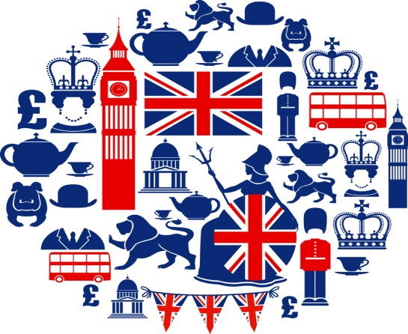

ЦВР 2019г.

Методическая разработка по лингвострановедению предназначена для учащихся 4 класса, включает в себя тексты, задания и пояснения к тексту для развития навыков самостоятельной работы.

Содержание:

- Great Britain
- The symbols of the UK

London
- Sights of London
- Queen Elizabeth II
- Christmas in Great Britain
- Schools and school life in the UK, USA and Russia

Great Britain

The United Kingdom of Great Britain and Northern Ireland (the UK) occupies the British Isles and consists of 4 parts: England, Wales, Scotland and Northern Ireland. The country has the population of 60 million people. The isles are washed by the Atlantic Ocean in the north and in the west and by the English Channel in the south.
There are many beautiful lakes and mountains in Scotland and England. The highest point in the Highlands is Ben Nevis. The longest river flows in England, it is the Severn. The main attraction in the north of England is the Lake District. Thanks to the warm waters of Gulf Stream the island is very green and the British climate is mild
The capital of Great Britain is London. It stands on the Thames. The country is a constitutional monarchy and officially the Queen is the Head of state. But it is ruled by the Prime Minister and the government. The legislative body is the Parliament which consists of the House of Lords and the House of Commons.
The UK is a highly developed industrial state. The chief industries are shipbuilding, fishing and mining, production of aircraft equipment, electronics, textile and chemicals. The country is the world’s largest exporter of iron and steel goods. The most important industrial cities of Great Britain are London, Birmingham, Manchester, Glasgow, Liverpool, Leeds, Edinburgh.
A lot of famous people were born and lived in Great Britain. Among them are Shakespeare, Newton, Churchill, Paul McCartney, Joanne Rowling, Sting, David Beckham and many others.
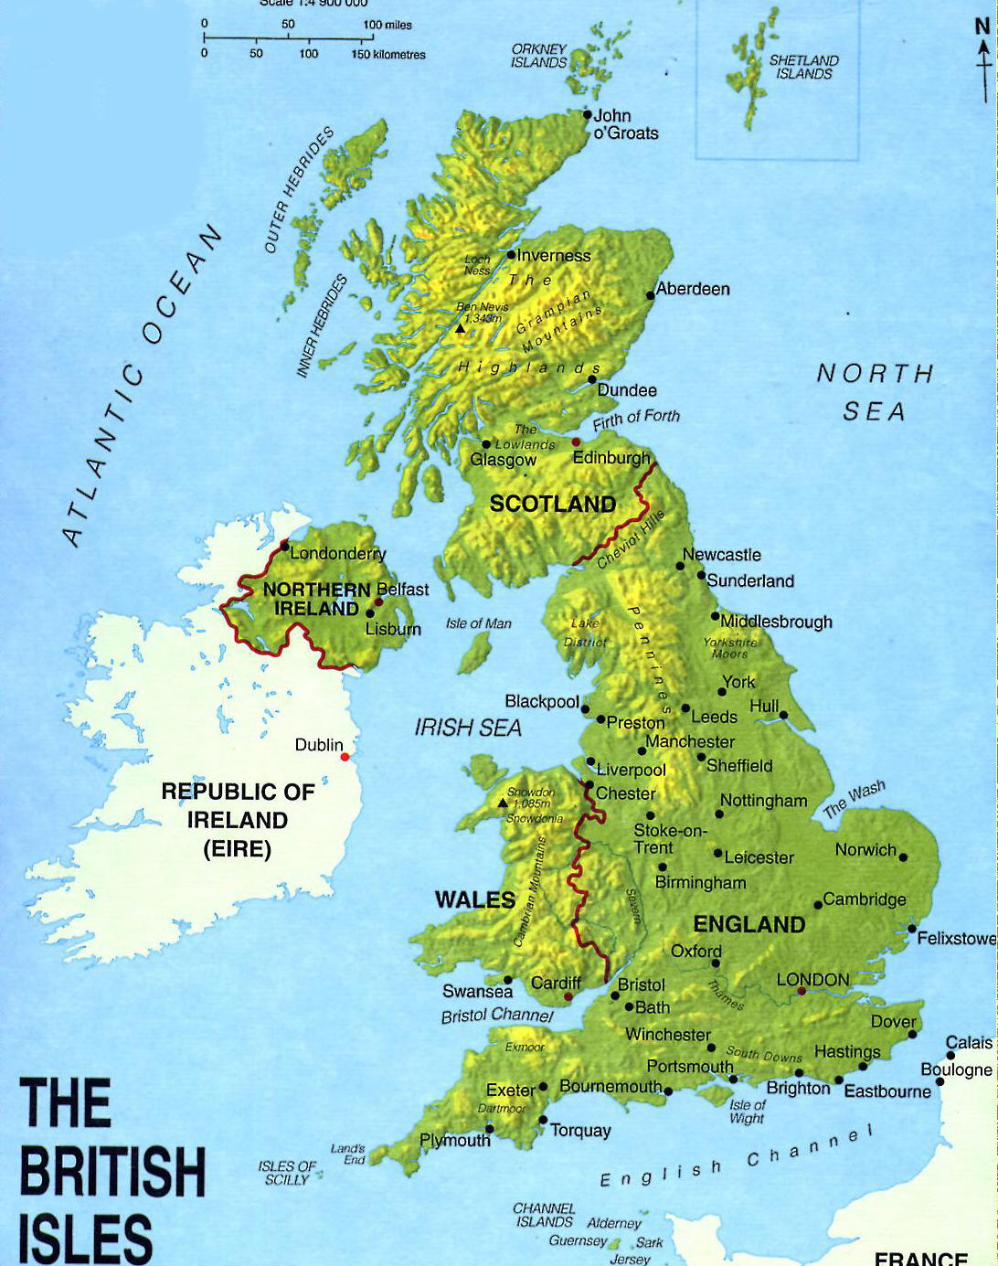

The symbols of the UK

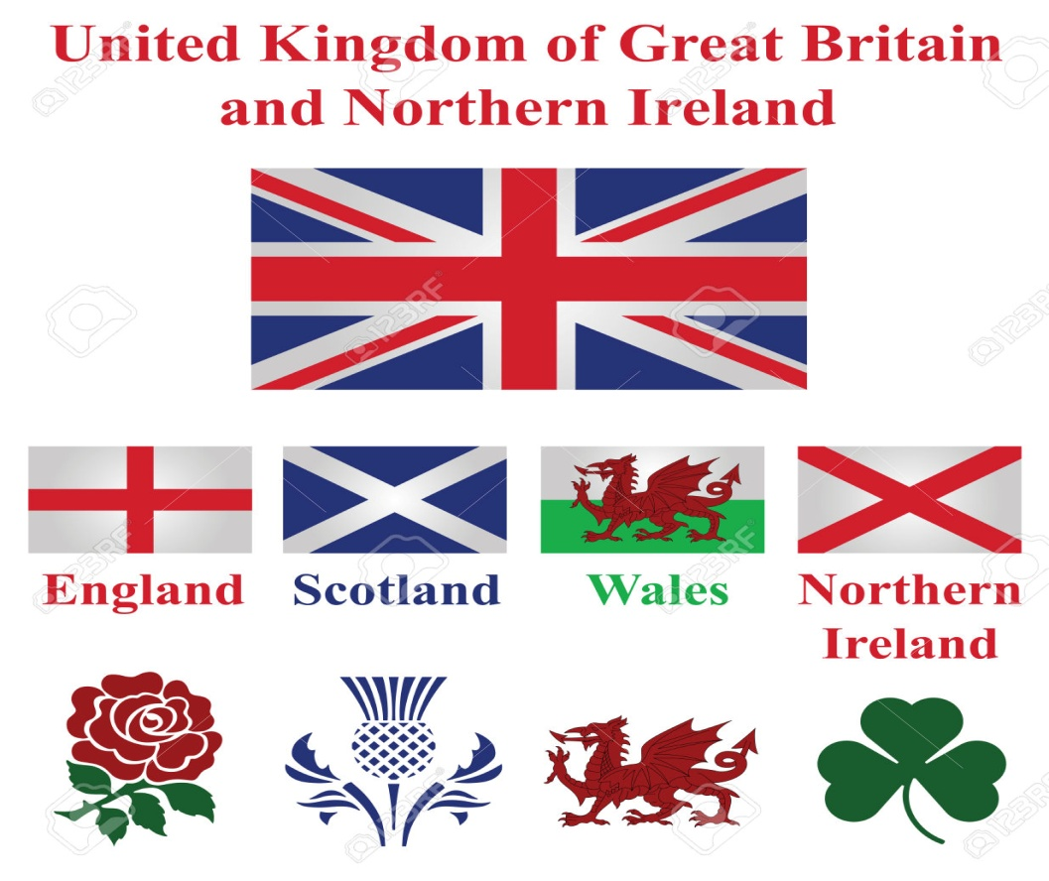

Every country has its specific culture and peculiarities which can be found in their symbols. The United Kingdom of Great Britain and Northern Ireland consists of four countries: England, Scotland, Wales and Northern Ireland. Each of them has its symbols and usually there are two types of them official and unofficial ones.
The floral emblem and at the same time the symbol of England is the red rose. Besides the floral symbol England has the national animal of England and it is a lion.
The national flower in Scotland is the Thistle or sometimes it is called Scottish Bluebell. Scotland also has its national animal and it is a unicorn
Wales has the symbol spring flower daffodil. Welsh national animal is a red dragon which is also on the welsh flag.
And the Northern Ireland also has its own flower symbol it is shamrock. Besides the flower symbols every part of the UK has its own patron. It is possible to call them the saint symbols.
In England St. George is a patron and in his honor every year on the 23rd April a national day, the Day of St. George, is celebrated there. The national day in Wales is on the 1st March and this day dedicated to St. David who is the patron of Wales. The patron of Scotland is St. Andrew and Scotsmen celebrate on the 30th November the national day, St. Andrew day. St. Patrick is a saint patron of the Northern Ireland and on the 17th of March it is a great holiday, the day of St. Patrick.
All the floral and saint symbols of the UK countries can be called unofficial and the official symbols are their flags and emblems. The official symbol of England is the Cross of St. George the red crosses on the white ground. The national flag of Wales is called the Welsh dragon. There is a red dragon on the white and green ground. The national flag of the Scotland is the Cross of St. Andrew the white diagonal crosses on the blue ground. And the national flag of Northern Ireland is the Cross of St. Patrick red diagonal crosses on the white ground.
Besides the individual symbols and the emblems the UK has the common symbol the Union Jack. It is a flag which unites the peculiarities of the patrons .
The capital of Scotland is Edinburgh, the capital of Wales is Cardiff, the capital of Northern Ireland is Belfast.

WORDS

to occupy - оккупировать, занимать

to consist - состоять, заключаться

population - население

beautiful- красивый, прекрасный

lake - озеро

mountain - гора

point - мыс, точка

to flow – течь, струиться

attraction - привлекательный

mild - мягкий

constitutional monarchy – конституционная монархия

government - правительство

a highly developed industrial state – высокоразвитая

промышленная страна

chief – глава, начальник

production of aircraft equipment – производство

авиационного оборудования

the most important – наиболее (самый) важный

among them – среди них

QUESTIONS
1. What is the official name of Britain?
2. Where is the UK situated?
3. What parts does the UK consist of?
4. What is the capital of Britain?
5. What is the longest river in Britain?
6. What birds live in the Tower of London?

7. What is the most important industrial cities of Great Britain?

London
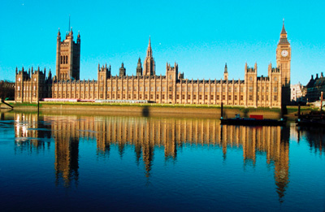

London is the capital of Great Britain, its political, economic and cultural centre. It’s one of the largest cities in the world. Its population is more than 9 million people. London is situated on the river Thames. It was founded more than two thousand years ago. London is an ancient city. It appeared at the place where the Roman invaders decided to build a bridge over the Thames. There are four parts in London: West End, East End, the City and Westminster.
The City is the oldest part of London, its financial and business centre. There are many offices, companies and banks in this part of the capital. The heart of the City is the Stock Exchange. The Tower of London and St Paul’s Cathedral are situated in the City.
Westminster is also important part of the capital. It’s the administrative centre of London. The Houses of Parliament, the seat of the British Government, are there. Opposite the Houses of Parliament is Westminster Abbey where kings and queens have been crowned and many famous people were buried.
The Towers of the Houses of Parliament stand high above the city. On the highest tower there is the largest clock in the country, Big Ben. Big Ben strikes every quarter of an hour.
To the west of Westminster is West End, the richest part of London. It is full of luxury hotels, super-markets, cinemas and concert-halls. In the centre of the West End the Trafalgar Square is situated with the famous statue of Lord Nelson.
To the east of Westminster is East End, an industrial district of the capital. Most of plants and factories are situated there.
The official London residence of the Queen is Buckingham Palace. The palace was built in 1703 by the Duke Buckingham. The daily ceremony of the Changing of the Guard takes place in its courtyard.
There are many museums in London. For example, the British Museum, the Natural History Museum, the Science Museum. The British Museum is the biggest museum in London. The museum is famous for its library — one of the richest in the world.
There are many beautiful parks in London. St James’s Park, Green Park, Hyde Park and Kensington Gardens are linked together and form above 300 hectares of parkland in the heart of London.

Sights of London

Buckingham Palace
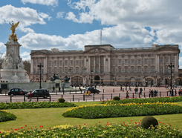 |  | Buckingham Palace is the official residence of Queen Elizabeth. It is located near Green Park. When the Queen is in the residence, the Royal Standard flies over Buckingham Palace.  There are 775 rooms where members of the Royal family and their servants live. There are also rooms for guests. There are offices, on-site post and even swimming pool in the palace. Throughout the year right in front of Buckingham Palace the ceremony of the Changing of the Guard takes place, attracting a lot of tourists.

The Tower of London
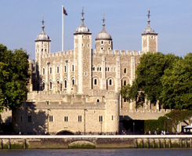 | The Tower of London is one of the main London's places of interest. It is located on the north bank of the River Thames and is one of the oldest buildings.  At different times the Tower was used as a royal residence, fortress, prison, mint and, even, zoo. Today the Tower of London is the place where the Crown Jewels are kept.Every day its doors are open for tourists. A few black ravens live on its territory. The walls of the Tower are still guarded by palace guard in historical outfits.

Trafalgar Square
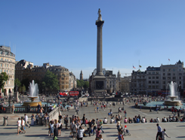 |  | Trafalgar Square is located in the centre of London. It was named after the victory in the Battle of Trafalgar. In the centre of the square there is Nelson's column with four lions at the bottom of it.  There are beautiful fountains in the square. Some famous buildings, such as the National Gallery, St. Martin-in-the-fields and Admiralty Arch, are also located there.  The square is the place where a lot of different events and celebrations are held.

Hyde Park
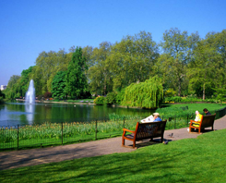 |  | Hyde Park is a big park located in central London. Today it is a popular place for meetings, celebrations and festivals.  The park is known for its artificial lake Serpentine where it is allowed to swim. There is a gallery, a museum and several sculptures on the territory of Hyde Park.  During the Olympic Games 2012 Hyde Park was the place where some competitions were held.

St. Paul's Cathedral
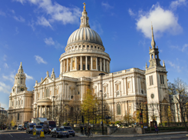 |  | St. Paul's Cathedral is located at the highest point of the City of London, Ludgate Hill. The Cathedral was seriously damaged during the Great Fire of London. It was redesigned by Christopher Wren, a famous architect.  There are three Galleries and 17 bells in the Cathedral. The largest bell is called Great Paul. The funerals of a lot of notable figures have occured at the cathedral.

The British Museum
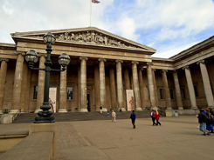 |  | The British Museum is one of the largest museums in the world. It was founded in the XVIII century and in the XIX century it was already divided into different departments.  The museum houses large collections of artefacts representing different cultures of the world, both ancient and modern.  So, there is the Department of coins and medals, the Department of prints and drawings, the Department of Ancient Egypt and Sudan and many others.

The London Eye
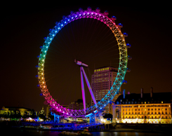 |  | The London Eye is one the largest Ferris wheels in Europe. Unforgettable views of the city open from its height of 135 metres.  The wheel consists of 32 air-conditioned capsules which symbolize 32 boroughs of London. The London Eye rotates with the speed of 0,9 km/hour. The ride takes 30 minutes. The wheel looks like a big bicycle wheel.

Oxford Street
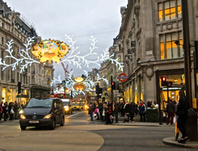 |  | Oxford Street is a lively shopping street located in the centre of London. There are hundreds of shops in this street. The street is 1,9 km long. It is one of the busiest commercial streets in Europe.  During Christmas time Oxford Street is decorated with lots of lights and garlands making it one of the most popular destinations for tourists.

Westminster
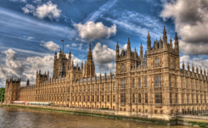 |  | Westminster is a historical area of central London with several famous landmarks.  Westminster Abbey, a Gothic church, is located there. The church is a traditional place of coronation and burial site for all British kings and queens.  Not far from the church there is the Palace of Westminster which is the meeting place of the House of Commons and the House of Lords.

Big Ben
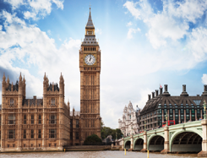 |  | Big Ben is the name of the Great bell of the clock at the Palace of Westminster. Nowadays this name mostly refers to the clock and the clock tower.  In 2012 the tower was renamed to celebrate the Diamond Jubilee of the Queen and is now officially known as the Elizabeth Tower.  The height of the tower is 96,3 metres. Big Ben is one of the most prominent symbols of the United Kingdom.

WORDS

- an ancient city – древний город
- to appear – выступать, появляться
- the Roman invaders – римские захватчики, оккупанты
- to decide – решать, принимать решение
- London is situated on…- Лондон расположен на…
- сourtyard – внутренний двор
- to take place- проходить, происходить, иметь место
- artificial lake – искусственное озеро
- to divide – делить(ся), разделять(ся)
- burial site – место захоронения
- the House of сommons – палата общин
- the House of lords – палата лордов
- nowadays this name mostly refers to…- в настоящее
время это название в основном относится к…
- prominent symbol – видный символ
- specific culture - специфическая культура
- рeculiarities - особенности
- the Thistle – чертополох
- spring flower daffodil – весенний нарцисс
- unicorn – единорог
- the Shamrock – трилистник

Queen Elizabeth II

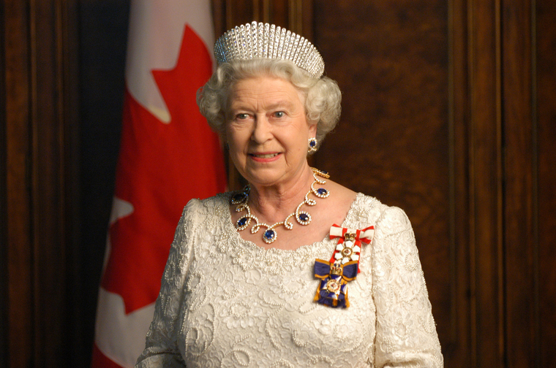

Queen Elizabeth II of Great Britain is the longest-reigning monarch in British history. She celebrated 65 years on the throne in February 2017 with her Sapphire Jubilee.
Queen Elizabeth II’s father, Prince Albert, was the second son of King George V and Queen Mary. She has ties with most of the monarchs in Europe. George V and Tsar Nicholas ll were cousins.
Queen Elizabeth II was crowned as queen at the age of 25 and today when we think of Queen Elizabeth Alexandra Mary (Her Full Name). Legally, the Queen Elizabeth II has the right of ownership of all the unmarked swans wandering around Britain waterways. Within 3 miles of UK shores, other species include; dolphins, whales, and sturgeons. Such is the power of the crown. One of the freedoms that emanate with throne is that Queen doesn’t need any driving license to drive around. In 1940, The little Elizabeth made her first radio broadcast addressing other children who had to be evacuated from the cities during the World War II. The central message of the speech is “in the end all will be well.”

WORDS
- the longest-reigning- самый долгоправящий(-щая)
- Sapphire Jubilee- сапфировый юбилей
- has ties- быть связанным(-ой), связана
- George V, Tsar Nicholas ll- Георг 5, Николай 2
- was crowned- был(-а) коронована
- legally-легально, по закону
- …has the right of ownership of all the unmarked swans- имеет право собственности на всех непомеченных лебедей
- shore-берег, побережье
- such is the power of the crown- такова власть (сила) короны
- emanate-исходить, истекать
- broadcast-радиовещание
- waterway-фарватер, водный путь, водная артерия

Christmas in Great Britain

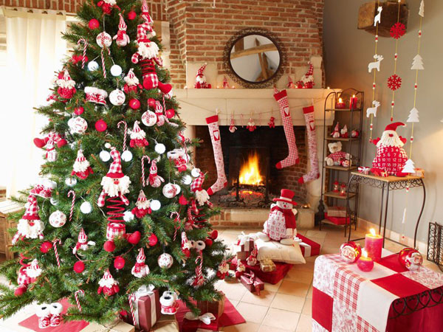
Christmas Day, December 25, is probably the most popular holiday in Great Britain. It is a family holiday. Traditionally all relatives and friends give each other presents. So, before Christmas all the department stores and shops are crowded, everybody is choosing a present.
In general, people get prepared for this holiday very carefully. They decorate their houses in the traditional way. Christmas trees are set up in houses, in the streets and churches. They are always decorated with fairy lights, angels and small toys. In addition, little packets with nuts, candies and special biscuits are hung on the tree. Presents are put around the tree and artificial «frost» is scattered over the branches.
The Germans are believed to be the first to use the Christmas tree in their celebrations and Martin Luther was the first to place a star on the top of the tree. This star represents the star appeared over the stable in which Christ was born.
In Great Britain, the Christmas tree became popular while Queen Victoria ruled the country.
Besides the Christmas tree, holly and mistletoe are used to decorate the house. Branches of holly are put up behind pictures and mistletoe is hung over doors, so the young people have a chance to kiss the girls under it, plucking each time a red berry from the mistletoe. It is said that the girl who was not kissed under it at Christmas would not get married that year.
On the eve of Christmas children hang their stockings, so that Santa Claus could put presents into them: oranges, sweets, nuts and if the child didn't behave properly Santa Claus can put there a piece of coal as punishment.
Santa Claus got his name from a man known as St. Nicolas, who lived in the fourth century. He gave his wealth to the poor and often to children. After he died, the Dutch brought this legend to colonial America. Soon the name Sinter Klaus became Santa Claus.
Carol singing is an essential part of Christmas. No church or school is without its carol service. Carols may be traditional or with some variations that express different feelings. Carols were used for the first time during Christmas in the fifteenth century.
Usually children come around in the evening to the front doors and start singing carols and people who live in these houses give children candies, nuts, pies and so on, to thank them for carol singing.
A typical Christmas lunch includes turkey with cranberry sauce and pudding. Every young woman in each household helps to stir the Christmas pudding, if she wishes to be married that year. Usually a coin or two are hidden inside the pudding and part of the fun is to see who finds it.
After the lunch they go to the sitting room to listen to the Christmas speech of the Queen, shown on TV.
So, Christmas is a merry family holiday for all the people of Great Britain. Christmas comes but once a year.

WORDS
1. relative - родственник, родственница
2. to choose -выбирать, избирать
3. department store - универсальный магазин
4. Christmas tree - рождественская елка
5. carefully - тщательно, аккуратно; внимательно; осторожно
6. candy - леденец; амер. конфета; сладости
7. nut - орех
8. biscuit - сухое печенье
9. frost - мороз; иней
9. holly - бот. падуб, остролист
10. to scatter -разбрасывать, раскидывать; рассыпать; посыпать, усыпать
11. branch - ветка
12. Martin Luther - Мартин Лютер
13. stable - конюшня; устар. загон для скота, хлев, овчарня, коровник, свинарник
14. mistletoe - бот. омела (в Англии традиционное украшение дома на Рождество)
15. eve - канун, преддверие
16. to behave -вести себя, поступать, держаться
17. punishment - кара, наказание
18. wealth - богатство
19. to pluck -срывать, щипать, собирать
20. berry - ягода
21. carol - веселая песня; гимн (обыкн. рождественский)
22. pie - пирог; амер. торт, сладкий пирог
23. turkey - индюк; индейка (тж. кул.)
24. the Dutch -датчане
25. household - хозяйство; двор, дом
26. to bring (past brought, p.p. brought) - приносить, привозить; приводить; доставлять
27. cranberry sauce - соус из клюквы
28. pudding - пудинг, запеканка
29. coin - монета, мелкая монета
30. Christmas comes but once a year - поcл. Рождество приходит только раз в году
31. to stir -мешать, помешивать, размешивать; взбалтывать

QUESTIONS
1. How do people get prepared for this holiday?
2. Is Christmas a popular holiday in Great Britain?
3. Who was the first to use the Christmas tree?
4. How is the Christmas tree decorated?
5. Who was the first to place a star on the top of the Christmas tree?
6. When did the Christmas tree become popular in Great Britain?
7. Where did Santa Claus get his name from?
8. What do children usually do on the Еve of Christmas in Great Britain?
9. What does a typical Christmas lunch include?
10. What is the carol?

Schools and school life in the UK, USA and Russia

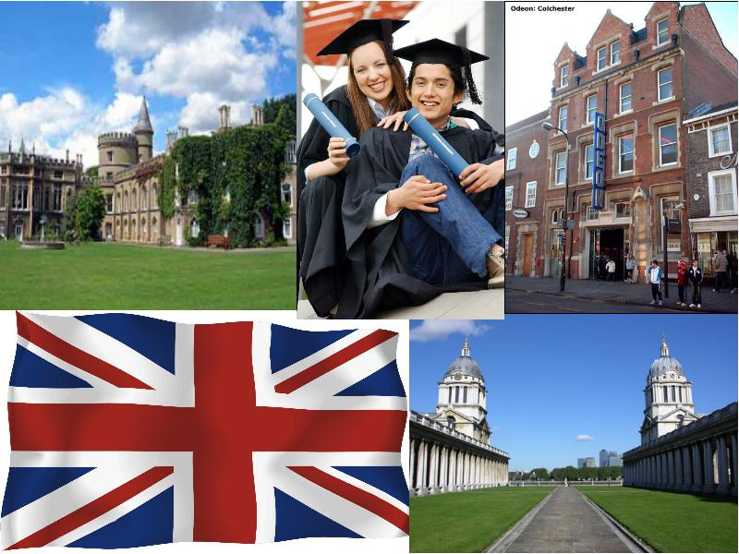

Children at secondary school study ten subjects. The main subjects are English, Maths and Science. Children get homework every day. They often have homework for about four different subjects. There are three school terms in Britain: autumn, spring and summer terms. Holidays can vary from region to region. The schools usually have ten days at the end of the first term, ten days at the end of the second term and six weeks in the summer from the end of July to the beginning of September.

Schools and school life in the USA
American children study four or five main subjects and choose a large number of other subjects. The lessons are about an hour. The American school year is not very long, it is about nine months, beginning early in September and continuing up to the first of June. American students are happy because there are many vacations in the school year. They have two weeks for spring vacation, two weeks for Christmas vacation and three months for summer vacation. There are two semesters. At the end of each semester pupils get a report card from their teachers. In the USA many children like to travel .

Schools and school life in Russia
In the Russian Federation the school education is compulsory. Pupils start going to school from the age of seven and till 16.Mandatory education in Russia is presented by three types of schools: primary, secondary and high. The primary school teaches its pupils elementary skills, such as reading, writing, counting. Many schools also offer foreign languages or some other special disciplines at this age.
The most important period is the secondary school, which starts from the 4th or 5th grade, depending on school. This is the time when children start learning Biology, Geography, Chemistry, Physics, Computing, and many other new subjects. At the 9th grade children have a very important period in their life. They decide to continue school education or to leave for other types of educational institutions, such as college, specialized schools and else. If the pupil decides to continue studying in high school, which lasts for two years, he can enter the university after school graduation. When school pupils leave school they can try to continue their education in institutes or universities.

WORDS
- exception - исключение
- compulsory - обязательно
- skill - мастерство
- to depend - зависеть
- mandatory - обязательный
- subject- предмет
- homework- домашнее задание
- term- срок, определенный период
- to choose- выбирать, подбирать
- vacation- каникулы, отпуск
- report card- табель успеваемости

QUESTIONS
- How long is a school year?
- How many terms are there in a school year?
- How long are summer holidays?
- How long is a lesson?
- When are summer holidays?
- When are the holidays?
- How many subjects do pupils study?
- Do pupils get homework?
- Do pupils get a report card at the end of semester?
- Is the school education in the Russian Federation compulsory?
- What does the primary school teach?
- Is the secondary school the most important period and why?
- When do children start learning Biology, Geography, Chemistry, Physics, Computing?

ТЕST
1. What is the official name of Britain?
a) The United Kingdom b) The United Kingdom of Great Britain and Northern Ireland c) Great Britain

2. Where is the UK situated?
a) On Victoria Island b) On New Zealand Island c) On the British Isles

3. What parts does the UK consist of?
a) England, Scotland, Wales, Northern Ireland b) England, Scotland, Wales c) England, Wales, Northern Ireland

4. What is the capital of Britain?
a) Washington b ) Edinburgh c) London

5. What is the oldest part of London?
a) The City b) The West End c) The East End

6. What river is the British capital situated on?
a) On the Severn b) on the Thames c) on the Mississippi

7. What is the capital of Scotland?
a) Belfast b) Edinburgh c) Cardiff

8. What is the capital of Wales?
a) Belfast b) Edinburgh c) Cardiff

9. What is the capital of Northern Ireland?
a) Belfast b) Edinburgh c) Cardiff

10. What is the symbol of England?
a) The thistle b) The daffodil c) The red rose

11. What is the symbol of Scotland?
a) The thistle b) The daffodil c) The red rose

12. What is the symbol of Wales?
a) The thistle b) The daffodil c) The red rose

13. What is the symbol of Northern Ireland?
a) The red hand and the shamrock b) The daffodil c) The thistle

15. When do British people celebrate Christmas?
a) On the 7th of January b) On the 25th of December c) On the 19th of January

16. What is the longest river in Britain?
a) The Severn b) The Thames c) The Tay

17. What is the deepest river in Britain?
a) The Thames b) The Severn c) The Tweed

18. What is the London home of the Queen?
a) Buckingham Palace b) Westminster Palace c)The Houses of Parliament

19. What is the official name of the parliament building?
a) Buckingham Palace b) Westminster Palace c)The Houses of Parliament

20. What was the Tower of London?
a) A palace, a fortress, a shop b) A palace, a prison, a fortress c) A prison, a fortress, a library

