Методическая разработка урока. М.З. Биболетова 8 класс
“Is beeing a reporter a dangerous job ”

Pre-reading tasks
Ex.1 Look at the pictures. What are we going to speak about?

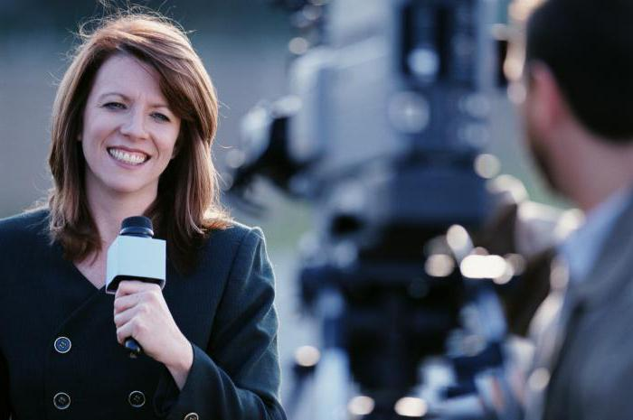
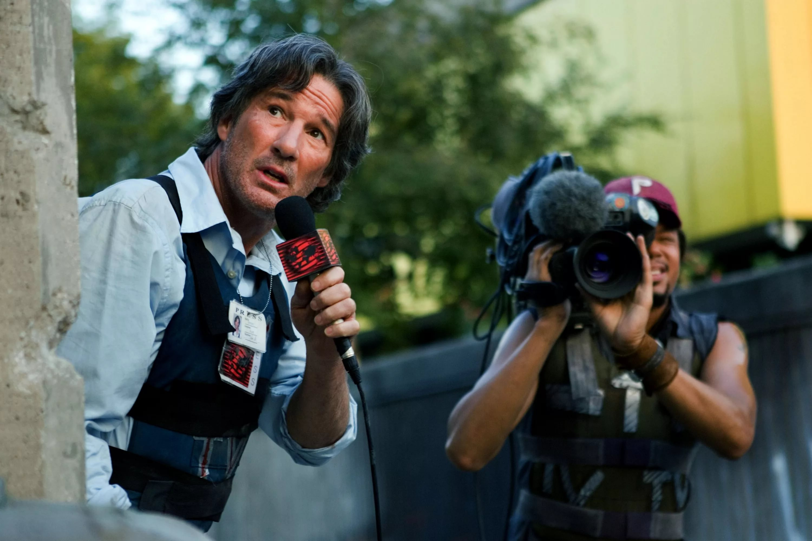

Ex.2 Answer the following questions.

- Do you know any famous reporters and photographers?
- Who is your favourite one?

Ex.3 What are the advantages and disadvantages of this job?

disadvantages
advantages

While-reading tasks
Ex.4 Read the text and entitle it.

Ex.5 Write down the main reasons from the text why this job is dangerous. Share your reasons with the other students.

(Courageous people)
Whenever and wherever something important happens, journalists and photographers are reporting on the events and taking pictures. These people often put themselves in dangerous situations. Some may be seriously hurt or even killed because of their efforts. Journalists go to areas where there are conflicts to report on the war. They also report on political protests.
Sometimes their responsibilities put them in danger as they try to find out the facts behind a story.
Photographers are courageous people. Wherever they go they are ready to put themselves in dangerous situations to take dramatic pictures. For instance to get the pictures of wild animals, photographers try to get as close as they can to the animals: sharks, snakes and crocodiles. They also may have to climb high mountains or dive deep into the sea. Why do they do it?
Post-reading task
Ex.6 If you were a reporter, you would have a lot of daily problems. Here is a list of a typical reporter’s problems. Choose the two most serious ones. Give your reasons:
- What kind of information should I choose for my reports?
- Where to go to get interesting news?
- How to “catch” an interesting person to talk to?
- Should I be polite/talkative/curious...?
- What questions to ask?
- Write about scandals or not?
- How to publish dangerous news?
- Any other...?

