Рабочая тетрадь
к учебнику английского языка для учреждений СПО
«Planet of English»

Министерство образования Оренбургской области
ГАПОУ «Сельскохозяйственный техникум»
г. Бугуруслана

Составитель: Александрова Ирина Александровна

Рецензия
на методическую разработку «Рабочая тетрадь к учебнику английского языка для учреждений СПО «Planet of English»
Составитель: Александрова И.А., преподаватель английского языка первой квалификационной категории ГАПОУ «Сельскохозяйственный техникум» г.Бугуруслан Оренбургской области.
Как известно, цели и содержание любого образования, в том числе и языкового, обусловливаются в первую очередь социальными потребностями. Поскольку во главе глобализации – английский язык и англосаксонские образцы, то в нашей стране существует социальная потребность в изучении английского языка как международного языка, который играет главную роль во всякого рода обменах между странами. Данная работа весьма актуальна, соответствует требованиям Федерального государственного образовательного стандарта и учебному курсу «Иностранный язык».
Рабочая тетрадь предназначена для организации самостоятельной и домашней работы по английскому языку для студентов 1 курса групп СПО.
Она содержит задания на развитие коммуникативной компетенции по
основным темам курса. Речевые клише, тематические тексты с заданиями,
диалоги, лексические и грамматические упражнения позволяют закрепить изученный материал.
Методическая разработка рекомендована преподавателям английского языка средних профессиональных учебных заведений России, а также всем, активно интересующимся английским языком и его изучением.
Рецензент: Бербасова Т.В., методист ГАПОУ «Сельскохозяйственный техникум» г.Бугуруслан Оренбургской области

Пояснительная записка
В последние годы все больше внимания уделяется самостоятельной работе учащихся в процессе обучения, в частности в обучении иностранным
языкам. Это связано со многими факторами, в том числе с тем, что в современном динамичном постоянно изменяющемся мире недостаточно обладать каким-то определенным количеством знаний. Человек должен уметь самостоятельно пополнять свои знания, заниматься самообразованием.
Способность к самообразованию в области английского языка приобретает особую актуальность, так как английский язык используется представителями большинства профессий и именно знание английского языка способствует успешной социализации выпускников.
В целом, можно сказать, что развитие самостоятельности, формирование навыков самостоятельной работы – являются одной из приоритетных задач в работе современного преподавателя иностранного языка.
Подобранный материал способствует развитию у студентов всех видов
речевой деятельности и соответствует содержанию рабочей программы.

Содержание
Introductory Unit. Welcome to the Planet of English!...........................................7
Lexical exercises
Grammar exercises
Unit 1. A United Family Is the Best Treasure…………………………………….13
Lexical exercises
Grammar exercises
Unit 2. There Is no Place like Home……………………………………………...19
Lexical exercises
Grammar exercises
Unit 3. What Do College Students Do?..................................................................23
Lexical exercises
Grammar exercises
Unit 4. A Dream Classroom………………………………………………………29
Lexical exercises
Grammar exercises
Unit 5. What’s Your Hobby?..................................................................................34
Lexical exercises
Grammar exercises
Unit 6. How Do I Get There?..................................................................................35
Lexical exercises
Grammar exercises
Unit 7. Eating Traditions………………………………………………………….38
Lexical exercises
Grammar exercises
Unit 8. Shops and Shopping………………………………………………………42
Lexical exercises
Grammar exercises
Unit 9. Sports on Land, in Water, in the Air……………………………………...46
Lexical exercises
Grammar exercises
Unit 10. What are You Doing Now?.......................................................................50
Lexical exercises
Grammar exercises
Unit 11. Moscow: Its Past and Present…………………………………………...53
Lexical exercises
Grammar exercises
Unit 12. “Russia – our beloved country…”………………………………………57
Lexical exercises
Grammar exercises
Unit 13. A Glimpse of Britain…………………………………………………….60
Lexical exercises
Grammar exercises
Unit 14. Customs, Traditions, Superstitions……………………………………...64
Lexical exercises
Grammar exercises
Unit 15. The Countryside or the Big City?.............................................................67
Lexical exercises
Grammar exercises
Unit 16. The Olympic Movement………………………………………………...71
Lexical exercises
Grammar exercises
Unit 17. Art and Culture………………………………………………………….77
Lexical exercises
Grammar exercises
Unit 18. Wonders of the World…………………………………………………...84
Lexical exercises
Grammar exercises
Unit 19. Man and Nature………………………………………………………….86
Lexical exercises
Grammar exercises
Unit 20. The Way into a Career…………………………………………………..89
Lexical exercises
Grammar exercises

Introductory Unit.
Welcome to the Planet of English!
Lexical exercises
1. Соотнесите описания людей с их изображениями:
1. He isn’t very tall. He’s short and stocky.
2. She’s tall and slim. She’s got a lovely figure.
3. He’s quite a big guy. He’s quite well-built.
4. She’s a bit overweight. She’s quite plump, isn’t she?
5. He’s very fat. He’s absolutely enormous.
6. He’s very thin. He’s so skinny.
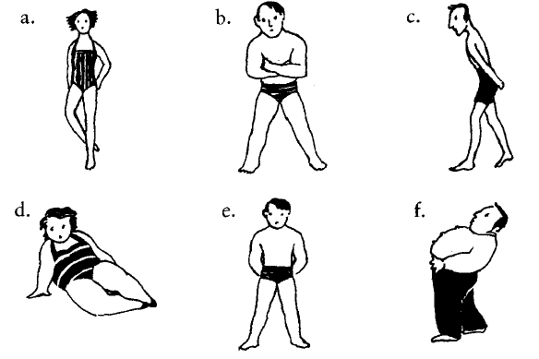

2. На картинках даны отрывки текстов. Соотнесите отрывки (под буквами) с их источниками (под цифрами).
1. An extract from a novel.
2. An extract from a newspaper report.
3. An extract from the Guinness Book of Records.
4. An advertisement in a lonely hearts section of a newspaper.
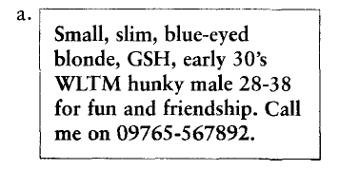
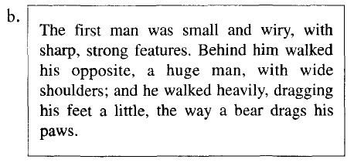
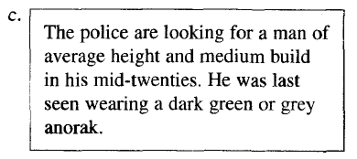
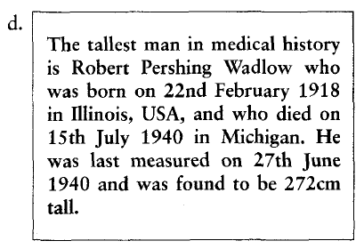
3. Поставьте в предложения следующие словосочетания:
long nails
big feet
lovely complexion
hairy chest
bad skin
deep voice
long legs
thin legs
1. Size 12! Are these your shoes? You’ve got _______ , haven’t you?
2. You’ve got such _______ . Would you like to move the seat back a bit?
3. I’ve never seen you in shorts before. You’ve got such _______ . You should go running and try to build up them up a bit!
4. My boyfriend’s got a really _______ . It’s like being with a gorilla.
5. You’ve got such lovely _______ . Are they real?
6. He’s got such a _______ . I find it very sexy when he speaks to me on the phone.
7. Keith’s new girlfriend must spend a fortune on face cream to have such a _______ .
8. Poor Tim. He’s had really _______ since he was 13.
4. Вместо пропусков поставьте данные в скобках слова.
1. He’s a _______ , _______ man with _______ , _______ hair.
(short, tall, fair, good-looking)
2. She’s a _______ , _______ woman with _______ hair.
(tall, long, thin)
3. I’ve got _______ , _______ hair and I’m tall and very _______ .
(thin, straight, black)
4. She’s very _______ with a _______ tan and _______ _______ hair.
(blonde, lovely, good-looking, long)
5. I wouldn’t describe my husband as _______ , _______ and _______ ! Short, overweight, and going thin on top is more accurate!
(handsome, dark, tall)
5. Соотнесите предложения с картинками:
1. The accident left a scar on his forehead.
2. He’s got a birthmark on his head.
3. I’ve just had a tattoo done.
4. He’s got a mole on his back.
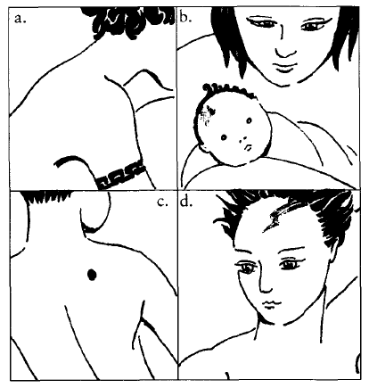

Grammar exercises
1. Глагол to be поставить в нужную форму - am / is / are. Где-то понадобятся полные формы, где-то – сокращенные.

1. you ready?
2. Where you from?
3. they married?
4. She’ Italian.
5. How old she?
6. Why you so sad?
7. They’ from Japan.
8. What class you in?
9. it cheap?
10. Why you late?
11. We’ excited about the trip.
2. Заменить существительное на нужное местоимение. Глагол to be как таковой здесь нам не нужен. Наша задача в другом – научиться видеть, какие местоимения прячутся за существительными.
Example:
my dog = it
1. France =
2. France and Germany =
3. Your parents =
4. Your mother =
5. My new shoes =
6. My new car =
7. Mary =
8. Mary and her husband =
9. Mary’s husband =
10. Mary’s children =
11. Your new job =
12. Your new girlfriend =
13. My old friends =

3. Глагол to be поставить в нужную форму. При этом придется подумать, какое местоимение прячется за существительным.
1. Where Jack from?
2. Where Jack and Kate from?
3. How old your father?
4. Why these jeans so expensive?
5. What color your car?
6. Russia a really big country.
7. How big your country?
8. Why these sentences so simple?
9. How you today?
10. Me and my friends students.
11. How much this postcard?
12. What’ your name?
13. What’ your father’s name?
14. your family big?
15. Swiss chocolate very famous all over the world.
16. Swiss watches famous, too.
17. this car German?

Unit 1.
A United Family Is the Best Treasure
Lexical exercises
1. Вставьте подходящие по смыслу слова.
1. Your parents’ parents are your ___ and your ___ .
2. Your father’s brother and sister are your ___ and your ___ .
3. Your aunt’s and uncle’s children are your ___ .
4. Your brother’s son and daughter are your ___ and your ___ .
5. Your children’s children are your ___ and your ___ .
Родственники со стороны мужа или жены объединяются одним термином in-laws. Так, чтобы назвать брата со стороны мужа или жены, необходимо к слову brother добавить in-law, чтобы получилось brother-in-law.
2. Посмотрите на картинку и определите, кто есть кто в семье.
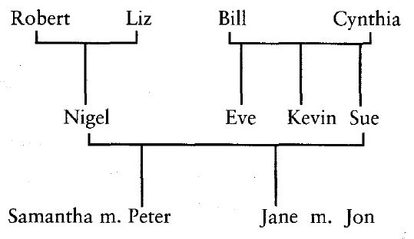
1. Nigel’s mother-in-law is …
2. His father-in-law is …
3. His brother-in-law is …
4. His sister-in-law is …
5. His son-in-law is …
6. His daughter-in-law is …

Существуют различные типы семей. Вот они:
a. a nuclear family
b. an extended family
c. a single-parent family
d. a couple who adopted a child
e. a couple with no children
3. Прочтите описание семей и определите, к какому типу они относятся.
1. We’re married with three kids. Our eldest son, Simon, has just started secondary school, our daughter, Lisa, is eight and our youngest son, Luke, is only five.
2. We’ve only been married for a year. We’re not planning to start a family just yet.
3. I’m a single mum. I bring up my son Josh on my own. Josh doesn’t mind being an only child but I think he’d like a brother or sister one day.
4. We share the house with my mother and father and my wife’s sister and her kids. Everyone helps to look after all the children.
5. We couldn’t have children of our own so we decided that adoption was the only answer. Lily came to live with us two years ago. She seems very happy at the moment but we realize that she might want to find her real mother one day.

4. Вставьте в предложения следующие слова и фразы:
the whole family
a very close family
a big family
family tree
a big family reunion
1. I come from … . I’ve got four brothers and two sisters.
2. We’re … . We see each other almost every day and if ever I’m in trouble, I know I can turn to one of them for help.
3. It’s my son’s eighteenth birthday next week. We’re hoping to get … together.
4. My wife and I are celebrating our 40th wedding anniversary soon. We’re planning to have … .
5. When I was researching my … . I found out that my great-great-grandfather came over to England from Ireland 120 years ago.

5. Заполните пропуски следующими глаголами в нужной грамматической форме: tell, look, run, get, take.
a. She……just like her mother.
b. She’s……her father’s nose.
c. He……after his father.
d. It……in the family.
e. You can’t……them apart.
Grammar exercises
1. В этом упражнении нужно решить, нужно ли добавлять к глаголу в скобках –s или нет, и вписать правильную форму глагола.
1. The gallery (open) at 8.
2. Your girlfriend (seem) nice.
3. Why do they (argue) all the time?
4. Me and my mum often (go) shopping together.
5. Where does he (live)?
6. She usually (have) breakfast at home.
7. My colleague (speak) five languages fluently.
8. Do your parents (help) you financially?
9. Lady Gaga (wear) weird clothes.
10. What time does the concert (start)?
11. Madonna (do) yoga.
12. My cat (sleep) all the time.
13. When does he (do) exercise?
14. Jack is crazy about TV series, he (watch) them non-stop.
15. My boyfriend and I (travel) a lot.
2. Потренировать вопросы и вопросительные слова. Напишите вопрос к выделенной фразе.
Example:
I wake up at 7am.
What time do you wake up?
1. Ellen lives in that house.
2. The match finishes at 9pm.
3. We go to the cinema at weekends.
4. I phone my mum once a week.
5. Pam and Nick have 3 children.
6. They listen to pop music.
7. My boss goes on holiday four times a year.
8. I don’t like chocolate because it’s too sweet for me.
9. Nancy plays the guitar very well.
10. We normally go to bed at midnight.
11. It takes me 30 minutes to get to work.
12. My dad always drinks coffee in the morning.
13. Before I start work, I check my email.
14. My surname is Beaver. B-E-A-V-E-R.
15. I drink 2 liters of water a day.
3. Послушайте короткий рассказ и заполните предложения. Не забудьте, что везде нужно будет добавить –s к глаголам.
He at five fifteen every morning and . Then, after he and a quick breakfast, he to work. He usually on the subway.He at seven in the morning, and he usually until eight at night. After he , he . Then he before bed.He usually about eleven o'clock.

Unit 2.
There Is no Place like Home
Lexical exercises
1. Соотнесите части комнаты с их названиями:
ceiling
power point
light switch
radiator
wall floor
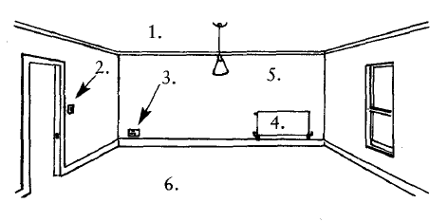

2. Подберите к началам предложений соответствующие окончания:
1. You relax and watch TV
2. You cook
3. You eat your dinner
4. You sleep
5. You have a shower
6. You put up guests
a. in the bathroom
b. in your bedroom
c. in the living room / lounge
d. in the dining room
e. in the spare room
f. in the kitchen
3. Вставьте слова в текст:
tenants, deposit, furnished, advance, landlord, share
When I was a student, I decided to (1) ____ a flat with a couple of good friends. We didn’t have any stuff of our own, so we tried to find a nice (2) ____ flat. We soon found somewhere that we all liked and we decided to take it.
We had to pay a (3) ____ of £500 and one month’s rent in (4) ____ – a total of £1,000. We were lucky because the previous (5) ____ had left the place really clean and tidy, so we moved in the next day.
Our (6) ____ said we could paint the rooms if we wanted to, so I painted mine bright red!
4. Соедините части слов и переведите их.
Arm  Book  Kit  Ward  Cup  Car  Bath  TV  Vacuum  Living  Apart | pet  cleaner  set  board  room  case  chair  room  chen  ment  robe

5. Соотнесите предметы с их названиями:
bookcase, blind, curtain, ornament, stereo system, television, lamp, picture, mantelpiece, clock, fireplace, dining chair, sofa, carpet, coffee table, armchair, rug, dining table, cushions, remote control
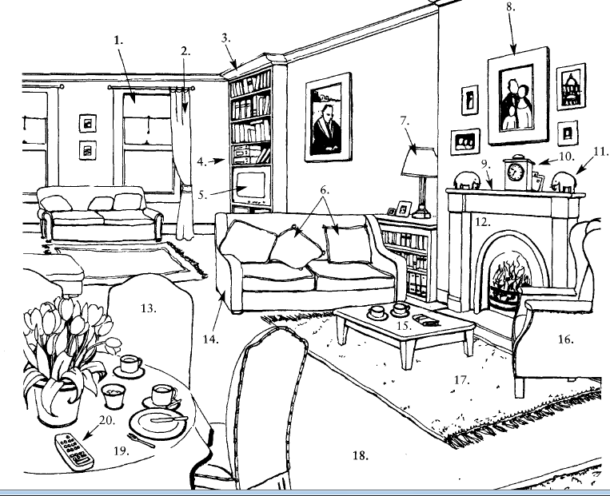
6. Соотнесите начала предложений и окончания:
1. Whatа
2. Come in and
3. Would you like
4.Black
5. These cakes look
6. I’d rather
7. Where’s
8. Make yourselves
9. Can I take
a. at home.
b. have tea, actually.
c. lovely house!
d. your jackets?
e. sit down.
f. delicious.
g. or white?
h. some coffee?
i. your too?

Grammar exercises
1. Вставьте is или are и переведите предложения.
- There … many old trees in the park.
- There … children under the trees.
- There … a lake in the park.
- There … boats on the lake.
- There … woman in the boat.
- There … a glass on the table.
- There … a cup of coffee on the coffee-table.
- There … flowers in the vase.
- There … seven bottles under the table.
- There … a water-melon in the fridge.
2. Составьте предложения из слов.
- five, there, in the park, children, are
- on the, there, a cat, is sofa
- little, balls, there, three, are, floor, on , the
- big, dog, in the, there, hall, is
- a cake, in the, there, picture, is.
3. Поставьте в множественное число.
- There is a bicycle near the tree.
- There is a book on the table.
- There is a sweet in the box.
- There is a bird in the cage.
- There is a pear on the dish.
4. Вставьте there is / there are в соответствующей форме.
1. Look!_________their telephone number in the letter.
2. Chester is a very old town. _________many old buildings there.
3. Excuse me,________ a restaurant near here?
4. How many students_________in your group?
5. I was hungry but_________anything to eat.
6. _____ a football match on TV last night.
7. ___________many people at the meeting?
8. Look!__________an accident. Call the ambulance!
9. __________24 hours in a day.
10. This box is empty.___________nothing in it.
11. ________somebody at the airport to meet you when you arrive tomorrow.
12. When we arrived at the cinema _________a lot of people outside.

Unit 3.
What Do College Students Do?
Lexical exercises
1. Соотнесите названия школьных предметов и их определений:
a. history
b. music
c. maths
d. economics
e. physics
f. chemistry
g. biology
h. IT (information technology)
i. geography
j. art
1. The study of plant, animal and human life.
2. The study of the world’s physical features, climate, populations etc.
3. The study of the past.
4. The study of painting and drawing.
5. How to use computers.
6. The study of heat, sound, electricity etc.
7. Arithmetic, algebra, geometry, calculus etc.
8. The study of elements and how they combine and react.
9. The study of financial systems.
10. Playing instruments and singing.
2. Вставьте следующие глаголы в пропуски в правильной форме:
resit, pass, fail, revise
A: Hi Tara, I’m so happy. I (1) ___ all my exams. I even got a grade A in English!
В: I didn’t do too badly, but I (2) ___ biology. That means I’ll have to (3) ___ it next term.
A: Oh no, I’m so sorry. You spent ages on biology, didn’t you? What happened?
В: Well, I guess I just didn’t (4) ___ hard enough. Perhaps I’ll get it next time.
3. Вставьте следующие слова в пропуски:
passed
sat
doing
primary
secondary
university
graduated
got
applied
nursery
college
degree
When I was very young I went to a playgroup and then a (1) ___ school. When I was five, I started at the local (2) ___ school.
School is compulsory in Britain for everybody between five and sixteen years old, but in lots of other countries children don’t start until they are seven.
My primary school was mixed, but when I was eleven, I went to an all-boys (3) ___ school. My favourite subjects were maths and English. After five years at secondary school, I decided to go to sixth form (4) ___ .
In my last year in the sixth form I (5) ___ exams in four subjects – maths, physics, chemistry, and geography.I (6) ___ them all and (7) ___ A grades in maths and physics.
I (8) ___ for a place at (9) ___ to study astronomy. It was a three-year (10) ___ course. I (11) ___ with first class honours. I thought about (12) ___ a postgraduate degree, but decided it was time to get a job and earn some money.
4. Соотнесите слова и их определения:
1. classroom
2. hall
3. playground
4. gym
5. playing fields
6. staff room
7. chemistry / physics lab
8. library
a. where you play football and other sports
b. the teachers’ room
c. where students go during breaks
d. a quiet place to read or look things up
c. where you have most of your lessons
f. a special room where you can do experiments
g. a big room where the whole school can meet for assembly
h. where you do PE
5. Вставьте слова в пропуски:
grade, rules, strict, discipline, hour, uniform, period, test
School was very different when I was young. We all had to wear a school (1) ____. There were lots of (2) ____ and the teachers were very (3) ____ . We had to stand up whenever a teacher came into the room. Once a week we had a (4) ____ and anybody who got a (5) ____ D or E had to do extra work during the lunch (6) ____. My favourite subject was art, but we only had that for one (7) ____ a week. Schools are more relaxed nowadays, but when you look at the problems in society, I think perhaps we should bring back some of the (8) ____.
6. Разделите следующие фразы на две группы:
a. work hard.
b. always do your homework.
c. get into trouble a lot.
d. play around in class.
e. pay attention all the time.
f. pick things up really quickly.
g. skip lessons.
1. If you ARE GOOD at school, you:
……
2. If you AREN’T a good student, you:
……
7. Соотнесите работников школы с их функциями:
head teacher
head of department
PE teacher
learning support assistant
caretaker
librarian
deputy head
lab technician
1. I teach football and hockey and other sports.
2. I run the English department.
3. I provide extra help in the classroom.
4. I make sure the doors are locked at night.
5. I’m the boss!
6. I’m in charge of the library.
7. I’m number 2!
8. I help the science teachers prepare their experiments.

8. Соотнесите выражение и картинку. Запишите перевод.
1. get up | a. b. c.  d.  e. f. g.  h.  i. j. k.
2. wash
3. have breakfast
4. go to school
5. go home
6. do homework
7. have supper
8. watch TV
9. go for a walk
10. read
11. go to bed

Grammar exercises
1. Напишите порядковое числительное.
5th | 4th
7th | 16th
9th | 27th
1st | 38th
3rd | 82nd
19rd | 31nd
85rd | 15nd
14rd | 41nd
53rd | 63nd
80rd | 74nd
20rd | 59nd
45rd | 35nd
24rd | 12nd
96rd | 11nd
10rd | 13nd
2. Найдите пары: слова из первого столбика и соответствующие цифры из второго.
Например: 1=d
- seventy-two a) 31
- thirteen b) 11
- fifty-six c) 660
- eighty d) 72
5. eighteen e) 315
- twenty-three f) 100
- eleven g) 13
- ninety h) 49
- twelve i) 925
- twenty j) 18
- nineteen k) 80
- forty-nine l) 504
- onehundred m) 217
- thirty-one n) 410
- four hundred and ten o) 90
- six hundred and sixty p) 56
- five hundred and four q) 23
- nine hundred and twenty-five r) 20
- two hundred and seventeen s) 19
- three hundred and fifteen t) 12
3. Напишите указанные в скобках даты словами.
Например: I was born on …… (13.05.1976). (Я родился ……) – I was born on the thirteenth of May, nineteen seventy-six.
My son was born on …… (02.12.2000).
Our dog was born on …… (21.08.2008).
My granddad was born on …… (23.06.1900).
My granny was born on …… (18.02.1910).

4. Решите пример и напишите ответ словами.
Например: twenty + fifty-eight = seventy-eight (20+58=78)
sixty-two + fourteen = …
fifteen + two hundred and forty-six = …
ninety + ten = …
thirty-one + nineteen = …
seventy-three + eighty-two = …
three thousand one hundred and twelve + ninety-nine = …
5. Напишите дроби словами.
Например: 5/6 – fivesixths, 2/3 – twothirds
½ 5. 9/10
5/8 6. 11/12
1/3 7. 2/5
4/7 8. 3/4
6. Преобразуйте количественные числительные в порядковые.
Например: one (один) – the first (первый), thirty (тридцать) – the thirtieth (тридцатый), sixty-four (шестьдесят-четыре) – the sixty-fourth (шестьдесят четвертый)
two
eighty-three
seven hundred and sixteen
twelve
eleven
twenty-five
ninety-six
thirty-eight
ten
two thousand and nine

Unit 4.
A Dream Classroom
Lexical exercises
1. Найдите слова по теме. Выпишите и переведите их.
c | d | i | n | n | e | r | w | a | s | h
o | v | a | d | o | g | e | t | l | w | o
l | m | k | r | w | o |  | w | e | i | u
l | b | r | e | a | k | f | a | s | t | s
e | a | e | s | t | l | s | l | s | h | e
g | c | a | s | c | u | p | k | o | t | w
e | k | d | r | h | n | o | c | n | h | o
h | b | f | e | a | c | r | h | u | e | r
o | e | b | s | w | h | t | a | p | n | k
m | d | o | t | l | i | s | t | e | n | a
e | v | i | s | i | t | h | e | l | p | t

2. Скажите, что вы делаете каждый день, что вы делаете обычно, часто, иногда, редко, никогда.
Every day I ………………………………………………………………………………………………
I usually …………………………………………………………………………………………………
I often ……………………………………………………………………………………………………
I sometimes ………………………………………………………………………………………………
I seldom …………………………………………………………………………………………………
I never ……………………………………………………………………………………………………

3. Скажите, что вы любите и не любите делать.
I like ……………………………………………………………………………………………………
I don’t like …………………………………………………………………………………………….

4. Напишите, какой это предмет.
- Pupils read different books and talk about writer and poets at the lessons of ________________________________________________________________________
- Pupils learn foreign words, read texts and speak at the lessons of ________________________________________________________________________
- Pupils run, jump, play games at the lessons of ________________________________________________________________________
- Pupils count, do sums, solve equations at the lessons of ________________________________________________________________________
- Pupils learn physical laws and do experiments at the lessons of ________________________________________________________________________
- Pupils learn chemical laws and do experiments at the lessons of ________________________________________________________________________
- Pupils learn about nature, plants and animals at the lessons of ________________________________________________________________________
- Pupils learn about historical events and great people at the lessons of ________________________________________________________________________
- Pupils learn about different countries and peoples at the lessons of _______________________________________________________________________
- Pupils learn how to cook, sew, knit and do other things with their own hands at the lessons of ________________________________________________________________________

5. Напишите о своих школьных годах, используйте опоры.

My SchoolYears
- I studied at school number ….. / in the village of ……………………………………………………………………………………………..
- At school we did many subjects: ……………………………………………………………………………………………..
- My favourite subject was/ subjects were ……………………………………………………………………………………………..
- Also I liked ……………………………………………………………………………………………..
- I was indifferent to ……………………………………………………………………………………………..
- I didn’t like …………………………………………………………………………………………….
- At school I had many/few friends, they were ……………………………………………………………………………………………..
- My class teacher was ……………………………………………………………………………………………..
- She / He was a teacher of ……………………………………………………………………………………………..
- My school years were happy / unhappy.

Grammar exercises
1. Поставьте множественное число существительных в скобках, обращая внимание на слова-исключения. Переведите предложения.
1. Sara is feeding … (goose) in the garden.
2. … (fish) live in water.
3. The … (thief) broke the windows in the bank.
4. I have 60 … (sheep) in my flock.
5. You should clean your … (tooth) after meals.
6. My … (child) hate cabbage soup.
7. My favourite fairy-tale is about … (elf).
8. My … (foot) always hurt after jogging in the park.
9. Those … (person) are waiting for the manager.
10. Where are the … (knife)?
11. Our … (sportsman) are the best!
12. How many … (woman) work in your office?
13. It’s autumn, the … (leaf) are falling down.
14. Let’s cut this orange into … (half).
15. We could hear … (deer) wandering in the forest.
16. There are … (mouse) in the kitchen.
17. Alice and I are wearing similar … (dress) today.
18. I need … (strawberry) for the cake.

2. Напишите единственное число следующих существительных:
Knives, mice, cities, faces, geese, matches, buses, children, oxen, datum, wives, flies, men, heroes, ladies, toys, teeth, toes, physics, villages.
3. Выберите из списка неисчисляемые существительные:
Room, boot, cheese, orange, cake, sweet, honey, salt, boy, friend, match, brush, window, money, soup, pen, spoon, sugar, bread, book.
4. Поставьте существительные в скобках в правильном числе:
More than one (day); twenty-one (day); a (pair) of shoes; two (pair) of shoes; four (dozen) buttons; the variety of (fish) in the aquarium; the Russian (people) are very hospitable; you must eat more (fruit); our (family) are all good chess-players.
5.
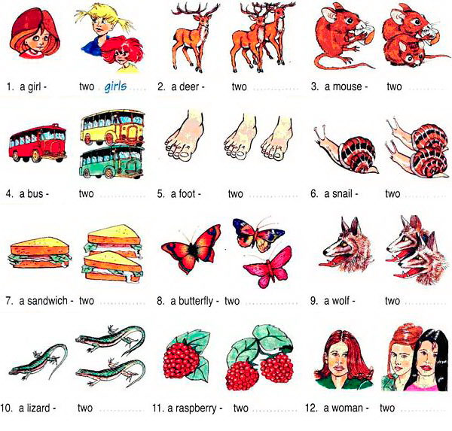
6. Образуйте множественное число существительных, обращая внимание на их окончания.
1. a sandwich (сэндвич)
2. a toy (игрушка)
3. a photo (фотография)
4. a city (город)
5. a bus (автобус)
6. a house (дом)
7. a tattoo (татуировка)
8. a phenomenon (феномен)
9. a housewife (домохозяйка)
10. a family (семья)
11. a life (жизнь)
12. a potato (картофель)
13. a bacterium (бактерия)
14. a church (собор)
15. a baby (ребенок)
16. a box (коробка)
17. a kiss (поцелуй)
18. a piano (фортепиано)
19. a medium (средство)
20. an oasis (оазис)

7. Образуйте множественное число существительных, сделав необходимые изменения во всем предложении.

Н-р: The child is from Mexico, he is 10 years old. (Ребенок из Мексики, ему 10 лет.) – The children are from Mexico, they are 10 years old. (Дети из Мексики, им по 10 лет.)

- The woman liked the story. (Женщине понравилась история.)
- The white mouse is in the box. (Белая мышь находится в коробке.)
- The policeman is an American. (Полицейский – американец.)
- His wife is a secretary. (Его жена – секретарь.)
- This is a sandwich with butter and cheese. (Это бутерброд с маслом и сыром.)
- He is my favourite actor. (Он – мой любимый актер.)
- My friend is a student. (Мой друг- студент.)
- There is a big fish in the river. (В реке большая рыба.)
- The bookshelf is between the mirror and the sofa. (Книжная полка находится между зеркалом и диваном.)
- I can see a sheep in the field. (Я вижу овечку в поле.)

Unit 5.
What’s Your Hobby?
Grammar exercises
1. Переведите на английский язык.
1. Я счастлив быть в Сан-Франциско. 2. Мне нужно работать сверхурочно. 3. Невозможно разговаривать по телефону с четырьмя людьми. 4. У тебя есть время помочь мне? 5. Шэрон хочет поехать в Канкун. 6. Питеру нужно еще время, чтобы закончить экзамен. 7. У меня нет времени смотреть телесериалы. 8. Я отказываюсь смотреть телесериалы. 9. Психологию трудно понять. 10. Фред хочет посетить Аляску.
2. Закончите следующие предложения, выбирая подходящий инфинитив из правой колонки.
1. San Francisco is a nice place __ a. to cook
2. The job of a teacher is __ students. b. to visit
3. It is very easy __ spaghetti. с to pay
4. Sharon wants __ to the beach. d. to teach
5. I need more money __ for my books. e. togo
3. Заполните пропуски, используя инфинитив или спрягаемый глагол там, где это требуется.
to need — to call — to make — to help — to go
Have you ever made plans for a vacation? There are many things to do ahead of time. For example, it’s important (1) __ hotel reservations. It is also essential (2) __ the airline to make sure your flights are arranged. You also (3) __ to take appropriate clothing for the climate of your destination. Sometimes, it is a good idea (4) __ to a travel agent. They can (5) __ you solve any problems related to your trip.
4. Чтобы закончить предложения, вставьте слова из правой колонки.
1. The __ includes Saturday and Sunday a. sitcom
2. Basketball and baseball are both __ b. happy
3. She wasn’t sad. She was very __ с weekend
4. A __ is a show that makes people laugh d. sports
5. A __ has many actors and actresses e. soap opera
Unit 6.
How Do I Get There?
Lexical exercises
1. Заполните пропуски предлогами места и направления.
1.The children are playing … the garden.
2. Yesterday I saw a friend of mine standing … the bus station.
3. My brother is a student. He is … University.
4. There are a lot of books … the library.
5. We heard a bird singing … the tree.
6. You can see a river and a forest … the picture.
7. Don’t write this exercise. Do it … home.
8. There are a lot of clouds … the sky.
9. Take your book and open it … page 10, please.
10. The pupils are writing words … their copy-books.
2. Вставьте предлоги on, in или into.
1. Where is the book? - - It is ... the table. 2. Where is the tea? — It is ... the cup. 3. Put the plates ... the table. 4. Put the book ... the bag. 5. There is a beautiful picture ... the wall. 6. He went ... the room. 7. I like to sit ... the sofa ... my room. 8. Mother is cooking dinner ... the kitchen. 9. She went ... the room and sat down ... the sofa. 10. There are many people ... the park today. 11. There is a girl standing ... the bridge. Why is she crying? - She has dropped her doll ... the water. 12. There is no tea ... my cup. 13. Pour some tea ... my cup. 14. Put these flowers ... the window-sill. 15. I saw many people ... the platform waiting for the train. 16. We went ... the garden and sat down ... a bench. 17. The teacher hung a picture ... the blackboard. 18. I opened the door and went ... the classroom. The teacher was writing some words ... the blackboard. The pupils were writing these words ... their exercise-books. There were some books and pens ... the teacher's table. There were two maps ... the wall and some flowers ... the window-sills. I saw a pen ... the floor. I picked it up and put it ... the table. 19. He put his hand ... his pocket, took out a letter and dropped it ... the mail-box which hung ... the wall of the house. Then he got ... his car and drove off.
3. Вставьте предлоги in или to.
1.We did not want to stay ... town on such a hot day, so we went ... the country. 2. It is very late: Go ... bed at once. 3. Where is your little sister? - - She is ... bed. Mother always puts her ... bed at eight o'clock. 4. In summer my mother does not go ... work and I don't go ... school. We live ... the country. My father goes ... work every day, so he stays ... town. But sometimes he comes ... the country after work and goes back ... town early in the morning, when I am still ... bed. 5. In winter I usually go ... bed at ten o'clock because I learn ... school and have to get up early.
4. Переведите на английский язык следующие словосочетания.
В четыре часа, в половине шестого, без четверти три, на закате, в четверть пятого, в полночь, в пять минут шестого, без десяти два, полдень, на восходе солнца, в двадцать пять третьего.
Grammar exercises
1. Задайте к следующим предложениям специальные вопросы, начиная со слов в скобках. Обращайте внимание на форму глагола, а также на вопросы к подлежащему.
1. Robert’s sister likes black coffee in the morning. (What? Whose? What kind of? Why? When?)
2. My dad went fishing to the lake with his brother twice a month. (Who? Where? Who…with? How often?)
3. They will book a room at a hotel in Madrid during their honeymoon. (Who? Where? When?)
4. I have just seen our neighbor in the supermarket. (Whom? Whose? Where?)
5. There are five polar bears in the zoo. (Who? How many? What kind of?)
6. Bob was a successful businessman because he owned 3 clothes stores in New York. (Who? Why? How many? Where?)
7. I can see hundreds of bright stars in the sky now. (Where? When? How many?)
8. Julia is cooking Mexican food in the kitchen. (Who? What kind of? Where?)
2. Выразите свое сомнение или удивление, образовав разделительные вопросы.
Например: Mark bought this souvenir in India. – Mark bought this souvenir in India, didn’t he?
1. Ella misses her mother.
2. Our receptionist isn’t friendly.
3. These skyscrapers were built before the war.
4. He will run a private hospital.
5. You don’t respect your boss.
6. She has made a final decision.
7. Your dog can crawl under a chair.
8. Sam and Kate are going to become vegetarians.
3. К каждому предложению задайте по одному общему вопросу и несколько альтернативных, используя предлагаемые в скобках варианты.
Например: Alice annoys me by her bright make-up. (Ann — clothes) – Does Alice annoy you? Does Alice or Ann annoy you? Does Alice annoy you by her bright make-up or clothes?
1. They heard a noise in the living room. (music – in the kitchen)
2. He has found two black kittens near the shop. (three – near the office)
3. Every morning I give my son some pocket money. (daughter – every evening)
4. The cargo will be delivered next Friday by ship. (Sunday – by plane)
5. The photos are in a drawer of the wardrobe. (the cupboard – the passports)
6. We can stay in Moscow for another week. (in Minsk – month)
4. Выберите из правой колонки верное окончание разделительного вопроса. Переведите вопросы.
Н-р: 1 – е (Она необщительна, не так ли?)
- She isn’t sociable, a. mustn’t they?
- Mark was satisfied, b. do they?
- Your kids never argue with you, c. didn’t she?
- Let’s dance, d. do you?
- Tom can dive well, e. is she?
- Our partners must keep their word, f. won’t it?
- Helen has washed up, g. doesn’t she?
- You don’t trust me, h. wasn’t he?
- Your mum works as an accountant, i. hasn’t she?
- It will be cloudy tomorrow, j. did they?

Unit 7.
Eating Traditions
Lexical exercises
1. Соотнесите морских животных с их названиями.
salmon, sole, squid, lobster, crab, prawn, mussels, trout, tuna, plaice, snapper, clam
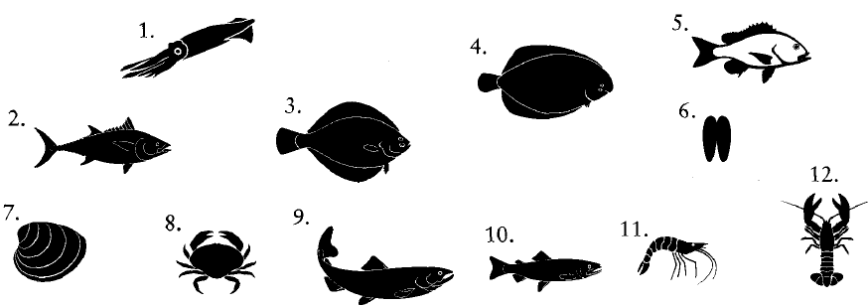
2. К указанным вопросам подберите наиболее подходящий ответ.
1. Do you take sugar?
2. Would you like some cereal for breakfast?
3. Why did you buy flour?
4. Can you get a loaf when you’re out?
5. Would you like marmalade on your toast?
6. Do you want some mustard on your burger?
7. Do you want anything on this salad?
8. Shall we have rice with this stir-fry?
a. I’d rather have noodles, actually.
b. I’m going to make a few cakes.
c. No thanks, ketchup is fine.
d. Yes, two, please.
e. Some cornflakes would be nice.
f. I’ll just have a little dressing, please.
g. White or brown?
h. No thanks, just butter.

3. Отнесите указанные слова к подходящим группам определений:
cheese, soup, bread, oil, rice, salad
1. green, mixed, potato, fruit ……..
2. white, brown, wholemeal, rye, sliced, garlic ……..
3. tomato, chicken, mushroom, home-made, tinned ……..
4. mild, mature, soft, cream, blue, goat’s ……..
5. brown, long-grain, wild ……..
6. olive, vegetable, sunflower ……..
4. Соотнесите слова под цифрами со словами под буквами.
1. salt and
2. fish and
3. bread and
4. cheese and
5. strawberries and
a. biscuits
b. butter
c. cream
d. pepper
e. chips
5. Вставьте слова в предложения:
shell, paprika, egg plants, beans, potato, peel, gherkins, zucchini
1. Aubergines are sometimes also called…..
2. In English we sometimes use the Italian word …….for courgettes.
3. Sweet peppers are red, green or yellow and are sometimes called……..
4. Haricot, broad, green, are kinds of…….
5. Small cucumbers which are pickled are called……..
6. Maris Piper, King Edwards and Jersey Royals are three kinds of……..
7. Before eating peas, you have to…..them.
8. You…..potatoes before cooking them.
Grammar exercises
1. Поставьте «+» при правильном использовании «much» или «many», поставьте «-» - при неверном.
- We don’t have many food in the house.
- I can’t give you many information about the company.
- I need much apples for the pie.
- How many people are there in your office?
- There is much wine in the
- She doesn’t have many luggage.
- My son earns much money now.
- They saw many snow in the mountains.
- I have tried diving many times in my life.
- John will have much exams next year.

2. Используйте «much» или «many» для выражения «Сколько…?»
- How … days?
- How … sugar?
- How … cigarettes?
- How … work?
- How … petrol?
- How … children?
- How … theatres?
- How … juice?
3. Поставьте «a lot of» (много) в необходимом месте в предложении. Переведите.
- We met interesting people at the party.
- I ate fish for lunch.
- She bought nice shoes for the next summer.
- They have problems in their business.
- There is water in the bath.

4. Перепишите вопросы, заменив some на «a little» или «a few».
- Would you like some cheese?
- Would you like some mineral water?
- Would you like some strawberries?
- Can I offer you some black coffee?
- Can I offer you some bread?
- Shall I bring you some biscuits?
- Shall I bring you some plums?
- Would you like some meat?

5. Поставьте подходящее слово из скобок.
- There is too … (much/many/a few) salt in the soup. (В супе слишком много соли.)
- There are … (much/a little/a few) sky-scrapers in our city. (В нашем городе есть несколько небоскребов.)
- I’ve got … (much/a few/a little) albums of this singer. (У меня есть несколько альбомов этого исполнителя.)
- My job allows me to travel … (much/many/a few). (Моя работа позволяет мне много путешествовать.)
- We’ve got … (little/many/few) free time. (У нас мало свободного времени.)
- I have never seen so … (much/little/many) stars in the sky. (Я никогда не видел так много звезд в небе.)
- Anna spent … (much/a few/a little) days in Rome. (Анна провела несколько дней в Риме.)
- I’d like just … (much/a few/a little) tea. (Я бы хотел лишь немного чая.)
- There was very … (little/few/many) rain last autumn. (Прошлой осенью было очень мало дождей.)
- Very … (few/little/much) Russian tourists are staying at our hotel. (Очень мало русских туристов проживает в нашем отеле.)

6. Переведите на английский язык следующие пары слов.
Мало домов, мало чая, мало чашек, мало яблок, мало окон, мало бумаги, мало кофе, мало статей, мало радости, мало супа, мало деревьев, мало травы, мало детей, мало игрушек, мало света, мало парт, мало колбасы, мало сока, мало книг, мало цветов, мало соли, мало друзей, мало дворцов.

Unit 8.
Shops and Shopping
Lexical exercises
1.Заполните пропуски.
advertising department different employ
families financial floors goods
handles jobs located merchandise
needs occupies optician's personnel
price purchases records roof
sales promotion section services shopping
staff store travel agency typical

Department Store
A department store is a which sells many kinds of goods, each in a separate . Modern department stores serve the of entire . People enjoy in such stores because they can make all their under one .
The department store one large building, with separate departments on a number of . A number provide special , such as a or .
Department stores hundreds of people for different . Employees buy, , and sell the . The manager and his promote the sale of through and other techniques. The comptroller heads the that keeps and manages the store's affairs. The staff hire employees and other employment problems.
2. Соотнесите слово с его значением.
1. bazaar -  2. mobile shop -  3. boutique -  4. department store -  5. kiosk -  6. market -  7. shopping arcade -  8. Shopping centre -  9. shopping precinct -  10. stall -  11. store -  12. supermarket - |  | a. a large shop divided into smaller parts, in each of which different types of goods are sold  b. a large shop selling mainly food where one serves oneself  c. a large shop  d. a table or small open-fronted shop in a public place  e. shop for the sale of cheap goods of great variety  f. a part of a town limited to shopping; often without cars  g. a covered moveable shop  h. a small open hut, such as one used for selling newspapers  i. a small shop selling fashionable clothes  j. a group of shops of different kinds, planned and built as a whole  k. a covered passage with a row of shops on either side  l. open place where people meet to buy and sell goods, especially food

3. Соотнесите магазины с товарами, которые они продают.
1. bookshop a. a loaf of bread, rolls, long loaf
2. newsagent’s b. a bouquet of roses, lilies, flowers
3. bakery c. a packet of painkillers, pills, medicine
4. butcher’s d. a gold necklace, a diamond ring, pendent
5. confectioner’s e. a magazine, a newspaper, greeting card
6. greengrocer’s f. hairspray, a bottle of perfume, hand cream
7. chemist’s g. pralines, chocolate, cake
8. florist’s h. books, novels,
9. department store i. fruits, vegetables, apples
10. hair and beauty salon j. lamb chops, ham, sausages
11. jeweller’s k. leather suitcase, a woolen skirt, a clock
12. antique shop l. shampoo, products, household chemicals
13. supermarket m. an old clock, bric-a-brac, silver bell

4. Вставьте правильное слово из списка.
could, loaves, greengrocer's, offer, credit, much, order
1. Can I have two .... of bread, please?
2. The large department stores .... a great variety of products.
3. You can buy fresh vegetables at this .... .
4. .... I have the pills in this prescription, please?
5. I’d like to .... a bouquet of lilies, please.
6. Excuse me – How .... are these trousers?
7. Do you take a .... card?

5. Переведите слова и фразы данные в скобках.

1. In Paris you can shop till you drop. Here there are a lot of boutiques, department stores, confectioner’s, antique shops, hair and beauty salons, jeweller’s.
2. The shops are open from 9 to 6 every day except Sunday.
3. The sales are usually in January and July in Brussels. I love this time because I can find some bargains.
4. This store is really big. In addition to fifteen bars and restaurants there is a travel agent’s, a dry cleaner’s and a bank.
5. They have a good selection and their prices are not so high, too.

Grammar exercises
1.Составьте из данных слов предложения. Переведите.
- some – the kitchen – I – for – want – furniture – to buy.
- aren’t – the table – cakes – on – there – on – any.
- have – I - please – can – some – butter?
- there – any – casinos – in – are – Berlin?
- take – book – you – any – can – here.
- lives – the west – Mary – somewhere – in.
- something – talk – let’s – else – about.
- loves – our family – fish – in – nobody.
- on TV – interesting – is – nothing – tonight - there.
- anybody – my dictionary – has – seen?

2. Преобразуйте следующие предложения в отрицательные.
Н-р: I’ve got some euros in my purse. (У меня есть немного евро в кошельке.) – I haven’t got any euros in my purse. (У меня нет евро в кошельке.)
- We saw some water under the fridge. (Мы видели воду под холодильником.)
- There are some fancy dresses in this store. (В этом магазине есть модные платья.)
- You’ll find some balls on the floor. (Ты найдешь несколько мячей на полу.)
- I’ve had some important phone-calls this morning. (У меня было несколько важных звонков этим утром.)
- He is reading some letters in the kitchen. (Он читает письма на кухне.)
- I recognized somebody at the party. (Я узнал кое-кого на вечеринке.)
- You can plant this flower somewhere in the garden. (Ты можешь посадить этот цветок где-нибудь в саду.)
- We should call somebody. (Нам нужно кого-нибудь позвать.)

3. Преобразуйте следующие предложения в вопросительные.
Н-р: I can speak some Russian. (Я могу немного говорить по-русски.) – Can you speak any Russian? (Ты можешь немного говорить по-русски?)
- My teacher gave me some advice. (Мой учитель дал мне совет.)
- We have seen some great films this month. (Мы посмотрели несколько классных фильмов в этом месяце.)
- He has got some beer in the fridge. (У него есть немного пива в холодильнике.)
- She said something strange about her neighbor. (Она рассказала кое-что странное о своем соседе.)
- They ate something for lunch. (Они что-то съели на обед.)
- We can find better food somewhere else. (Мы можем найти более лучшую еду где-нибудь еще.)
- There is something wrong with your car. (С твоей машиной что-то не в порядке.)
- Somebody is calling my name. (Кто-то зовет меня.)

4. Поставьте подходящее местоимение.
- Would you like … (some/any/no) milk?
- You can leave at … (some/any/no) time.
- Could you give me … (some/any/no) help, please?
- We must buy … (some/any/no) vegetables for dinner.
- I haven’t got … (some/any/no) eggs for pancakes.
- I think … (something/anything) is burning.
- … (Somebody/Anybody) told me about his job.
- I couldn’t find my umbrella … (somewhere/anywhere/nowhere).
- Sorry, I can do … (someone/anyone/nothing) for you.
- There was … (something/anything/nobody) to answer the phone in the office.

Unit 9.
Sports on Land, in Water, in the Air
Lexical exercises
1. Заполните пропуски следующими словами
captain coach draw fair
football ground (or pitch) footballer fouls free (or penalty)
kick goal kick-off league
opponents referee score soccer
1. What Europeans call "football", Americans call .
2. The instructor of the team is the .
3. When you play in a football team you are a .
4. The games take place on a .
5. The leader of the team is the .
6. The man in the is the goal-keeper .
7. The beginning of the match is the .
8. During the match each team tries to as many goals as possible.
9. When the teams have scored the same number of goals we say it's a .
10. The players of the other team are the .
2. Choose the right word to complete these opinions.

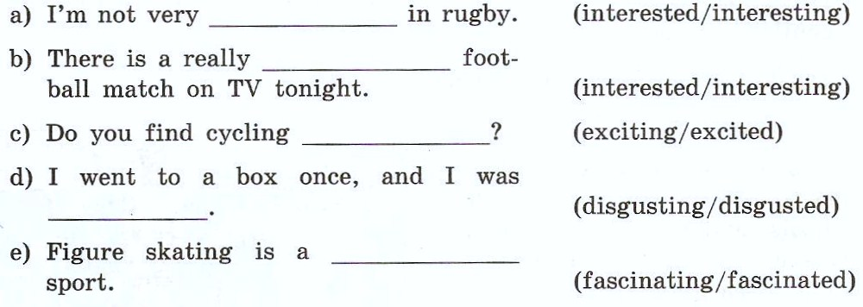

3. What kind of sport?

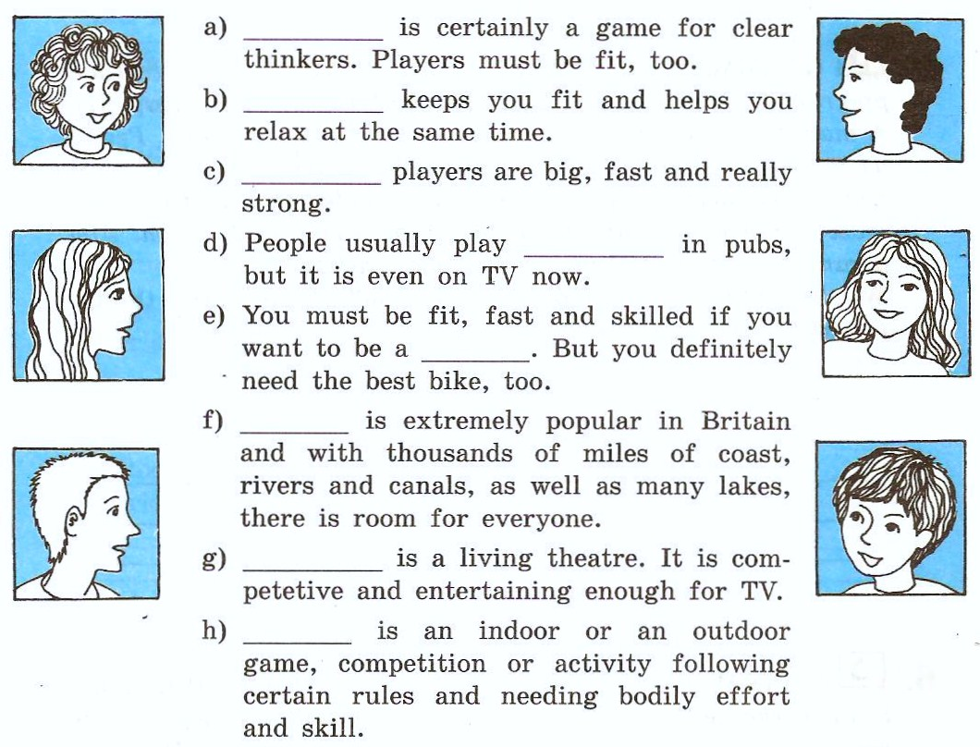4.
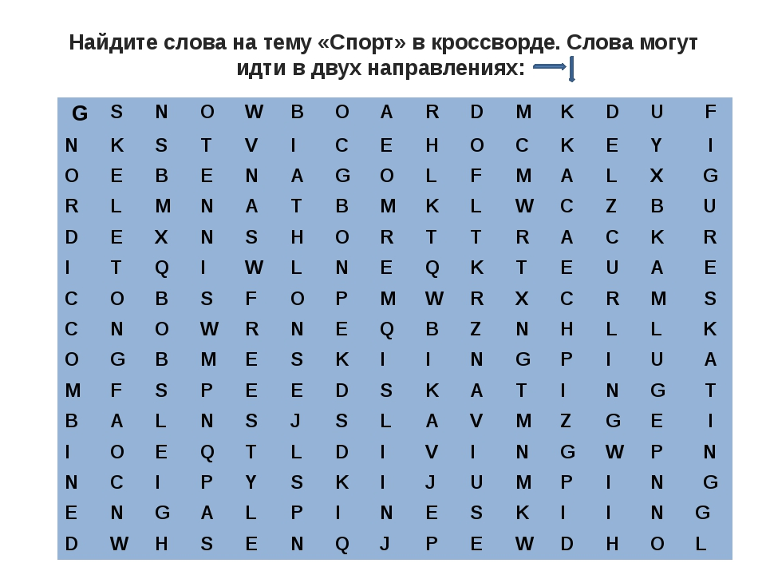
Grammar exercises
1. Выберите в скобках правильную степень прилагательного:
- Nick is (happier, the happiest) boy that I k now. – Ник – самый счастливый мальчик, которого я знаю.
- Of the six cars, I like the silver one (better, best). – Из шести машин мне нравится серебристая больше всего.
- Jane’s notebook is (cheaper, the cheapest) than mine. – Ноутбук Джейн дешевле, чем мой.
- This is (more delicious, the most delicious) cheese-cake I have ever had! – Это самый вкусный чизкейк, который я пробовала!
- This bookcase is (more beautiful, the most beautiful) than that one. – Этоткнижныйшкафкрасивее, чемтот.
- Do you feel (better, the best) today than yesterday? – Тычувствуешьсебялучшесегодня, чемвчера?
- I think my cat is (prettier, the prettiest) of all the cats in the world. – Думаю, чтомоякошка – самаякрасиваякошкавмире.
- Steve Jobs is (more famous, famouser) than Stephen Wozniak. – СтивДжобсболееизвестен, чемСтивенВозняк.
- This week the weather is (hotter, more hot) than last week. – Наэтойнеделепогодажарче, чемнапрошлойнеделе.
- Our new house is (more expensive, expensiver) than the old one. – Нашновыйдомдороже, чемстарый.
- Girls are usually (cleaner, more clean) than boys. – Девочкиобычноболеечистые, чеммальчики.
- Chemistry was (harder, the hardest) subject at school. – Химиябыласамымтруднымпредметомвшколе.

2. Дайте степени сравнения прилагательных.
Н-р: wet – wetter – thewettest
expensive – more expensive – the most expensive
1. big (большой) 2. clever (умный) 3. good (хороший) 4. pleasant (приятный) 5. poor (бедный) 6. bad (плохой) 7. funny (смешной) 8. important (важный) 9. sunny (солнечный) 10. far (далекий) 11. comfortable (удобный) 12. wise (мудрый)

3. Составьте из данных слов предложения и переведите их.
- most – the Mona Lisa – in – is – painting – the – famous – the – world.
- longer – the Don – is – the Volga – than.
- more – Spain – Germany – than – beautiful - is.
- London – city – in – biggest – the – England – is.
- the – team – Adam – is - worst – the – player – in.

4. Переведите на английский язык, используя прилагательные в положительной, сравнительной и превосходной степени:
1. Я такой же сильный, как Джон.
2. Я сильнее Джона.
3. Джон — самый сильный в классе.
4. Эта комната такая же холодная, как та комната.
5. Эта комната — самая холодная из всех.
6. Мой дом такой же большой, как твой дом.
7. Мой дом больше твоего.
8. Мой дом — самый большой в городе.
9. Мэри такого же возраста, как Джейк.
10. Мэри старше Джейка.
11. Джейк — самый старший в классе.
12. Эта книга — такая же интересная, как та книга.
13. Эта книга интереснее той.
14. Эта книга — самая интересная.

5. Раскройте скобки, употребляя требующуюся форму прилагательного.
1. Which is (large): the United States or Canada? 2. What is the name of the (big) port in the United States? 3. Moscow is the (large) city in Russia. 4. The London underground is the (old) in the world. 5. There is a (great) number of cars and buses in the streets of Moscow than in any other city of Russia. 6. St. Petersburg is one of the (beautiful) cities in the world. 7. The rivers in America are much (big) than those in England. 8. The island of Great Britain is (small) than Greenland. 9. What is the name of the (high) mountain in Asia? 10. The English Channel is (wide) than the straits of Gibraltar. 11. Russia is a very (large) country.

Unit 10.
What are You Doing Now?
Lexical exercises
1. Запишите разговор в правильном порядке.
A: We’ll take a room on the second floor. How much is it?
B: Okay. It suits us. We’ll take this room.
A: Seventy dollars a night, sir.
B: Yes, we’ll be able to put you up. Which floor would you like, sir?
A: Have you got any vacant rooms?
B: One double-room, please.
A: Single or double, sir?

2. Подберите синонимы.
1. luggage a. trip
2. return ticket b. baggage
3. journey c. a buffet car
4. cloakroom d. schedule
5. a dining car e. round-trip ticket
6. booking-office f. left-luggage office
7. timetable g. ticket office
8. fellow-passenger h. travelling companion

3. Соотнесите слова в колонке A со словами в колонке B.
1. room service a. остановиться в отеле
2. travel agency b. прибытие
3. book tickets c. место у окна
4. arrival d. бюро путешествий
5. departure e. отправляться по расписанию
6. leave on time f. купить билеты
7. stay at the hotel g. справочное бюро
8. window seat h. бюро обслуживания
9. passport i. отправление
10. information office j. паспорт

4. Переведите слова и фразы данные в скобках.
1.I hate flying and always prefer to travel (на поезде).
2. Would you like (носильщика) for your luggage, miss?
3. Unfortunately there was no (кафе-ресторана) on the train and we had to take a lot of food with us.
4. Modern planes have very comfortable (сиденья) in all cabins.
5. There are always bustle and confusion (настанции).
6. Before boarding the plane (пассажир)must register at the airport.
7. You (приземлитесь) in London at ten-fifteen p.m.
8. If you’ve got something to declare you come through (красный коридор).

5. Переведите предложения русского на английский.

1. Куда я могу отнести ваш багаж, сэр?
2. Давайте поспешим, иначе мы опоздаем на поезд.
3. Вот мой билет и паспорт.
4. К сожалению, все билеты проданы на сегодня.
5. Как долго вы собираетесь оставаться в стране?
6. У вас есть вещи подлежащие декларированию?

6. Переведите предложения с английского на русский.

1. I’m sorry I’m late. When did you arrive?
2. Excuse me, please, where’s Platform six?
3. I’d like to book a single ticket.
4. Don’t make a fuss, we have still a lot of time left.
5. I’d like two tickets for the 7 o’clock train to Warsaw.

7. Выберите подходящее слово из списка и вставьте его в предложение.

accommodation, abroad, visit, arrives, journey, in advance, hotel

1. It’s always more convenient to book tickets ... 2. London Tourist Board is here to help you enjoy your ... to London. 3. We can provide ... in a wide range of price categories in over 900 hundred hotels and guest houses of Berlin. 4. Will you tell me about the facilities offered by your ... ? 5. Good-bye! I wish you a pleasant ... . 6. She was as excited as a child about her first trip ... , and spent the next days buying clothes. 7. It ... at 11.00 but it may be a little late because the weather forecast is bad.

Grammar exercises
1. Переведите предложения в настоящем продолженном времени.
- Хелен покупает помидоры на рынке.
- Маленький Том плачет в спальне.
- Идет дождь.
- Мы играем в теннис с друзьями.
- Мама готовит куриный суп.
- Обезьянки едят бананы на дереве.
- Мой брат учит стишок.
- Куда идет твой отец?
- Что ты читаешь?
- Почему он спит сейчас?
- Где играют твои дети?
- Поезд не движется.
- Мальчики не танцуют.
- Джек и Джейн не помогают мне.
- Учитель не смотрит на нас.

2. Составьте из слов предложения.
Н-р: the – I – beach – going – to – am. – I am going to the beach. (Я иду на пляж.)
- Anna – juice – is – orange – drinking.
- not – sun – shining – the – is.
- are – parents – the – in – my – sitting – garden.
- dress – she – long – is – a – today – wearing.
- we – playing – not – violin – are – the.

3. Напишите утвердительные (+), отрицательные (-) или вопросительные (?) предложения в настоящем продолженном времени.
Н-р: George/drive very fast. (+) - George is driving very fast. (Джорджедеточеньбыстро.)
I/learn Russian. (-) - I am not learning Russian. (Янеучурусский.)
It/snow. (?) - Is it snowing? (Снегидет?)
- George/driveveryfast. (+)
- I/learnRussian. (-)
- It/snow. (?)
- They/walk in the park. (+)
- Sophie/eatberries. (-)
- Mother/vacuum-clean. (?)
- Jenny/write a postcard. (+)
- We/swim in the swimming-pool. (-)
- I/listentomusic. (+)
- Kevin/work. (?)

4. Раскройте скобки, употребляя глаголы в Present Continuous.(NOW)
1. The boys (to run) about in the garden. 2 I (to do) my homework. 3. John and his friends (to go) to the library. 4. Ann (to sit) at her desk. She (to study)geography. 5. A young man (to stand) at the window. He (to smoke) a cigarette. 6. The old man (to walk) about the room.7. The dog (to lie) on the floor. 8. You (to have) a break? 9. What language you (to study)? 10. Who (to lie) on the sofa? 11. What they (to talk) about? 12. It still (to rain).

Unit 11.
Moscow: Its Past and Present
Lexical exercises
1. Ответьте на вопросы.
- What is the capital of Russia?
- When was Moscow founded?
- Who founded Moscow?
- What do you know about Yuri Dolgoruky?
- What city was the capital of Russia before the 16-th century?
- What city was the centre of the struggle of Russian lands for the liberation from the Tartar yoke?
- When did Moscow become the capital of the state?
- When was the capital moved to St. Petersburg? Who decided to do it?
- What city of Russia became the main target of Napoleon`s attack in 1812?
- What part of Moscow was destroyed by fire buring Napoleon`s occupation?
- When was Moscow completely restored?
- When did Moscow become the capital again?
- Where is Moscow situated?
- What is the total area of modern Moscow?
- What is the population of Moscow?
- What is the heart of Moscow?
- What tower is the symbol of Russia?
- What old cathedrals and historical monuments are there on the territory of the Kremlin?
- When was St. Basil`s Cathedral built?
- What legend about the creation of St.Basil`s Cathedral do you know?
- How many museums are there in Moscow?
- What are the most famous and largest Moscow museums?
- What Moscow theatre is one of the best theatres of the world?
- Moscow is the centre of political life of Russia, isn`t it? Why?

2. Подберите к началу предложения продолжение.
A
- There is a legend that …
- The main Kremlin tower, the Spasskaya Tower, has become …
- The population of the city is …
- In 1712 the Russian King, Tsar Peter the Great, …
- Kiev was ..,
- Moscow was founded …
- In the 13th century Moscow was …
- In 1918 Moscow became …
- Prince Yuri Dolgoruky had …
B
… the capital again.
… moved the Russian capital to St. Petersburg.
… Ivan the Terrible blinded the architects Barma and Postnik, because he didn`t want them to create another masterpiece.
… many fights with other Russian princes and soon he became Prince of Kiev
… the symbol of Russia.
… in 1147 by Prince Yuri Dolgoruky.
… over 8 million.
… the capital of Russia.

3. True or false
1. Moscow is situated on the hills.
2. Prince Yuri Dolgoruky was the Russian Prince of Rome.
3. In 1818 Moscow became the capital againg.
4. The largest Moscow museums are the Pushkin Museum of Fine Arts and the State Tretyakov Gallery.
5. St. Basil`s Cathedral was built in the mid-18th century.
6. The total area of Moscow is about two hundred square kilometers.
7. St. Petersburg is the seat of the Russian Parliament (the Duma).
8. The Speaskaya Tower has become the symbol of Russia.

4. Заполните пропуски.
1. Moscow is political, economic, … and cultural centre of the country.
2. Moscow became the main… of Napoleon`s attack.
3. Gradually Moscow became more and more … .
4. Prince Yuri Dolgoruky had many … with other Russian princes and soon he became Prince of Kiev.
5. Three-quarters of the city was destroyed by fire during Napoleon`s … .
6. St. Basil`s Cathedral was built in the mid-16th century in … of the victory over Kazan.
Grammar exercises

1. Поставьте глаголы в следующих предложениях в утвердительную, вопросительную иотрицательнуюформы Past Simple.
1. I (to do) morning exercises.
2. He (to work) at a factory.
3. She (to sleep) after dinner.
4. We (to work) part-time.
5. They (to drink) tea every day.
6. Mike (to be) a student.
7. Helen (to have) a car.
8. You (to be) a good friend.
9. You (to be) good friends.
10. It (to be) difficult to remember everything.

2. Раскройте скобки, употребляя глаголы в Past Simple.
1. Alice (to have) a sister.
2. Her sister’s name (to be) Ann.
3. Ann (to be) a student.
4. She (to get) up at seven o'clock.
5. She (to go) to the institute in the morning.
6. Jane (to be) fond of sports.
7. She (to do) her morning exercises every day.
8. For breakfast she (to have) two eggs, a sandwich and a cup of tea.
9. After breakfast she (to go) to the institute.
10. Sometimes she (to take) a bus.
11. It (to take) her an hour and a half to do her homework.
12. She (to speak) English well.
13. Her friends usually (to call) her at about 8 o’clock.
14. Ann (to take) a shower before going to bed.
15. She (to go) to bed at 11 p. m.

3. Раскройте скобки, употребляя глаголы в PastSimple.
1. My working day (to begin) at six o'clock.
2. I (to get) up, (to switch) on the TV and (to brush) my teeth.
3. It (to take) me about twenty minutes.
4. I (to have) breakfast at seven o’clock.
5. I (to leave) home at half past seven.
6. I (to take) a bus to the institute.
7. It usually (to take) me about fifteen minutes to get there.
8. Classes (to begin) at eight.
9. We usually (to have) four classes a day.
10. I (tohave) lunchatabout 2 o’clock.

4. Используйте слова в скобках для образования предложений в PastSimple. Обратите внимание, в какой форме должно стоять предложение (утвердительной, вопросительной или отрицательной).
1) They _____ football at the institute. (to play)
2) She _____ emails. (not / to write)
3) ____ you____ English? (to speak)
4) My mother ____ fish. (not / to like)
5) ____ Ann ____ any friends? (to have)
6) His brother _____ in an office. (to work)
7) She ___ very fast. (cannot / to read)
8) ____ they ____ the flowers every 3 days? (to water)
9) His wife _____ a motorbike. (not / to ride)
10) ____ Elizabeth_____ coffee? (to drink)

5. Вставьте глагол “tobe” втребуемойформеPastSimple.
1. I ... a student.
2. My father ... not a shop-assistant, he ... a scientist.
3. ... your aunt a nurse? - Yes, she ... .
4. ... they at home? - No, they ... not. They ... at school.
5. ... you an engineer? - Yes, I....
6. ... your friend a photographer? No, she ... not a photographer, she ... a student.
7. ... your brothers at school? - Yes, they ... .
8. ... this her watch? - Yes, it ... .
9. Max ... an office-worker.
10. We ... late, sorry!

6. Переведите на английский язык:
1. Она была занята. (tobebusy)
2. Я не был занят.
3. Вы были заняты?
4. Они были дома? (tobeathome)
5. Его не было дома.
6. Я не знал.
7. Они знали?
8. Она не знала.
9. Кто знал?
10. Никто не знал.
11. Он читал английские книги? (toreadEnglishbooks)
12. Они никогда не читали. (never / toread)
13. Унеёбылаквартира? (tohaveaflat)
14. У него ничего не было.
15. Ктоэтобыл?

Unit 12.
“Russia – ourbelovedcountry…”
Lexicalexercises
1. True or false
1. State power in Russia is exercised by the President, the Federal Assembly, the Government and the courts.
2. One of the basic principles of constitutional government is the division of powers.
3. The President is at the summit of the system of state power.
4. The president of Russia is the government’s chief executive, head of state, and most powerful official.
5. The president is elected by the people to serve a four-year term.
6. Each institution of state power is only partially responsible for enforcing the Constitution.
7. Only the President has the responsibility of safeguarding the state system, the state’s sovereignty and integrity overall.
8. Legally, the President is distanced from all the branches of power, but he nonetheless remains closer to the executive branch.
9. The Constitution does not link the process of forming a government to the distribution of seats in parliament among the different political parties and fractions.
10. The President has the right to dismiss the government or to accept the Prime Ministers resignation, which automatically entails the resignation of the government as a whole.

Grammarexercises

1. Поставьте глаголы в следующих предложениях в утвердительную, вопросительную иотрицательнуюформы Future Simple.
1. I (to do) morning exercises.
2. He (to work) at a factory.
3. She (to sleep) after dinner.
4. We (to work) part-time.
5. They (to drink) tea every day.
6. Mike (to be) a student.
7. Helen (to have) a car.
8. You (to be) a good friend.
9. You (to be) good friends.
10. It (to be) difficult to remember everything.

2. Раскройтескобки, употребляяглаголыв FutureSimple.
1. Alice (to have) a sister.
2. Her sister’s name (to be) Ann.
3. Ann (to be) a student.
4. She (to get) up at seven o'clock.
5. She (to go) to the institute in the morning.
6. Jane (to be) fond of sports.
7. She (to do) her morning exercises every day.
8. For breakfast she (to have) two eggs, a sandwich and a cup of tea.
9. After breakfast she (to go) to the institute.
10. Sometimes she (to take) a bus.

3. Раскройте скобки, употребляя глаголы в FutureSimple.
1. My working day (to begin) at six o'clock.
2. I (to get) up, (to switch) on the TV and (to brush) my teeth.
3. It (to take) me about twenty minutes.
4. I (to have) breakfast at seven o’clock.
5. I (to leave) home at half past seven.
6. I (to take) a bus to the institute.
7. It usually (to take) me about fifteen minutes to get there.
8. Classes (to begin) at eight.
9. We usually (to have) four classes a day.
10. I (tohave) lunchatabout 2 o’clock.

4. Используйте слова в скобках для образования предложений в FutureSimple. Обратите внимание, в какой форме должно стоять предложение (утвердительной, вопросительной или отрицательной).
1) They _____ football at the institute. (to play)
2) She _____ emails. (not / to write)
3) ____ you____ English? (to speak)
4) My mother ____ fish. (not / to like)
5) ____ Ann ____ any friends? (to have)
6) His brother _____ in an office. (to work)
7) She ___ very fast. (cannot / to read)
8) ____ they ____ the flowers every 3 days? (to water)
9) His wife _____ a motorbike. (not / to ride)
10) ____ Elizabeth_____ coffee? (to drink)

5. Переведитенаанглийскийязык:
1. Онабудетзанята. (tobebusy)
2. Я не буду занят.
3. Вы будете заняты?
4. Они будут дома? (tobeathome)
5. Его не будет дома.
6. Я не буду знать.
7. Они будут знать?
8. Она не будет знать.
9. Кто будет знать?
10. Никто не будет знать.

6. Посмотрите на записи в ежедневнике Ани. Напишите, чем она займется на следующей неделе

Н-р: She will buy a new bicycle on Monday. – Она купит новый велосипед в понедельник.
Monday buy a newbicycle (покупать новый велосипед)
Tuesday visit my grandparents (навеститьбабушкусдедушкой)
Wednesday go to the gym (сходитьвтренажерку)
Thursday tidy my apartment (убратьсявквартире)
Friday wash the car (помытьмашину)

Unit 13.
A Glimpse of Britain
Lexical exercises
1. Ответьтенавопросы:
1. What is Great Britain?
2. What seas is the UK washed by?
3. What is it separated by from the continent?
4. What are the main countries of the UK?
5. What are the capitals of the UK main countries?
6. How many people live in the UK?
7. What languages do the peoples of the UK speak apart from English?
8. What is the flag of the UK?
9. What are the symbols of the UK main countries?
10. Who is its Head of State?
11. Who is the Head of the government in the UK?
12. What are the' most important industries of the UK?
13. What are the largest cities of the UK?
14. What is the favourite topic of conversation in the UK?
15. What British traditional holidays can you name?
2. Match Russian and English proverbs.

1. East or West - home is best.
2. So many countries so many customs.
3. Every country has its customs.
4. When at Rome, do as the Romans do.
5. Dry bread at home is better than roast meat abroad.
1. В чужой монастырь со своим уставом не ходят.
2. В гостях хорошо, а дома лучше.
3. Сухой хлеб дома лучше, чем жареное мясо за границей.
4. Сколько стран, столько и обычаев.
5. У каждой страны свои обычаи.

3. Соотнесите:
1. The City of London a. was built after the Great Fire of London.
2. Buckingham Palaceb. is for Queen Elizabeth ' home
where she often stays at Christmas and Easter.
3. Trafalgar Square c. was a fortress, a palace, a prison, a zoo, and
now it is a museum.
4. Royal Opera House d. is where the Queen lives.
5. St Paul's Cathedral e. was built to remember the battle of Trafalgar.
6. Oxford Street f. is London's biggest art museum.
7. The National Gallery g. is the lake in the middle of Hyde Park.
8. Windsor Castle h. is one of the most famous libraries in the
world.
9. Westminster Abbeyi. is Britain's main banking centre.
10. The Speaker's Corner J. is London's main shopping centre.
11. The Tower of London k. is in Covent Garden.
12. Regent's Park l. is famous for its lake as well as for London
Zoo.
13. The Serpentine m. is the largest private collection in the world.
14. The Queen's Gallery n. is in Hyde Park where anyone can make a speech.
15. The British Museum o. is famous for the Poet's Corner.
4. True or False.
"The Most Popular English Personalities”.
Prince William Arthur Philip Louis was twenty years old on June 21st 2002. He is a very popular member of the Royal family and looks like his mother. Princess Diana. Like his father. Prince William went to Eton College, exclusive boys - only boarding school. He left it in 2000 and then went to Chile to help in charity project with Raleigh International. At the moment he is studying Art history at St. Andrew's University in Scotland. The Prince likes to be active and loves sport, especially swimming, tennis, skiing, rowing, and cycling. After University Prince William is going to join the army or navy. This is a family tradition. The prince does not want tobecome King, but one day in the future people will call him King William the 3d of England.
1. The public like Prince William very much.
2. There are no girls at Eton College.
3. Prince William is Irish.
4. Like his father and grandfather. Prince William is going to join the army.
5.The Prince wants to become King.
Grammarexercises
1. Раскройтескобки, поставивглаголвнужнуюформу
1. This book (write) many years ago.
2. His car (break) so he had to take a taxi.
3. This castle (build) in the 16th century.
4. I’ve missed the news block! When it (repeat)?
5. This dress is brand new, it never (wear).
6. I am reading a book while my car (repair).
7. At what time the dinner usually (serve) here?
8. To my great surprise the problem (solve) yet.

2. Составьтепредложения, расставивсловавнужномпорядке
1. the not to letter the has been report According delivered still.
2. A accessories with room is various decorated.
3. in was He 1984 born.
4. already have said Many about been love words.
5. light and was sunshine due The to house large with windows filled.
6. his after Mark named grandfather was.
7. grown tomatoes in These the countryside are.
8. on held the each This last is summer fest weekend year.

3. Переведите предложения на английский язык, используя страдательный залог
1. Когда была куплена эта книга?
2. Они были расстроены, потому что проиграли.
3. Эта песня была прослушана 10 раз на данный момент.
4. Обычно, когда мой отец приходит домой, ужин уже готов.
5. Нужно чистить зубы минимум 2 раза в день.
6. Когда я пришла в магазин, туфли еще не были проданы.
7. Москва была основана в 1147 году.
8. Ее мечты были разрушены из-за его ответа.
4. Превратите предложения в отрицательные и переведите.
- Ann was bitten by a homeless dog.
- The zoo is being reconstructed at the moment.
- The luggage must be checked at the customs.
- Souvenirsaresoldeverywhere.
- The job will be finished at 3 o’clock.

Unit 14.
Customs, Traditions, Superstitions…
Lexical exercises
1. Соотнесите праздники и даты:
January, 1 | Easter
April-May | New Year
February, 14 | Thanksgiving Day
December, 25 | St. Valentine’s Day
November, 26 | Halloween
October, 31 | Christmas

2. Разгадайте кроссворд.

 |  |  |  |  |  |  |  | 4
 |  |  |  |  |  | 3
 | 1 |  | 2
1
 |  |  |  |  |  |  | 2 | 5
5
 |  |  |  |  |  | 3
 |  |  |  |  |  |  | 4

Across:
- Celebrating this holiday children knock at people’s doors and say “Trick or treat”. (Halloween)
- Children leave it at the fireplace, hoping that Santa Claus will come and fill it with presents. (stocking)
- This holiday celebrates on 25th of December. (Christmas)
- The symbol of St. Valentine’s Day. (heart)
- The Englishmen’s favourite drink. (tea)
Down:
- The English like to speak about it. (weather)
- Something that the English put into tea. (milk)
- A typical feature of an English house. (fireplace)
- On the Halloween children make a jack-o’-lantern from this vegetable. (pumpkin)
- The traditional Christmas food. (turkey)
3. Переведите пословицы и найдите русский эквивалент:
1. Lucky to knock on wood.
2. The luck runs out of the horseshoe if it is upside down.
3. Friday the thirteenth is a very unlucky day.
4. The bride and groom must not meet on the day of the wedding.
5. Ifyoudropatableknife, expectamalevisitor.
6. Unluckytospillsalt.
7. Cut your hair when the moon is growing.
8. To give someone a purse or wallet without money in it will bring that person bad luck.
9. If your palm itches, you will soon receive money.
10. The one who catches the bridal bouquet will be next to marry.

Grammar exercises
1. Поставьте “the” или “ – “ с географическими названиями.
- Are you going to ... France or ... CzechRepublic?
- ... North Pole is situated in ... Arctic.
- My dream is to visit ... Lake Baikal in ... Russian Federation.
- ... Suez Canal in ... Egypt connects ... Mediterranean Sea with ... Red Sea.
- The tallest mountain in the world, ... Mount Everest is situated in ... Himalayas.
- ... Sahara desert covers most of ... NorthAfrica.
- ... United Kingdom of ... Great Britain and ... Northern Ireland is surrounded by ... AtlanticOceanand ... NorthSea.
- ... Mississippi is the second longest river in ... UnitedStates.
- She was born in ... Kiev, in ... Ukraine.
- ... Bahamas are a group of islands near ... Florida.

2. Поставьте “the” или “ – “ с именами собственными.
- We met ... Peter Smith in ... Trafalgar Square, near ... National Gallery.
- Have you ever been to ... GreatWallof ... China?
- The shop is in ... Fleet street, next to ... McDonald’s.
- ... Flintstones sold their house just before ... Christmas.
- When I visit ... Hermitage Museum in ... Petersburg, I’ll find the collection of paintings by ... Rembrandtthere.
- ... Doctor Brown was a veteran of ... WorldWar II.
- ... Kremlin and ... Bolshoi Theatre are in the heart of ... Moscow.
- ... Mary studies ... French in a school near ... EiffelTower.
- ... Japanese language is too difficult for me.
- ... Henry studies ... Medicine at ... Oxford University.

Unit 15.
The Countryside or the Big City?
Lexical exercises

1. Закончите предложения:
- The building next to the railway line where people buy tickets is called a ___
- Native North Americans lived in a ___
- A king or queen lives in a ___
- The Empire State Buildingis so tall that it’s called a ___
- Eskimos traditionally live in a house made of ice called an ___
- A lightweight portable shelter used when camping is called a ___
- A tall round building that warns ships of dangerous rocks is called a ___
- A place where lots of students sleep when they live on campus is called a ___
- A kind of house found moored and floating is called a ___
- A place that has many doctors and nurses is called a ___

railway station wigwam palace sky-scraper igloo tent lighthouse dorm port hospital

2. Закончитепредложения:
1. If you want to see monkeys, lions, tigers and bears, you would go to the ___.
2. A place where famous paintings and sculptures are kept and displayed to the public is called an ___.
3. The building where you can go and watch the latest blockbuster film is called a ___.
4. A place where you can go to see many different kinds of fish swimming is called an ___.
5. If you want to watch a basketball game or a soccer match, you would go to a ___.
6. A place which serves drinks such as beer and whiskey and where people go to relax and meet friends is called a ___.
7. The place, where rock musicians and orchestras play is called a ___.
8. The place to go if you want to ride on a roller coaster or drive bumper cars is called an ___.
9. A place where you can arrange loans, keep your money in an account which receives interest is called a ___.
10. A place where you can buy stamps, post letters and pay some bills is called a ___.
zoo museum cinema aquarium stadium bar concert hall motordrome bank post-office tourist office funeral agency
dry-cleaner’s plumber employment centre notary real estate agency laundry

3. Соединислова
Museum |  | Театр
Gallery |  | Аэропорт
Cinema |  | Музей
Theatre |  | Цирк
Circus |  | Галерея
Station |  | Кинотеатр
Airport |  | Школа
Plant |  | Вокзал
Factory |  | Фабрика
Bank |  | Завод
School |  | Аптека
Hospital |  | Почта
Drugstore |  | Банк
Club |  | Клуб
Café |  | Больница
Post-office |  | Церковь
Hotel |  | Отель
Church |  | Кафе

Grammar exercises
1. Используйте список слов, чтобы заполнить пропуски.

time — reading — exercise — hiking — dinner

1. He doesn’t like to He prefers to watch sports on TV.
2. I thought about invitingyou and your family for
3. poems is very relaxing.
4. Since the weather was beautiful, I decided to go
5. Writing letters takes a lot of B.
2. Переведите следующие предложения на английский язык, используя, если возможно, герундий.

1. Мне нравится купаться (плавать) в море.
2. Шэрон предпочитает работать по выходным.
3. Вместо того, чтобы поесть дома, они пошли в итальянский ресторан.
4. Курить вредно для здоровья.
5. Готовить еду — очень трудное занятие.
6. Питер любит есть спагетти каждый день.
7. Моя сестра ненавидит работать по воскресеньям.
8. Я делаю упражнения ради развлечения.
9. Я играю в футбол (soccer), но также люблю плавать.
10. Читать стихи о любви очень интересно.

3. Заполните пропуски, используягерундийследующихглаголов.

Toshop — todrink — toeat
to get up — to visit — to talk
to open — to swim — to travel

EXAMPLE: I like shopping at big stores.

1. Ice cream is bad if you ‘re on a diet.
2. I enjoy coffee in the morning.
3. I’m not an early riser. I prefer up at 10:00 A.M.
4. Antonio likes around the world.
5. Is good for your health.
6. I don’t like to the chairman of the company. He’s always very serious.
7. On Christmas, people are excited about their presents.
8. He always enjoys San Francisco. It’s a beautiful city.

Unit 16.
The Olympic Movement
Lexical exercises
2. SOCCER. Complete the following sentences with the words or phrases from the list below.
captain coach draw fair
football ground (or pitch) footballer fouls free (or penalty) kick
goal kick-off league opponents
referee score soccer
1. What Europeans call "football", Americans call .
2. The instructor of the team is the .
3. When you play in a football team you are a .
4. The games take place on a .
5. The leader of the team is the .
6. The man in the is the goal-keeper .
7. The beginning of the match is the .
8. During the match each team tries to as many goals as possible.
9. When the teams have scored the same number of goals we say it's a .
10. The players of the other team are the .
11. The man who enforces the rules during the game is the .
12. Playing correctly is called play.
13. Unfair moves are called .
14. When a player breaks the rules the other team may get a .
15. A federation of football clubs is called a football .
3. FOOTBALL. Choose the right answer.
1. This year our team are the ....... favourites to win the cup.
firm
full
grand
hard
2. The team's coach insisted on a programme of ....... , training before the big match.
harsh
rigorous
severe
searching
3. The team has practised hard so that it could ....... the trophy.
regain
replace
restore
return
4. The team's recent wins have ....... them for the semi-finals.
fitted
matched
promoted
qualified
5. John is always ....... about how well he plays football.
boasting
flaunting
parading
puffing
6. His poor standard of play fully justifies his ....... from the team for the next match.
ban
exception
exclusion
rejection
7. The footballer was ....... the field for kicking the referee.
brought off
put off
sent off
taken off
8. The footballer scored four ....... so his team won the match.
aims
games
goals
scores
9. The fan shouted at the ....... of his voice.
head
height
limit
top
10. The ....... at the football match became violent when their team lost.
customers
groups
observers
spectators
Grammar exercises
- Поставьтеглаголвформу Present Perfect, Past Perfect или Future Perfect.
toarrive
- Our taxi … by 9 o’clock yesterday morning.
- Let’s go. The guests already … .
- They … by the time the meeting starts.
tobe
- I am tired of waiting. Whereyou … ?
- By the time I’m 30 I … a famous scientist.
- He didn’t remember where he … before the accident.
topaint
- We … the house by next Tuesday.
- She … more than 10 pictures already.
- I wondered if they … the room.

2. Раскройтескобки, употребивглаголвформе Present Perfect, Past Perfect или Future Perfect.
- Sam … (lose) his keys. So he can’t open the door.
- When I woke up in the morning, the rain already … (stop).
- I hope I … (finish) my test by midnight.
- The film turned out to be much longer than we … (expect).
- My sister just … (leave) for the bank.
- The girls were good friends. They … (know) each other for 5 years.
- Mother … (lay) the table before we come.
- I never … (try) Japanese food.
- Ted was so happy because his dream … (come) true.
- We … (be) to Paris many times.
3. Выберите в скобках подходящее слово или словосочетание. Переведите предложения.
- She will have finished her resume … (on Monday/by Monday/last Monday).
- The aircraft hasn’t landed … (yet/just/already).
- We have lived in New York … (since/from/for) three years.
- … (After/Already/Ago) they had eaten the cake, they cleared the table.
- They will have decorated the Christmas tree … (by the time/before/by then).
- My uncle has … (already/yet/ago) repaired his car.
- I haven’t met them … (from/since/for) their wedding.
- … (By the time/Already/Just) the sun set, the farmers had already stopped working.
- Have you … (just/ever/yet) been married, Kelly?
- … (When/How much/How long) has he known her?

- Выберитеправильныйвариантглагола
- Last summer we visited / have visited all the interesting places in the region.
- There are foot prints everywhere! Someone came / has come here!
- It is an interesting book, I have read / read it.
- They are not in the city, they moved / have moved to the country for the summer.
- Mr Brown has changed / changed his job last year.
- When did you go / have you gone to France?
- I never watched / have never watched this film.
- They watched / have watched an interesting movie a week ago.
- Last winter she has sold / sold her flat and went / have gone to live abroad.
10.She broke / has broken her leg in the childhood.

- Поставьте глагол в скобках в нужную форму (PastSimple, PresentPerfect)
- Mary (finish) school 10 years ago.
- He (write) a letter and now he is going to send it.
- Last weekend they (go) to the sea.
- When you (come)?
- I (not decide) yet where to go this weekend.
- John (leave) his bag in the library last Monday.
- Harry and Jane (buy) new TV set and now are enjoying a film.
- His grandfather (die) when he was a child.
- Clara (be) never abroad.
10.John (notarrive) yet.

- Переведите предложения с русского на английский, используя PresentPerfect или PastSimple
- Я знал этого мальчика, когда я ходил в школу.
- Они никогда не встречались раньше.
- Мои родители поженились 20 лет назад.
- Я уже целую вечность не видела своих друзей!
- Я только что приготовил кофе, будешь?
- Генри отправил письмо своим родителям на прошлой неделе.
- Он еще не получил ответ.
- Я потерял телефон вчера и до сих пор не нашел его.
- Он был таким голодным, что съел все, что было в холодильнике, и уснул.
10.Уже 11 часов утра, а она все еще не встала.

Unit 17.
Art and Culture
Lexical exercises
- Прочитайте и переведите текст.
In a Small Town
Text 1
Toscanini was a great musician. He lived in America. One day he came to a very little town. He was walking along the street when he saw a piece of paper in one of the windows. He read:
MRS.SMITH.MUSIC LESSONS.
TWO DOLLARS A LESSON.
Then Toscanini heard the music. Somebody was playing Tchaikovsky.
“Mrs. Smith is playing,” he thought, “she isn’t a very good musician. She doesn’t play Tchaikovsky well. I must show her how to play it.”
He went up to the door of the house and rang. The music stopped and soon a woman opened the door.
“Are you Mrs. Smith?” asked Toscanini. “My name is Toscanini and I want to show you how to play Tchaikovsky.”
Mrs. Smith was very glad to meet the great musician. She asked him to come in. Toscanini played Tchaikovsky for her and went away.
A year later Toscanini visited the same town again. When he went up to the house where he had played Tchaikovsky the year before he again saw a piece of paper. Now it read.
MRS.SMITH. (TOSCANINI’S PUPIL)
MUSIC LESSONS.
FOUR DOLLARS A LESSON.
- Ответьте true или false
- Toscanini came to a very little town.
- He liked how Mrs. Smith was playing.
- He wanted to play the piano for her.
- Tchaikovsky visited Mrs. Smith one day.
- Mrs. Smith was a teacher of music.

- Напишите предложения в правильной форме
- Mrs. Smith was very glad to meet the great musician.
- HelivedinAmerica.
- The music stopped and soon a woman opened the door.
- The music stopped and soon a woman opened the door.
- “Mrs. Smith is playing,” he thought, “she isn’t a very good musician.
- Ответьте на вопросы
- WheredidToscaninilive?
- Toscanini was a great musician, wasn’t he?
- Did he want to show Mrs. Smith how to play?
- What did he see in one of the window?
- Did he think that Mrs. Smith was playing well?
- Допишите предложения
- Onedayhecame…
- I mustshowher…
- The music stopped and soon…
- ToscaniniplayedTchaikovskyfor …
- Fourdollars…
Grammar exercises
1. Переведите на английский язык.
1. Вы должны бросить курить.
2. Вечеринка была замечательная. Вам следовало прийти.
3. Ты можешь решить эту проблему.
4. Тебе следует навестить своего больного друга.
5. Тебе следовало навестить своего больного друга, но ты не навестил.
6. Не хотите еще чая?
7. Я вынужден был сделать это.
8. Я не знаю, почему мы спешили. Нам не нужно было спешить.
9. Я бы хотел пойти с тобой.
10. Ты можешь делать все, что хочешь.

2. Переведите на английский язык.
1. Вы можете взять эту книгу, если хотите.
2. Вы можете взять эту книгу: она не тяжелая.
3. Вы можете и не брать эту книгу.
4. Я не могу взять эту книгу.
5. Подумай только: можно было и не ходить туда.
6. Можешь сразу не соглашаться: подумай несколько дней.
7. Можете сегодня туда пойти.
8. Можете сегодня туда не ходить.
9. Можете не переписывать сочинение.
10. Можете остаться: ведь у вас есть время.

3.Вставьтеподходящиемодальныеглаголы (must, may, can, need, to have to, to be able to).
1. You … not come to help them tomorrow: the work is done.
2. You … not change the whole text as the beginning is all right. You … only rewrite the second part of it.
3. … you help me now? — I am afraid not: I am in a great hurry. I shall be free in the evening. Come to my place at about eight, and I … help you.
4. John … not tell us the rules of the game: we know them.
5. … I return the book to you on Friday? I am afraid I … not finish it before. — No, that is too late. You … bring it to me not later than Wednesday.
6. It is already six o’clock. We … hurry if we don’t want to be late.
7. … you translate this text into English? — I think I ….
8. They spent all the morning on the river bank. Only Ann … return home as she … not stay in the sun for such a long time.
9. How do you feel when you … take a test? — I’m always a little frightened and unhappy.
10. She … decorate a room nicely.

4.Употребление модального глагола should.
Переведитенарусскийязык.
1. You should know how to raise your children not to be losers.
2. You shouldn’t give the child everything he wants. You shouldn’t satisfy his every craving for food, drink and comfort. Otherwise, he will grow up to believe the world owes him a living.
3. You shouldn’t laugh at him when he picks up bad words. This will make him think he isn’t cute. It won’t also encourage him to pick up «cuter» phrases.
4. You shouldn’t avoid use of the word «wrong». This won’t condition him to believe, later, when he is arrested for stealing a car, that society is against him.
5. You shouldn’t pick up everything he leaves lying around — books, shoes and clothing. You shouldn’t do everything for him, otherwise, he will be experienced in throwing all responsibility onto others.

5.Переведитенаанглийскийязык, употребляямодальныйглагол should всочетаниистребующейсяформойинфинитива (Indefinite Infinitive — Perfect Infinitive).
1. Дети должны быть более внимательны к своим родителям.
2. Ему следует обратиться к врачу.
3. Ему следовало давно обратиться к врачу.
4. Вы не должны давать ребенку столько конфет.
5. Ему следует прочитать эту книгу.
6. Ему следовало уже прочитать эту книгу.
7. Вам следует пойти туда и поговорить с ними.
8. Вам следовало сходить туда (раньше) и поговорить с ними.
9. Он не должен был так грубо разговаривать.
10. Он не должен был забывать о моей просьбе.

- Переведите английские пословицы, обращая внимание на модальные глаголы. Постарайтесь вспомнить русские эквиваленты пословиц, где это возможно.
- A man can do no more than he can.
- Anyone who has to ask the price cannot afford it.
- People who live in glass houses should not throw stones at their neighbours.
- You must learn to walk before you can run.
- He who falls today may rise tomorrow.
- A bird may be known by its song.
- He who laughs at crooked men should need to walk very straight.
- Talk of the devil and he is to appear.
- A tree must be bent while young.
- The wind can’t be caught in a net.

7. (продвинутый уровень)Переведите на английский язык.
1. Я должен был вчера встретить ее, но не смог. Я действительно был очень занят. Мне очень жаль.
2. Вы должны немедленно напечатать и отправить это письмо. Оно очень срочное.
3. Мне приходится вставать рано, я должен начинать работу в 7 часов.
4. Если вы хотите сдать экзамен по английскому языку вы должны заниматься ежедневно.
5. Ей приходится помогать сыну делать уроки. Он очень невнимательный и поэтому часто делает много ошибок.
6. Ты должен помогать своей старенькой маме. Ты знаешь, что ей 75 лет. Она часто болеет и не может заниматься домашней работой.
7. В этом месяце он пропустил много уроков и поэтому ему приходится сейчас много заниматься.
8. Вчера была плохая погода и поэтому им пришлось остаться дома.
9. У нее не было учебника английского языка и поэтому ей пришлось переписать все упражнения в тетрадь.
10. Вам нет необходимости идти в библиотеку. У меня много книг дома и вы можете взять любую книгу, которая вам нужна.

8.Вставьтеглаголы can, could, may, might, should, would.
1. … you be prosperous and happy!
2. I trust that your fears … not be realized.
3. In my perplexity I appealed to my guide to know what I … do.
4. A good general makes every preparation against defeat … such a contingency arise.
5. It makes my blood boil to think that such cruelties … go on around us.
6. … such circumstances arise. I shall take steps to deal with them.
7. Whatever … have happened, the result is the same.
8. Who can say what … have happened, had not the accident been averted?
9. Some of these rocks … perhaps have been deposited by passing icebergs.
10. He was so indifferent to public opinion that he did not care what the papers … say.

9. (начальный уровень)Переведите на английский язык.
1. Дети должны ложиться спать рано.
2. Вы обязательно должны пригласить их на обед.
3. Я плохо себя чувствую. Я должен пойти к врачу.
4. Я опять должен встать так рано в воскресенье?
5. Во время экзаменов вы не должны задавать вопросов?
6. «Вечером ты должен возвращаться в 11 часов», — сказала мать.
7. Вы обязательно должны ездить весной за город.
8. Мне нужно слушать радиопередачи на английском. Я хочу хорошо говорить по-английски.
9. Мне привести с собой друга?
10. Детям нельзя смотреть телевизор так поздно.

10.Заполните пробелы одним из модальных глаголов (must или have to):
1. “Now look here, young lady, you *** be home before 2.00 AM. Do you understand?”
2. He *** take the bus today as his car broke down yesterday.
3. In a mosque you *** take off your shoes before entering.
4. Dogs *** be kept on leads.
5. You *** leave now if you want to catch the 9.30.
6. In a decent kitchen the staff *** wash their hands frequently.
7. “You *** prepare this exercise for tomorrow!”
8. In Third World countries people often *** be very ingenious simply to survive.
9. Our sales people *** be more persistent when dealing with customers.
10. I *** go now, I’m late already.

11. (средний уровень)Употребление глагола may (might).Переведите на английский язык.
1. Возможно, они и знает обо всем, да не хочет нам сказать.
2. Уже пять часов. — Подождите немного, он может скоро прийти.
3. Где Павел? — Не знаю, он, возможно, пошел в консерваторию.
4. Скажите ему, что он мог бы быть более внимательным к своим старшим друзьям.
5. Хотя похоже на то, что будет дождь, но, кто знает, может быть, завтра будет хорошая погода.

Unit 18.
Wonders of the World
Grammar exercises
1. Раскройте скобки в условных предложениях I типа и поставьте глаголы в правильную форму.
Н-р: If it … (rain), we … (stay) at home. (Если пойдет дождь, мы останемся дома.) – If it rains, we shall stay at home.
- If he … (practice) every day, he … (become) a champion. (Если он будет тренироваться каждый день, он станет чемпионом.)
- She … (help) us if we … (ask). (Она поможет нам, если мы попросим.)
- If they … (have) enough money, they … (open) a restaurant next year. (Если у них будет достаточно денег, они откроют ресторан в следующем году.)
- I … (not talk) to you anymore if you … (insult) me. (Я не буду с тобой больше разговаривать, если ты обидишь меня.)
- If Bob … (not keep) his word, Anna … (beangry) withhim. (Если Боб не сдержит слово, Анна разозлится на него.)

2. Раскройте скобки в условных предложениях II типа и поставьте глаголы в правильную форму.
Н-р: If Susan … (move) to Tokyo, she … (live) near her sister. (Если бы Сюзан переехала в Токио, она бы жила рядом со своей сестрой.) – If Susan moved to Tokyo, she would live near her sister.
- If you … (have) a driving license, you … (get) thisjob. (Если бы у тебя были водительские права, ты бы получил эту работу.)
- My dog … (be) 20 years old today if it … (be) alive. (Моей собаке исполнилось бы 20 лет сегодня, если бы она была жива.)
- I … (go) to the police if I … (be) you. (Я бы обратился в полицию на твоем месте.)
- If people … (not buy) guns, the world … (become) safer. (Если бы люди не покупали оружие, мир стал бы безопаснее.)
- Tom ... (not eat) much “fast food” if his wife … (cook) athome. (Том не ел бы много «фастфуда», если бы его жена готовила дома.)

3. Раскройте скобки в условных предложениях III типа и поставьте глаголы в правильную форму.
Н-р: John … (not have) a car accident if he … (choose) another road. (Джоннепопалбывавтомобильнуюаварию, еслибывыбралдругуюдорогу.) – John wouldn’t have had a car accident if he had chosen another road.
- I … (visit) Sarah yesterday if I … (know) that she was ill. (Я бы навестил Сару вчера, если бы знал, что она больна.)
- If you … (go) with me to Paris last month, you … (see) the Eifel Tower too. (Если бы ты поехал со мной в Париж в прошлом месяце, ты бы тоже увидел Эйфелеву башню.)
- We … (not get wet) if you … (take) anumbrella. (Мы бы не промокли, если бы ты взяла зонт.)
- If Mum … (not open) the windows, our room … (not be) full of mosquitoes. (Если бы мама не открыла окна, наша комната не была бы полна комаров.)
- Nick … (not be) so tired this morning if he … (go to bed) early last night. (Ник не был бы таким уставшим этим утром, если бы рано лег спать прошлой ночью.)

4. Подберите к первой части условных предложений (из первого столбика) их окончание (из второго столбика). Обратите внимание на тип условного предложения. Переведите получившиеся предложения.
Н-р: 1 – с (Мы бы испекли торт, если бы мы купили немного яиц вчера.)
1) We would have made a cake a) if he hadn’t shouted at them.
2) If it rains much b) if she loses weight.
3) If I knew English well c) if we had bought some eggs yesterday.
4) My kids wouldn’t have cried d) if I were you.
5) I would call him e) I would be an interpreter.
6) She will put this dress on f) the flowers will grow very fast.

Unit 19.
Man and Nature
Lexical exercises
- Соотнесите слова:
- topollutea) оружие
- environmentb) загрязнять
- a weapon c) безопасный
- topoison d) сбрасывать
- waste e) отравлять
- destruction f) разрушение
- todump g) отходы
- tocause h) окружающая среда
- tosurvive i) вызывать
- safe j) выживать
- Найдите лишнее слово:
1. dustbin – cupboard – waste-paper basket – ashtray
2. tin – can – metal – plastic
3. waste – litter – glass – rubbish
4. response – reply – answer – question
5. reduce – involve – deflate – decrease
3. Составьте словосочетания и переведите их на русский язык:
to protect the atmosphere
to drop the environment
to pollute old containers
to turn off public transport
to recycle litter
to pay lights
to go by a fine

Grammarexercises

1. Продолжите предложения в косвенной речи, соблюдая правила согласования времен.
Н-р: He said, “I work in New York.” (Он сказал: «Я работаю в Нью-Йорке.») – Hesaidthathe … . (He said that he worked in New York. – Онсказал, чтоработаетвНью-Йорке.)
- She said, “I speak French.” – She said that she …
- She said, “I am speaking French.”
- She said, “I have spoken French.”
- She said, “I spoke French.”
- She said, “I am going to speak French.”
- She said, “I will speak French.”
- She said, “I can speak French.”
- She said, “I may speak French.”
- She said, “I have to speak French.”
- She said, “I must speak French.”
- She said, “I should speak French.”
- She said, “I ought to speak French.”
2. Найдите предложения, в которых глагол в скобках может стоять в настоящем времени.
- Our neighbour said his name (be) Fred. (Наш сосед сказал, что его зовут Фред.)
- He said he (be) tired. (Он сказал, что устал.)
- I thought you (call) the doctor. (Я думал, что ты вызвал врача.)
- We met the woman who (live) next door. (Мы встретили женщину, живущую рядом.)
- Jane said she (can’t afford) to buy a new car. (Джейн сказала, что не может позволить себе покупку новой машины.)
- She asked me how many books I (read) last month. (Она спросила меня, сколько книг я прочитал в прошлом месяце.)
- Bob said he usually (go to bed) before midnight. (Боб сказал, что обычно ложится спать до полуночи.)
- I wondered why Sam (leave) without saying a word. (Мне было интересно, почему Сэм ушел, не сказав ни слова.)
- Cavendish discovered that water (consist of) hydrogen and oxygen. (Кавендиш открыл, что вода состоит из водорода и кислорода.)
- Alice and Henry said that they (be) from Florida. (Алиса и Генри сказали, что они родом из Флориды.)
3. Выберите верный вариант глагола и переведите предложения.
- I knew that my sister … (have/has/had) a problem.
- I know that my sister … (have/has/had) a problem.
- I knew that my sister … (will have/would have/had) a problem soon.
- He said he … (lived/has lived/had lived) in Moscow since 2005.
- She asks me if the flight … (has been cancelled/had been cancelled/been cancelled).
- She asked me if the flight … (has been cancelled/had been cancelled/was cancelled).
- Nobody knew what … (will happen/would happen/happens) next.
- Mike said that he … (hasn’t met/didn’t meet/hadn’t met) Helen since they parted.
- Kelly said that she … (didn’t want/doesn’t want/hadn’t wanted) to wear her hat.
- We didn’t expect that he … (showed/will show/would show) us the film.

Unit 20.
The Way into a Career
Lexical exercises
  - Определите профессию по описанию:
journalist, bricklayer, accountant, physicist, sports instructor, interpreter, architect, manager, pharmacist, physician, announcer, receptionist, cashier, conductor, interior decorator, programmer, fashion designer.

1. someone who can count well and keeps the money records of a business
2. someone who makes walls with bricks
3. someone who designs clothes
4. someone who writes computer programs
5. someone who stands in front of the group of musicians or singers and directs their playing or singing
6. someone who gets cash or pays out money in a shop
7. someone who works at the reception desk of a hotel
8. (Am.) a doctor
9. someone who changes spoken words from one language to another
10. someone whose job is to design buildings
11. someone whose job is to manage a company
12. someone who studies or works in physics
  - Дайте определение профессиям:
bricklayer, teacher, accountant, driver, musician, singer, photographer, shop-assistant
3. Task: choose the suitable words.
1. A person whose job is to keep and examine the money accounts of business or people is called …
2. A person who plans new buildings and sees that they are built properly is called … .
3. A person who practices or works in one of the fine arts is called … .
4. A person who is skilled at making and repairing wooden objects is called … .
5. A scientist who specializes in chemistry is called … .
6. A person who prepares and cooks food is called … .
7. A person professionally trained to treat the teeth is called … .
8. A person who works at a dock is called … .
9. A person who drives a car is called … .
10. A person who plans and understands the making of machines, roads, bridges is called … .
11. A person who owns or plans the work on a farm is called … .
12. A person who changes speech from one language into another is called … .
13. A person whose profession journalism is called … .
14. A person whose business is to advise people about laws and to represent them in court is called … .
15. A worker in a mine is called … .
16. A person who performs on a musical instrument, or who writes music is called … .
17. A person qualified to practise both medicine and surgery is called … .
18. A person who studies physics is called … .
19. A person who flies an aircraft is called … .
20. A member of a navy, or sailor on a ship, who is not an officer is called … .
21. A person who makes or repairs shoes is called … .
22. A worker in iron or other metals is called … .
23. A man who serves passengers on a ship or plane is called … .
24. A person who makes garments (одежда) for men is called … .
25. A person who changes writing from one language into another is called … .
26. A person whose job is to weave cloth is called … .
For help:
a) dentist, b) shoemaker, c) artist, d) tailor, e) accountant, f) driver, g) seaman, h) architect, I) physician, j) chemist, k) smith, l) docker, m) translator, n) farmer, o) carpenter, p) lawyer, g) steward, r) weaver, s) journalist, t) cook, u) physicist, v) interpreter, w) pilot, x) miner, y) musician, z) engineer.

Grammar exercises
1. Поставьтеглаголыизскобоквформу Present Perfect Continuous.
- The vegetables … (boil) since 10 o’clock. (Овощи варятся с 10 часов.)
- He … (wait) for her answer for six months. (Он ждет ее ответа в течение 6 месяцев.)
- My sister … (send) job applications for 3 months. (Моя сестра рассылает заявления о приеме на работу в течение 3 месяцев.)
- I … (try) to find my documents since last Sunday. (Я пытаюсь найти свои документы с прошлого воскресенья.)
- They … (learn) Japanese for a couple of years. (Они изучают японский язык пару лет.)
- Father … (drill) holes in the wall since noon. (Папа сверлит отверстия в стене с полудня.)
- My brother … (play) computer games for 3 hours. (Мой брат играет на компьютере в течение 3 часов.)
- I … (listen) to you very carefully. (Я слушаю тебя очень внимательно.)
- He … (not take) his medicine for the last week. (Он не принимает лекарство в течение последней недели.)
- We ... (save) the money for a holiday for a year. (Мы копим деньги на отпуск в течение года.)

2. Ответьте на вопросы, используя одно их предлагаемых ниже действий в PresentPerfectContinuous.
Н-р: Why are you angry? (Почемутырассержен?) – Because I’ve been waiting for a bus for a long time. (Потомучтоядолгождуавтобус.)
- wait for a bus for a long time
- wash the floors
- decorate a Christmas tree
- use expensive creams for a couple of years
- peel the onions
- make a snowman in the garden
- playfootballonthegrass
- Whyareyouangry?
- Whyisshecrying? (Почему она плачет?)
- Boys, why are your shorts dirty and green? (Мальчики, почему ваши шорты грязные и зеленые?)
- Why are you sweating? (Почемутыпотеешь?)
- Why are your hands so cold? (Почему у тебя такие холодные руки?)
- Why are the children so excited? (Почему дети так взволнованы?)
- Why does she look so young? (Почему она выглядит так молодо?)

3. Поставьте в предложения for или since.
- Bob has been playing hockey … he was a small boy.
- She’s been driving that car … five years.
- We have been planning our vacation … last month.
- He has been talking on the phone … 8 o’clock.
- You have been telling the same anecdotes … many years.
- I have been feeling ill … a couple of days.

4. Опишите каждую ситуацию одним предложением, используя for или since и глаголы в PresentPerfectContinuous.
Н-р: I started writing an article last month and I’m still writing it. (Я начал писать статью в прошлом месяце, и до сих пор пишу ее.) – I havebeenwriting anarticlesincelastmonth. (Я пишу статью с прошлого месяца.)
- Tom started playing chess when he was 6 and he still plays it.
- Martha started looking for a job 4 months ago and she is still looking for it.
- Mother started cooking chicken in the morning and she is still cooking it.
- It started snowing 3 days ago and it’s still snowing.
- Kate went to bed last night and she is till sleeping.
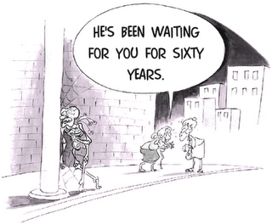

Список литературы и Интернет-ресурсов:
- Голицынский Ю.Б. Грамматика: сборник упражнений. – СПб.: КАРО, 2014.
- Гималетдинова Г.К., Халитова Л.К. Английский язык. Аудирование: Учебное пособие к комплексу «English File» (Oxford). - Казань: Казанский гос. ун-т, 2007.
- Гиндлина И.М. Вся грамматика английского языка с упражнениями. – М.: ООО «Издательство Астрель», 2004.
- Гуд В. Сборник статей для переводов с русского языка на английский, с приложением и словарем. Москва, 2007.
- Зверева Е.А., Лихачева И.К. Щукарева Н.С. Сборник упражнений по неличным формам английского глагола для групп устной практики. Москва - Ленинград, 2007.
- Израилевич Е.Е., Качалова К.Н. Практическая грамматика английского языка. Москва, 2009.
- Качалова К.Н., Израилевич Е.Е. Практическая грамматика английского языка, Москва, 2007.
- Михельсон Т.Н., Успенская Н. В. «Сборник упражнений по основным разделам грамматики английского языка» (практическое пособие). Москва - Ленинград, 2008.
- Новицкая Т. М., Кучин Н. Д. Практическая грамматика английского языка. Москва, 2006.
- ПредвечнаяЛ. А. Практический курс английского языка. Ростов-на-Дону, 2006.
- Экерсли К.Э. Учебник английского языка. – Ростов н/Д: изд-во «Феникс», 2001.
- Яковлев В.Н., Кацюба А.В. Сборник научно-популярных и технических статей на английском языке. М., 2009.
- http://www.interactive-english.ru/
- https://open-lesson.net/contest/
- http://www.tea4er.ru/
- http://sajtichek.narod.ru/grammarbooks.html

