Открытый урок в 8 классе

Тема: «Do you know Miss Manners?»

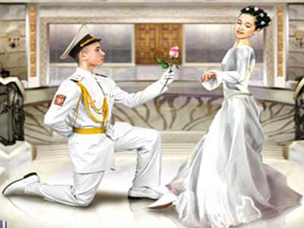

Составитель: Оберемко О.А.,
учитель английского языка

2022г.

Цели урока:
- Познавательные:
знакомство учащихся с правилами поведения принятыми в Великобритании, с главными человеческими качествами. «В чем красота человека».
- Развивающие:
развитие умение сравнивать и делать выводы;
развитие языковой догадки.
- Воспитательные:
формировать адекватное восприятие и отношения к системе ценностей, образу жизни и поведению.
- Учебные:
развитие умения воспринимать на слух информацию, с общим охватом содержания и полным пониманием;
совершенствование грамматических навыков говорения.
(Структура разделительного вопроса)
ХОД УРОКА
•I. Организационный момент и сообщение целей урока
Teacher. Good morning, boys and girls. Glad to see you. What is the date today? What day of the week is it today?
Teacher. There is a saying in English “Manners makes man”.
The expression means that if you want to be a real man, you have to have good manners.
Manners means the way that you behave to other people particularly in public.
Let’s speak about good manners and compare Russian and British customs and manners at lesson today
The theme of our lesson you can see on the screen. (слайд 1). Read and translate it.

•II. Фонетическая зарядка
(Слайд 2)Read and learn the poem:
Let’s try to be polite
In everything we do
Remember always to say “please”
And don’t forget “thank you”

T. Each country has its own unwritten behavior rules. Britain is no exception.
Look at the screen, read and say. Which behavior rules do British people follow? (Слайд 3). Good for you! Now you know some manners and I offer you to continue our lesson.
Now we will remember the main characteristics of British people. Read and translate them. (Слайд 4). Do you agree with them?
T. Now we will remember the table manners. What manners do you know? Now two students will do exercises on cards, others will work with me. Look at the screen and read one more table manners. (Слайды 5-7). Translate it, please. Well!
I think it’s time to check your knowledge about right and wrong manners. Look at the screen and try to do this task. (Слайд 8). Well done! I hope you remembered it.
T. (Слайд 9)Now let’s do grammatical exercise. Firstly, read and translate the words which you will fill in the gaps. Good! Now read the text and fill in the gaps. Well done!
I think you know a lot about British and Russian manners, that’s why let’s do the next task. (Слайд 10). You should choose here “true” or “false”. Well done!
T. In the end of our lesson we will have a quiz (Слайд 11) which is called “Are you well-mannered?” You have some lists of paper. Answer the questions and write them down. Now I will read the descriptions of your manners (Слайд 12).
KEYS: 1 – a, 2 – b, 3 – a, 4 – a
T : What is your score ?Are you well–mannered ?
If you have:
4 right answers – you are well–mannered
3 answers – sometimes break the rules.
2 answers – you should pay attention to your manners.
Now you know everything about yourself.
(слайд 13) There are some English proverbs, which you can see at the screen. Read them and say do you agree with them?
Keep your mouth shut and your ears open
Think today and speak tomorrow
Better to do well than to say well
At the end of our lesson I would like to give you some advices, which you see at the screen. Read them, please. Don’t forget them and be well-mannered.
Always follow the rule of thee R:
1) Respect for Self – Уважай себя.
2) Respect for Others – Уважай других.
3) Responsibility for all your Actions – Будь в ответе за все свои поступки.
Your home task will be: Workbook p.21 Ex.1. Ребята, домашним заданием будет написание письма другу по переписке. При выполнении задания вам следует учесть вежливые фразы обращения и прощания, а также форму написания письма.
This is the end of the lesson.
Thank you for your active work.
I wish you good luck! Good bye.

