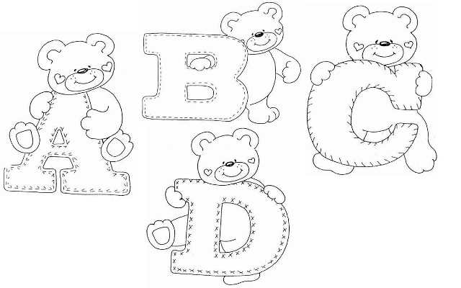

My name is Dubinina Elena Konstantinovna
I am 16 years old.

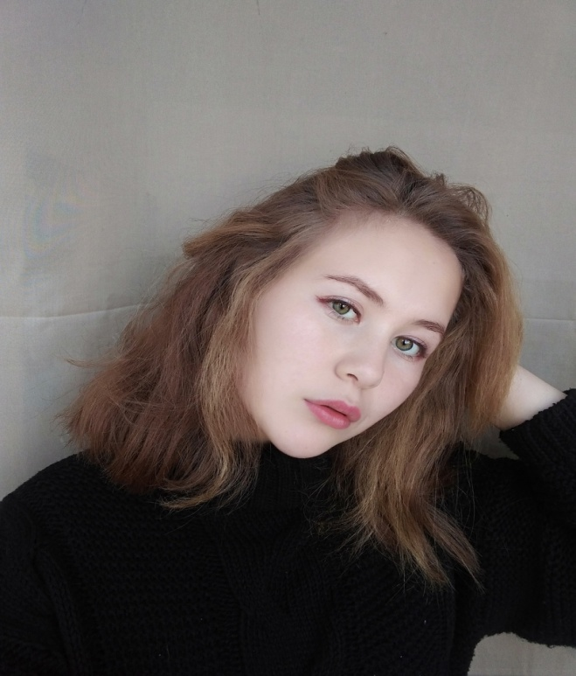

My hobby is dancing, playing the guitar
My family:
My mummy’s name is Dubinina Maya Vladimirovna
My brother’s name is Dubinin Kirill Vladimirovich
My sister’s name is Dubinina Olga Konstantinovna

Why do I need English?
1.I want to travel
2.I want to read books written in English
3.I want to sing songs in English
4.I want to find a friend from another country
5.English will be useful to me for further study and work
6.I want to watch cartoons in English and understand the characters ' speech
7.I want to tell poems in English
8.I want to write texts in English

Homework
The description of the picture
In front of me hangs a painting "Flowers and fruits." by Ivan Khrutsky. This is a very bright and colorful style of life, which depicts the gifts of autumn. In the center of the composition we see a vase with wonderful and very wonderful flowers. There are also large peonies, and toffee, and small wildflowers.
Next to the vase there are fruits: peaches, pears, grapes, lemon. On the right is a large pumpkin. Behind it you can see a decanter, and in the foreground - a glass of water. The master Khrutsky managed to subtly convey the mood of autumn and show how generous and kind our fertile land is.

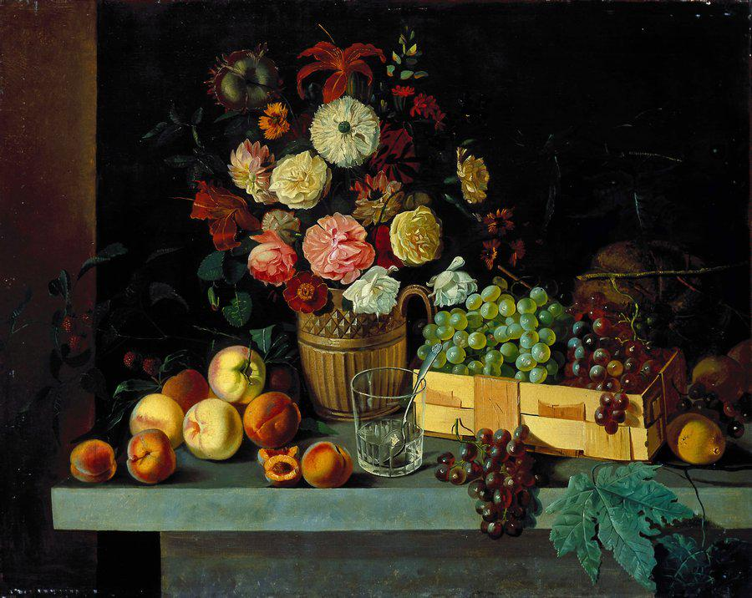
An endangered animal.
The far Eastern fish owl, which cannot be find everywhere, is a huge rarity!
What is the first thing to note about this bird?! It is a representative of the owl family, which is directly visible in the photo of the fish owl. This species is listed in the Red book, its number is very small, and is on the verge of extinction.
Fish owl lives mostly in North Korea, China and Japan, rarely found in other nearby areas. Prefers old, dense forests with flowing, rich on living creatures rivers, where strictly speaking, and feeds.
The fish owl is a bird resistant to severe frosts, but has one very bad trait that can play a very cruel joke and even lead to death. Their plumage does not have a fat layer that protects the bird from water, because of what, wet feathers freeze, not giving the opportunity to fly or even move.
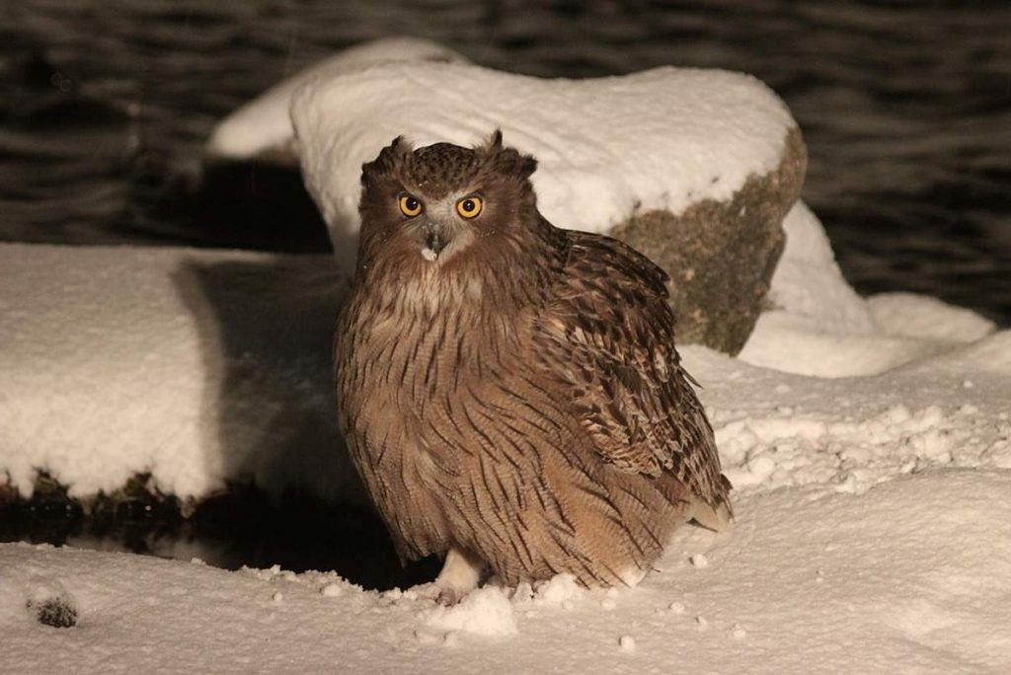
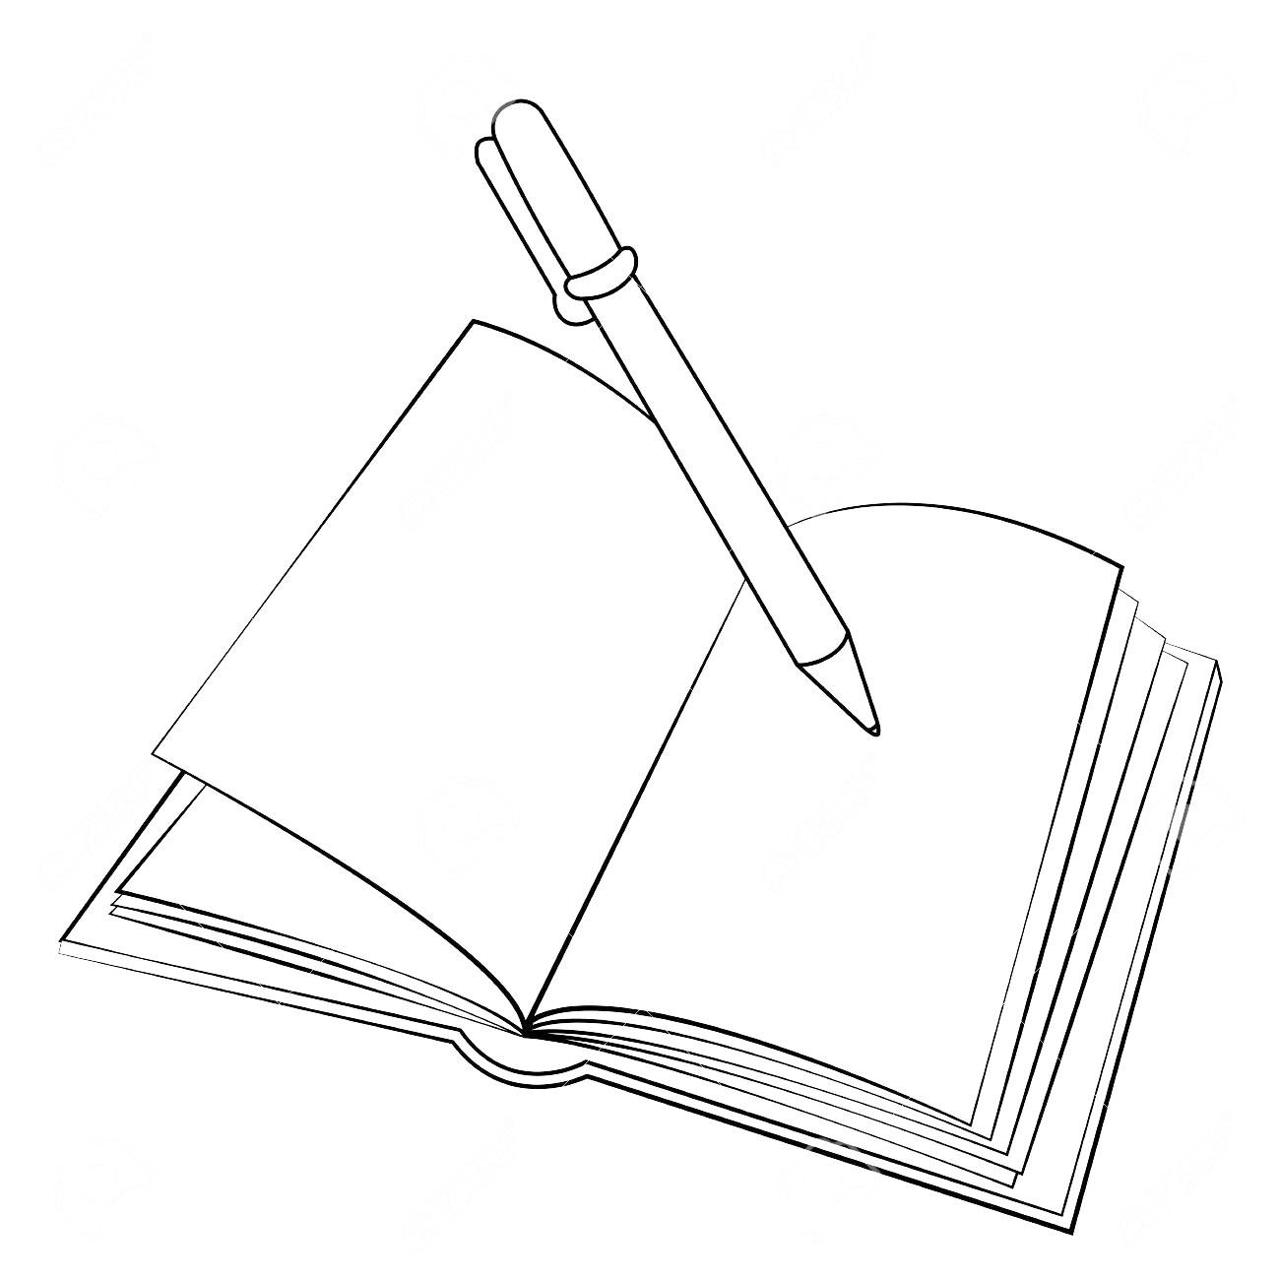
Prediction in 100 years.

I think that after 100 years will be the latest technology: flying cars, people will be able to travel back in time to see the past or the future. People will live in a glass houses, live long and invent a cure against aging. People will communicate telepathically, invent robots and they do the housework, treat animals with love, the poachers will not kill endangered and protected animals because these animals included in the Red Book

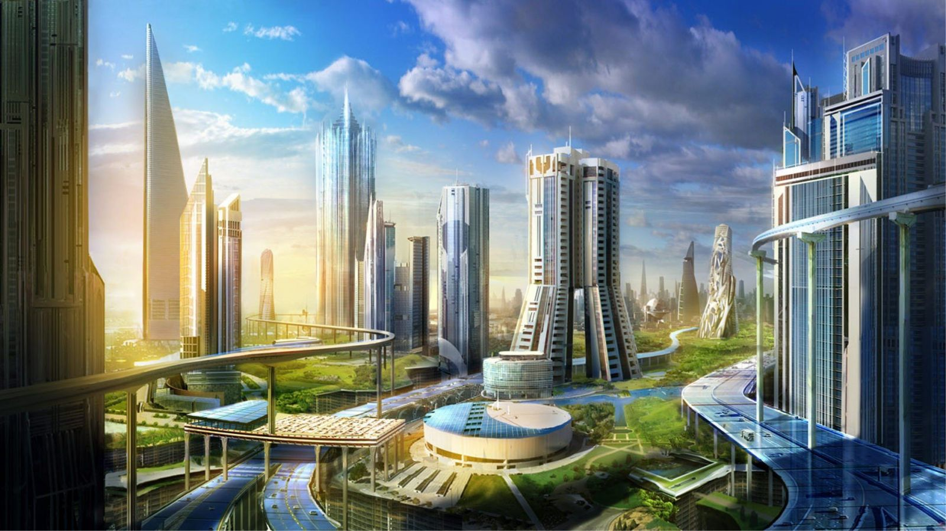

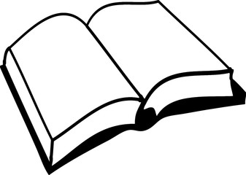

Shrek 2.
Shrek 2 is an animation film. It’s directed by Endryu Adamson, Kelli Esbori, Konrad Vernon. It’s starring by Kameron Dias, Eddi Morfi, Mayk Mayyers. Shrek and Fiona return after the honeymoon and find a letter from Fiona’s parents with an invitation to dinner. However, they do not suspect that their daughter has become too big! This film is impressed me a lot.

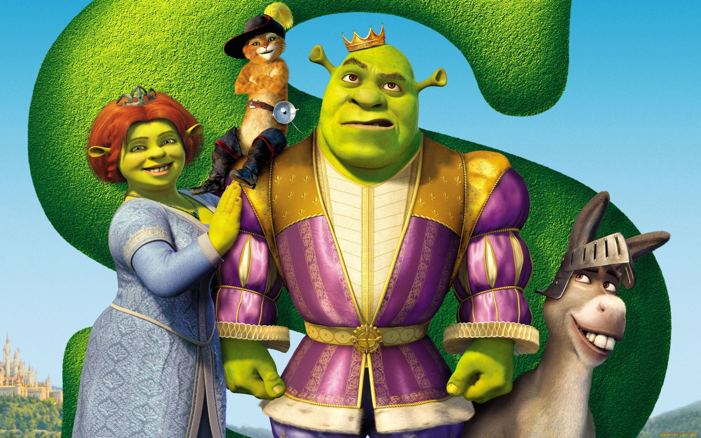

Composition.
Music for life.
People cannot live without music. They can listen to music everywhere even in the forest, when they walk and hear birds singing.
Music can be classical and modern. Classical music is performed by symphonic orchestras in the great halls. Most people prefer modern music. Modern music has different kinds: pop, rock, disco, rap, techno, k-pop and others. Now there are a lot of disco and records of different performers.
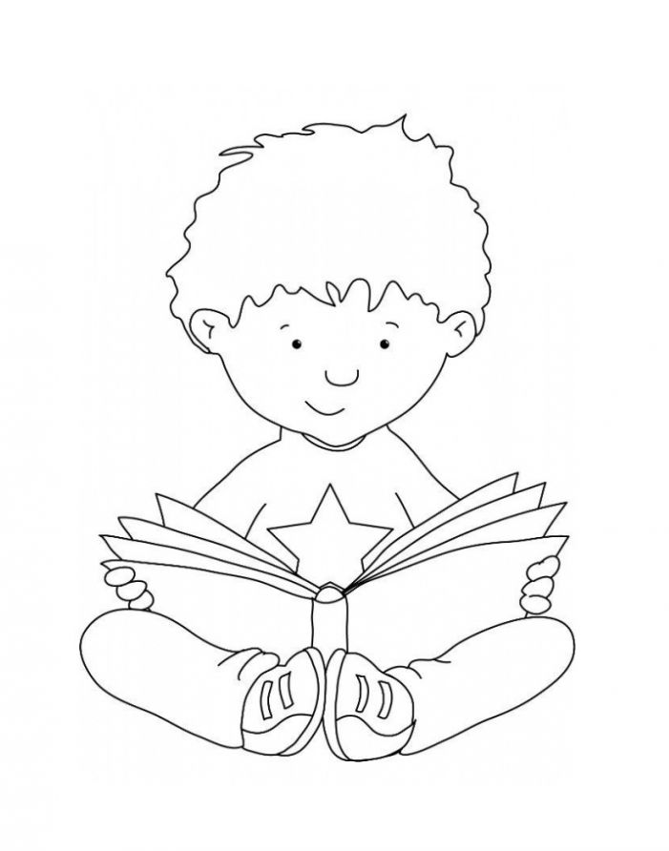
The last achievement in music production is a clip. Musical clips are short films accompanied by the melody. People like to watch clips because it’s not only listening to music but also watching interesting things. I’m fond of music and like listening to it. It helps me to have good relaxation.

News
Henny Admoni is a robotics professor at Carnegie Mellon University, in Pittsburgh, Pennsylvania. She has a big goal. “My dream is to have a robot that can act as a practice partner for kids”, she told TIME for kids. According to Admoni, that dream could soon become a reality. “I don’t think it will be next year”, she says, “but I don’t think we will have to wait 20 years”.
Already, robots are being tested in classrooms around the world. They have been programmed to teach math lessons and to ask and answer questions in different languages. Researchers say robot make ideal study buddies. They are engaging. They never lose their patience. And more and more, they are able to adjust their lessons to the needs of a particular learner.
Bad habits.
The health of a person is the main value in the life. It cannot be bought with any money! There is no price for it. Being the sick person, you cannot realize all your dreams and be successful in the modern world. But how to be healthy, when there are a lot of fatal temptations around us?
Don’t begin! Don’t make the first cigar inhalation, the first sip of alcohol! Everything begins so simply, but comes to the end with a trouble. It was said so much about the harm of smoking. For a long time it was been proved, that smoking is not only reflected on the budget of a family, pollutes air, but also ruins our heath. But, in spite of all that the number of smoking people are not diminished. And what is more grievous, not only the teens but also the junior schoolboys begin to smoke. Smoking is not a harmless pastime which can be given up without efforts. It is necessary to have the will-power to stop smoking.
In addition to smoking, we can name the other fatal habit: the drinking of alcohol. Unfortunately, very other they combine with each other. Alcohol is a poison! Even a single sip of alcohol causes a poisoning which can lead to death.
And the usage of drugs…They ruin all human organs, so the drug addicts die young. Few of them live longer than several years after they have started taking drugs.
So, I consider that there is no place to these habits in our life.

