Сборник заданий и упражнений
по английскому языку

What do you know about famous people
of cinema and theatre?
Образовательное учреждение:
МКОУ ООШ д. Ежово Омутнинского района Кировской области

Автор: Сенатская Галина Михайловна
Должность: учитель английского языка

Номинация: Сборник практических заданий и упражнений

Название работы:
«What do you know about famous people of cinema and theatre?»

Содержание

Пояснительная записка | c. 4
Part A
- What do you know about Hollywood? The first film stars of Hollywood. | c. 5
- Ask your classmates… | c. 8
- Match actors with their films | c. 9
- Cinema in the USA . Test | c. 11
Part B
- What do you know about cinema? | c. 13
- From the history of cinematography in Russia. | c. 14
- The first film makers of Russia | c. 16
- Outstanding film makers of Russia | c. 17
- Cinema in Russia. Test | c. 19
Keys | с. 20
Источники информации | c.21

Пояснительная записка

Практические задания “ What do you know about famous people of cinema and theatre?» предназначены для обучающихся 10-11классов общеобразовательных школ, изучающих английский язык. Задания направлены на развитие навыков чтения, устной и письменной речи. Их можно использовать в классах, работающих по различным учебникам английского языка, так как задания составлены с учётом программы средней школы.

В сборнике два раздела.
В первом разделе «What do you know about famous people of cinema and theatre?» включены коммуникативные задания об истории развития кинематографа англоязычных стран, побуждающие учеников выразить своё отношение к театральной жизни, просмотренным фильмам и различным жанрам, а также грамматические, тестовые и письменные задания.

Во второй раздел вошли коммуникативные задания об истории развития кинематографа в России, грамматические, коммуникативные, тестовые и письменные.
Задания снабжены многочисленными фотографиями, что делает их более привлекательными.

Значимость заданий состоит в том, что они могут использованы учителями средних школ при работе с разными категориями детей, поскольку в основе лежат общедидактические принципы обучения иностранным языкам:
- воспитывающего обучения;
- сознательности;
- активности;
- наглядности;
- доступности и посильности;
- прочности;
- индивидуализации.
Part A

- What do you know about Hollywood?
- The 20 th century is the century of film making. The development of cinematography brought to life the world cinema empire called Hollywood.
- The story of Hollywood Up to 1907 – If was a little city with orange forest and great weather 1908 – A group of people from Chicago came to Los Angeles to shoot a film 1911 – The first studio appeared in Hollywood (a part of Los Angeles)
- 1920-s – Hollywood made 80% of the world’s films. They were silent and black-and-white films.

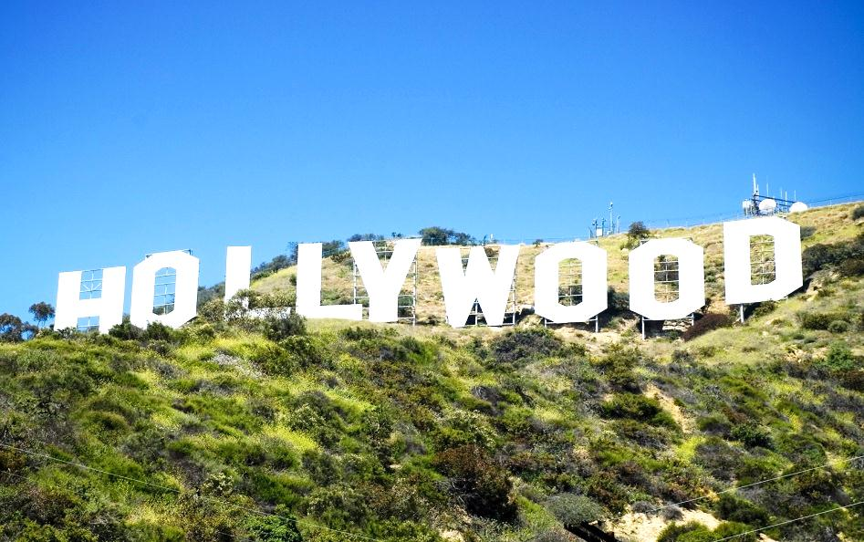

The first film stars of Hollywood
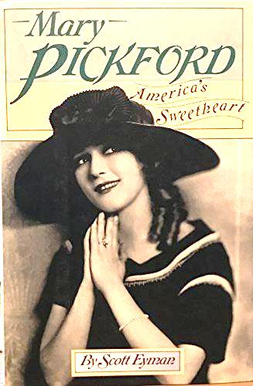 | Mary Pickford  (1893 - 1979) The stage name of Gladys Mary Smith. A Canadian-born US actress. The film star of the silent films, she was known as “America’s Sweetheart”, played the roles of innocent girls into her thirties.
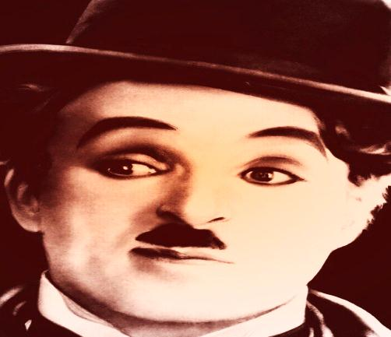 | Charlie Chaplin  (1889 – 1977) An English film actor and director, made his reputation as a tramp with a small black moustache, bowler hat in silent comedies, including “The Rink “(1916) “The Kid “(1920) “The Gold Rush” (1925)
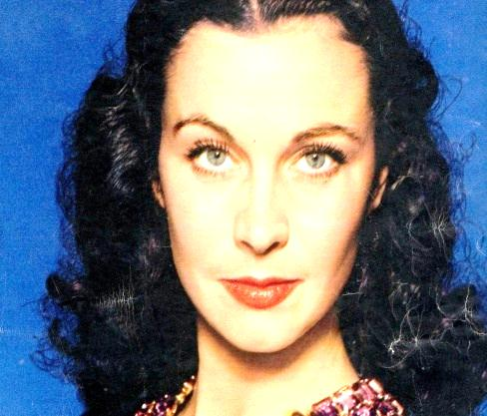 | Vivien Leigh  (1913 - 1967) The stage name of Vivien Mary Hartley. Indian-born English actress, won Academy Awards as Scarlett O’Hara in” Gone with the Wind” . Her other films – “Lady Hamilton” (1941) “Anna Karenina “(1948)
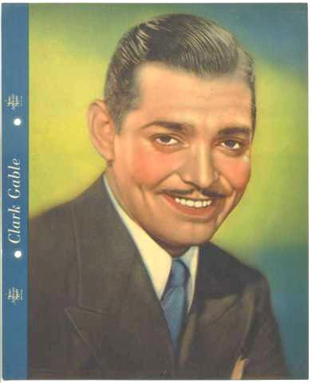 | Clark Gable  (1901 – 1960) An American film actor. 90 films. The most famous role – Rhett Bulter in” Gone with the Wind” (1939)

Let’ s talk
1.Who were the first film stars of the Hollywood film making?
2.And which of the first Hollywood film stars did the first colour film bring a great success to?

2. Ask your classmates…

- What city , the world capital, filmed entertainment , is considered , to be , of(?)
(Los Angeles)

- What , called , is , cinema empire, the greatest(?)
(Hollywood, a part of Los Angeles)

- When , made, in Los Angeles , was , the very, first film (?) Who were , it, to shoot , the first people (?)
(1908:a group of people from Chicago)

- When, Hollywood, appear, did , the first, film studio(?)
(1911)

- What kind of, first, were shot, films, in Hollywood(?) (silent, black-and-white films)
- Who were, film stars , Hollywood film making, the first , of the (?)
(Mary Pickford, Charly Chaplin)

- What were , in the 1920s, of Hollywood , the silent black-and-white films, forced out, by (?)
(sound films)

- What films, of short films, to take place, came up(?)
( full –length films)

- When was , in Hollywood, colour film, the first, shot (?) What, its name, was (?)(1939 ; “Gone with the wind”)
- Which of , a great success to, film stars, the first , Hollywood, the first colour film , did, bring (?)
(Vivien Leigh, Clarc Gable)

- What are , nowadays, the biggest, in the USA, film making companies(?)
(MGM,Paramount, 20th Century Fox, Columbia Pictures, Warner Bros, Universal)

- What genres, at that time, were typical of , shot, the first films, in Hollywood(?)
(melodrama, western, comedy,
adventure and historical films)

There are some names from the Hollywood film making industry that are known all over the world: Walt Disney, Steven Spielberg, Eddie Murphy, James Cameron, Leonardo DiCaprio, Sylvester Stallone, Arnold Schwarzenegger, Bruce Willis, Steven Seagal, Dolph Lundgren, Jean-Claude Van Damme, Wesley Snipes, Jackie Chan and others.

First strike
First strike
First strike
First strike
First strike
First strike
- Match actors with their films
1. 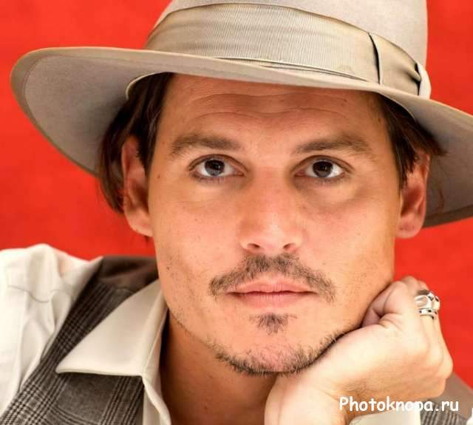  Johnny Depp  Johnny Depp | First strike  First strike  First strike  First strike  а 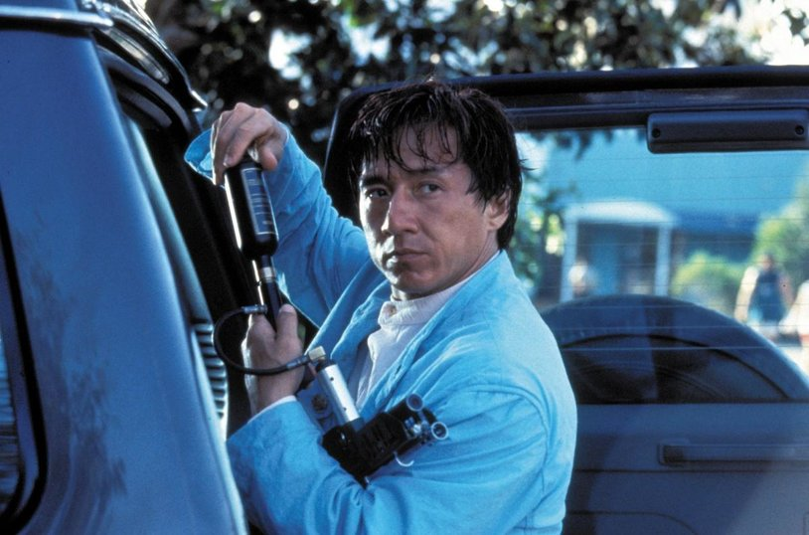  First strike  First strike
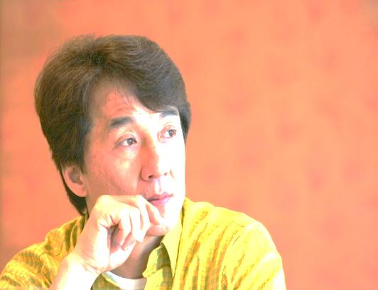  Jackie Chan  2. | 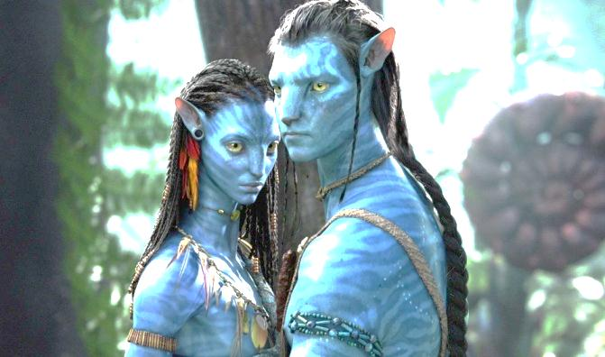  Avatar  b  First strike
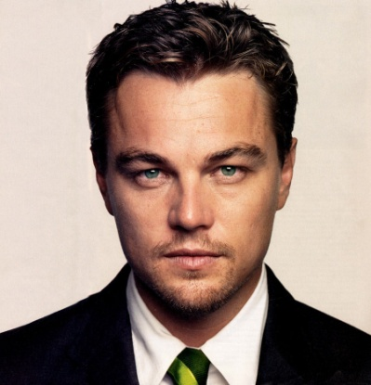  Leonardo DiCaprio  3. | 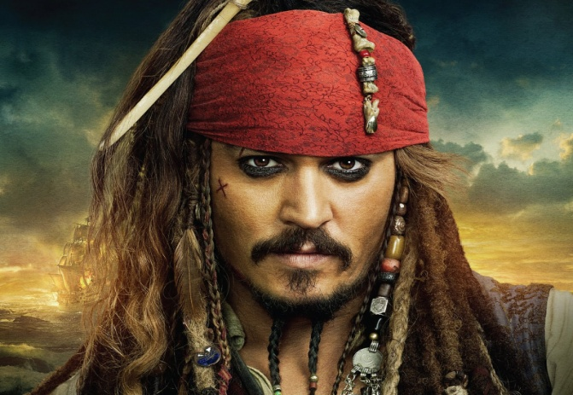  Pirates of the Caribbean  c
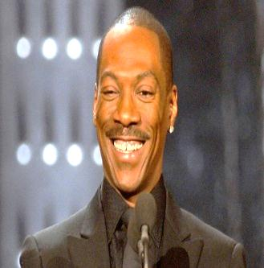  Eddie Murphy  4. | 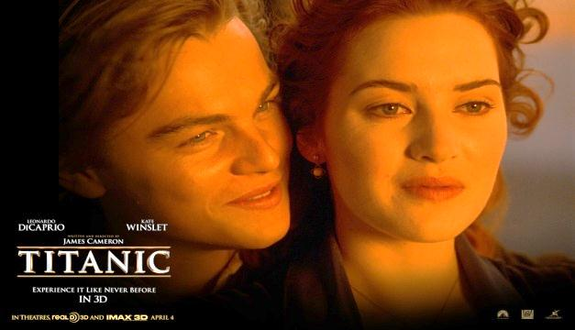  Titanic  d
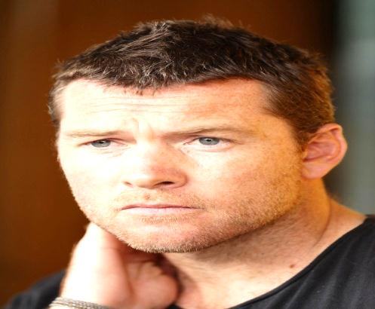  Sam Worthington  5. | 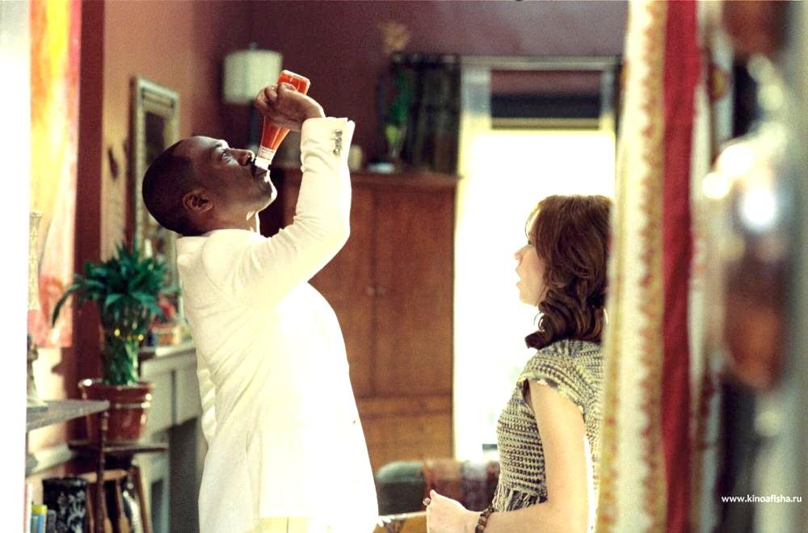  Meet, Dave  e

First strike
First strike
4. Cinema in the USA
Test
1. The ----1------are considered to be the inventors of the cinema.
a)-British; b)-American; c)-French

2. The first three minutes film demonstrated by the Lumiere brothers was called _____2_____
a)-“Arrival of the Train”; b) –“Departure of the Train”
c)-“ The Passenger without a ticket”

3. Everybody knows that _____3_______was chosen in 1908 to become the world capital of film entertainment.
a)- Chicago b)-New York; c)- Loc Angeles

4. The first film studio in America appeared in _____4____.
а)-1908; b)- 1911; c)- 1913

5. The first genres of American films were_______5_____.
a)-thrillers, action and horror films;
b) – western, comedies and melodrama;
c)-adventutes and historical films.

6. The first colour film in america “ Gone with the Wind” was shot in the ____6_____.
a)-1910s; b)- 1920s; c)-1930

Part B
1.What Do You Know About Cinema?

HOW IT ALL BEGAN

Read the text about Lumiere brothers.
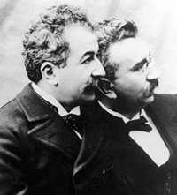
Auguste and Louis Lumiere are credited with the world’s first public film screening on December 28, 1895. The showing of approximately ten short films lasting only twenty minutes in total was held in the basement lounge of the Grand Cafe on the Boulevard des Capucines in Paris and would be the very first public demonstration of their device they called the Cinematograph which effectively functioned as camera, projector and printer all in one. Their work consisted mainly of moving images from scenes of everyday life. Ironically, as we look back in retrospect, in comparison to what film has developed into today, the Lumiere Brothers believed it to be a medium without a future. They suspected that people would get bored of images that they could just as easily see by walking out into the street. However, their film sequence of a train pulling into the station reportedly had audiences screaming and ducking for cover as they believed that the train itself was about to plow into the theatre.
Born in the Haute-Saone District in 1862 and 1864, with Auguste being the elder, the Lumiere family eventually settled in Lyon. Their father Antoine opened his own photographic studio and was equally intrigued by this new phenomenon of moving pictures that was slowly developing. Antoine saw to it that his sons received a formal education as they attended the largest technical school in Lyon, La Martiniere.
The Lumiere Brothers have been credited with over 1,425 different short films and had even filmed aerial shots years before the very first airplane would take to the skies.
Let’ s talk
1. What are Lumiere brothers famous for?
2. What was their first film about?
3. How did they call their device for the demonstration of films?
4. Why did Lumiere think that cinematography had no future?
5. The Lumiere brothers shot over 1,425 different films but they are usually remembered for their first one. Why, in your opinion, is it so?

2.From the history
of cinematography in Russia
Ask your classmates…
- What, and when, did, in Russia, the spreading of cinematography, start with(?) (the demonstration of the Lumiere brothers’ film “Arrival of the Train” in St.Petersburg, Moscow, Nizhni Novgorod;1896)

- Where, in Russia, did, film making industry, develop, mainly(?) (St.Petersburg, Moscow)

- Who, in Russia, founded, film studio, the first(?) ( A. Khanzhonkov)

- Who were, of Russian silent films, film stars, the first(?) (V. Kholodnaya, V. Polonski, V. Maksimov)

- What were, of Russian films, genres, popular, the most (?) (historic films, screen versions of famous novels)

- When, start, in our country, sound cinema house, did, the first, its work (?) (1929, October)

- Who was, in our country, paid to , great attention, while shooting films(?) (children)

- What was , famous for, A. Rou, one of the most outstanding film directors(?) (the creator of fairy tales)

- Why is, inseparably linked , one of the most famous directors, the name of , R.Bykov, with childen’s films too(?) (to shoot films for children” Attention! The Tortoise” and “Aibolit-66”)

- What, all over the world, other names , are known, of the creators, of film art, of unforgettable realistic pieces, in Russia (?) ( N. Mikhalkov, A. Konchalovski, A. Tarkovski)

3.The first film makers of Russia
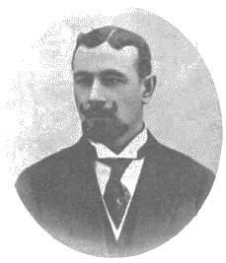 | Alexandr Khanzhonkov  (1877-1945)  Khanzhonkov founded Russia’s first cinema factory in 1911. He was film studio owner and shot Russia’s first full-length feature film “Defence of Sevastopol”.
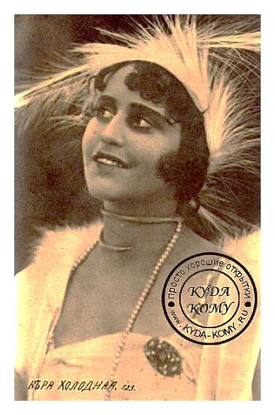 | Vera Kholodnaya  (1893-1919)  She was the first star of Russia’s  silent films. She starred in “The Song of the Triumphant Love”, “Children of the Age”, “The Mirages”, “A Life for a Life”, “A Corpse Living” and “Be Silent, My Sorrow, Be Silent”.
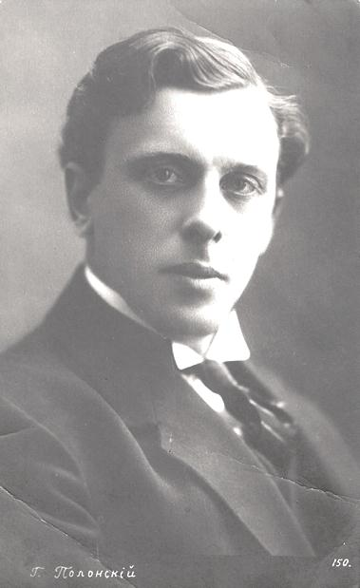 | Vitold Polonski  (1879-1919)  A Russian actor was best-known for his roles in pre-revolutionary films. He played in “The Mirages”, “Be Silent, My Sorrow, Be Silent”, “The Song of the Triumphant Love”, “Natasha Rostova” and other films.
- Outstanding film makers of Russia
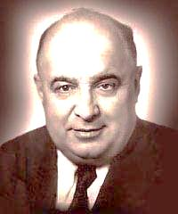 | Alexander Rou  (1906-1973)  is known as the Soviet film director who shot fairy tales films for children: “Morozko”, “By the Wave of the Wand” and “Fire, Water and Copper Trumpets”.
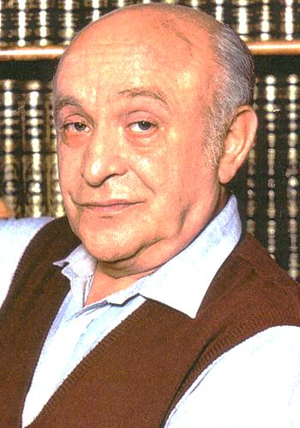 | Rolan Bykov  (1929-1998)  was one of the most famous Russian actors and directors of film making indusrty for children .
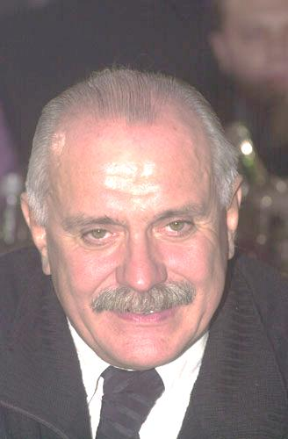 | Nikita Mikhalkov  (1945-)  He is a Soviet and Russian filmmaker, actor, and head of the Russian Cinematographers‘  Union, shot such film as Urga (1991), Burnt by the Sun (1994), The Barber of Siberia (1998), 12 (2007) etc. The film Burnt by the Sun received the Grand Prize at Cannes and the Academy Award (Oscar) for Best Foreign Language Film.
Andron Konchalovsky
(1937-)
A Russian film director and screenwriter is famous for films The First Teacher ( 1965)
Uncle Vanya ( 1970)
Sibiriada (1978) and others.
He got prizes at several film festivals
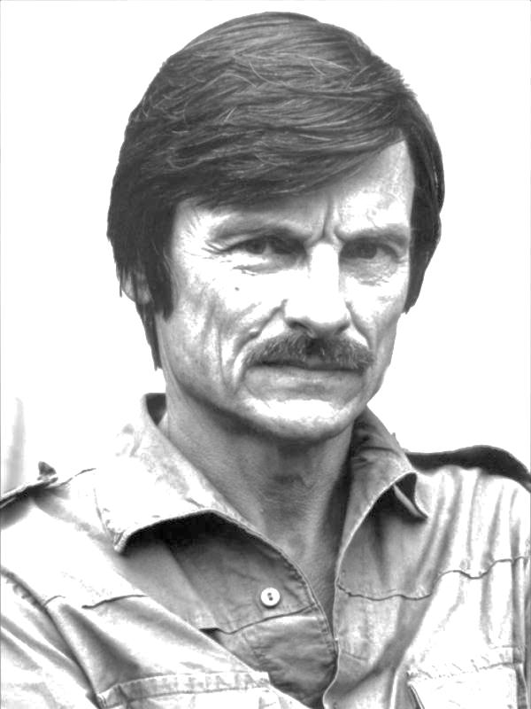 | Andrei Tarkovsky  (1932-1986)  A Soviet film director and screen writer is best known for his works:  Ivan’s Childhood (1962)  Andrei Rublev (1966)  Solyaris (1972)  The Mirror (1975)  Stalker (1979)
Let’ s talk
1.Who founded the first film studio in Russia?
2. And what about the first film stars of Russian silent films?
3.What was Alexander Rou , one of the most outstanding film directors, famous for?
4. And what other names of the creators of unforgettable realistic pieces of film art in Russia are known all over the world ? Do you know?

4.Cinema in Russia
Test
- The Lumiere brother’s film was first demonstrated in Russia in ____1________
(a)-1895; b)- 1896 ; c)-1897)

2. The development of film making industry in Russia was connected with ____2______who founded the first film studios.
(a)-A. Khanzhonkov; b)- V. Polonski; c)- V. Mashkov)

3. The most popular genres of Russian films were ____3___.
(a)- historical films and screen versions of famous novels;
b)- science fiction and love stories; c) – horror films and thrillers.)
- The first sound cinema house was opened in Russia in ____4_______.
(a)- 1910s; b)- 1920s; c)- 1930s)

5. One of the most famous directors who created film versions of fairy tales for children in Russia was ___5_____.
(a) –A. Rou; b)- M. Sholokhov ; c)- R. Bykov)
- When you can’t help yawning while watching the film you are sure to say: ___6__.
- – “What a fantastic film it is!”; b)- “What a horrible film it is!” c)-“ What a boring film it is!”

Keys
Part B
Part A

Ex.3  1-c; 2-a; 3-d; 4-e; 5-b | Еx.4  1-b; 2-a; 3-a; 4-b; 5-a; 6-c
Ex.4. Cinema in the USA
Test
1-c; 2-a; 3-c; 4-b; 5-b; 6-c

Источники информации:

http://finione.ucoz.ru/news/11
- http://kinorelease.com/note/page/2/
- http://deloru.ru/news/461457/
- https://ru.wikipedia.org/wiki/%D0%A4%D0%B0%D0%B9%D0%BB
- Aleksandr_Khanzhonkov_001.jpg
- https://ru.wikipedia.org/wiki/%D0%A4%D0%B0%D0%B9%D0%
- https://ru.wikipedia.org/wiki/%D0%A4%D0%B0%D0%B9%D0%BB
- http://blogs.privet.ru/user/udzxubtxqajbc07vkwryinbnz9eudqgx/13737666
- http://www.day.kiev.ua/ru/article/kultura/koroleva-nemogo-ekrana
- http://www.barbacuca.ru/index.php?showtopic=3623&st=320
- http://prokino.uol.ua/ukr/text/5067268/
- http://subscribe.ru/group/vselennaya-cheloveka/2164584/
- http://dovzhenko.ucoz.ru/photo/julija_solnceva/2-0-17
- http://sherryvolpin.livejournal.com/48059.html
- http://film.cmlt.tv/person/4448301
- http://modernlibz.ru/books/dyatleva_galina/populyarnaya_istoriya_teatra/read_37/
- http://www.maly.ru/history.php?shift=66&search=histact
- http://film.cmlt.tv/film/33474
- http://www.dvreclama.ru/blogi/kondratenko/8099/a_na_zachemnam_lichnostto_rostit/?commentId=1417
- http://netupi.kz/gorozhane-nedarom-poinit-vsya-rossiya-pro-den-borodina/
- http://all-posad.livejournal.com/
- http://www.liveinternet.ru/users/4024448/post175060376/
- http://1212079.vkrugudruzei.ru/x/blog/all/
- http://clubs.ya.ru/4611686018427447202/replies.xml?item_no=659688
- http://koto-mush.livejournal.com/59480.html
- http://cpo009.ucoz.hu/blog/kadry_iz_filma_ajbolit_66/2013-05-31-21
- http://kinokartoshka.net/sovetskie-detskie-filmy/880-avtomobil-skripka-i-sobaka-klyaksa-smotret-online.html http://alternathistory.com.ua/comments/recent?page=5484
- http://www.vokrug.tv/photo/person/Andrey_Tarkovskiy/
- http://forum.znyata.com/viewtopic.php?p=222114
- http://shalomfilm.com/2498-stanislav-lem-yekranizacii-shedevra-solyaris.html
- http://retro-obzor.ru/movies/domestic-films/290-stalker-1979-dvdrip.html
- http://hq-photo.net/1011-andrey-konchalovskiy-ya-poznakomilsya-s-dzholi-kogda-ey-bylo-5-let.html

