**[](http://images.yandex.ru/yandsearch?source=wiz&fp=0&text=%D0%BA%D0%B0%D1%80%D1%82%D0%B8%D0%BD%D0%BA%D0%B0%20%D1%82%D1%83%D1%87%D0%BA%D0%B0%20%D0%BF%D0%BB%D0%B0%D1%87%D0%B5%D1%82&noreask=1&pos=3&lr=47&rpt=simage&uinfo=ww-1349-wh-673-fw-1124-fh-467-pd-1&img_url=http%3A%2F%2Fwww.stihi.ru%2Fpics%2F2013%2F02%2F06%2F9830.jpg)**

**Намр -ар**

**[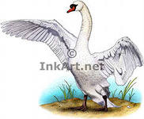](http://images.yandex.ru/yandsearch?text=%D0%BA%D0%B0%D1%80%D1%82%D0%B8%D0%BD%D0%BA%D0%B0%20%D0%A0%D0%98%D0%A1%D0%9E%D0%92%D0%90%D0%9D%D0%9D%D0%90%D0%AF%20%D0%9B%D0%95%D0%91%D0%95%D0%94%D0%98&fp=0&img_url=http%3A%2F%2Fwww.inkart.net%2Fanimals%2Fdrawings%2Fwaterfowl%2Fimages%2Fmute_swan.jpg&pos=13&uinfo=ww-1349-wh-673-fw-1124-fh-467-pd-1&rpt=simage)эклдг**

**Хавр -ар**

[](http://images.yandex.ru/yandsearch?text=%D1%80%D0%B8%D1%81%D0%BE%D0%B2%D0%B0%D0%BD%D0%BD%D1%8B%D0%B5%20%D0%BA%D0%B0%D1%80%D1%82%D0%B8%D0%BD%D0%BA%D0%B8%3A%20%D1%87%D0%B5%D0%BB%D0%BE%D0%B2%D0%B5%D0%BA%20%D0%B2%20%D0%BE%D1%87%D0%BA%D0%B0%D1%85%20%D0%B8%20%D1%81%20%D0%BA%D0%BD%D0%B8%D0%B3%D0%BE%D0%B9&fp=0&pos=17&uinfo=ww-1349-wh-673-fw-1124-fh-467-pd-1&rpt=simage&img_url=http%3A%2F%2Fi.allday.ru%2Fdf%2Ff3%2F2e%2F1314130942_school_boy2_500a.jpg) **-ǝ кеермҗ**

**УХАН,**

[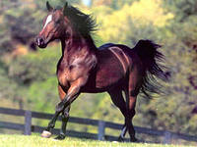](http://images.yandex.ru/yandsearch?text=%D1%80%D0%B8%D1%81%D0%BE%D0%B2%D0%B0%D0%BD%D0%BD%D1%8B%D0%B5%20%D0%BA%D0%B0%D1%80%D1%82%D0%B8%D0%BD%D0%BA%D0%B8%3A%20%D0%A1%D0%9A%D0%90%D0%9A%D0%A3%D0%9D&fp=0&img_url=http%3A%2F%2Fimg-fotki.yandex.ru%2Fget%2F6402%2F164513677.10%2F0_9167e_b812a41_XL&pos=29&uinfo=ww-1349-wh-673-fw-1124-fh-467-pd-1&rpt=simage) **-ǝ кеермҗ**

**ХУРДН**

[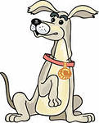](http://images.yandex.ru/yandsearch?p=5&text=%D1%80%D0%B8%D1%81%D0%BE%D0%B2%D0%B0%D0%BD%D0%BD%D1%8B%D0%B5%20%D0%BA%D0%B0%D1%80%D1%82%D0%B8%D0%BD%D0%BA%D0%B8%3A%20%D0%A1%D0%9E%D0%91%D0%90%D0%9A%D0%90&fp=5&img_url=http%3A%2F%2Fimg-fotki.yandex.ru%2Fget%2F3705%2Finmira.39%2F0_3a21c_3c559258_S&pos=166&uinfo=ww-1349-wh-673-fw-1124-fh-467-pd-1&rpt=simage) **УГАД –**

[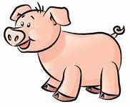](http://images.yandex.ru/yandsearch?source=wiz&fp=0&img_url=http%3A%2F%2Fwww.howtodrawguide.com%2Fwp-content%2Fuploads%2Fimage%2Fhow-to-draw-animals%2Fhow-to-draw-a-pig%2Fpig1.jpg&text=%D1%80%D0%B8%D1%81%D0%BE%D0%B2%D0%B0%D0%BD%D0%BD%D1%8B%D0%B5%20%D0%BA%D0%B0%D1%80%D1%82%D0%B8%D0%BD%D0%BA%D0%B8%3A%20%D0%A1%D0%92%D0%98%D0%9D%D0%AC%D0%AF&noreask=1&pos=4&lr=47&rpt=simage) **ХУЦДГ**

[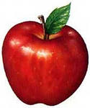](http://images.yandex.ru/yandsearch?p=13&text=%D1%80%D0%B8%D1%81%D0%BE%D0%B2%D0%B0%D0%BD%D0%BD%D1%8B%D0%B5%20%D0%BA%D0%B0%D1%80%D1%82%D0%B8%D0%BD%D0%BA%D0%B8%3A%20%D1%8F%D0%B1%D0%BB%D0%BE%D0%BA%D0%BE&fp=13&img_url=http%3A%2F%2Fwww.webdesign.org%2Fimg_articles%2F16258%2F335x402xdraw-an-apple-01.jpg.pagespeed.ic.Erg0RHVWV7.jpg&pos=403&uinfo=ww-1349-wh-673-fw-1124-fh-467-pd-1&rpt=simage) **ишǝсн**

**холд ундго**

[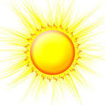](http://images.yandex.ru/yandsearch?p=8&text=%D1%80%D0%B8%D1%81%D0%BE%D0%B2%D0%B0%D0%BD%D0%BD%D1%8B%D0%B5%20%D0%BA%D0%B0%D1%80%D1%82%D0%B8%D0%BD%D0%BA%D0%B8%3A%20%D1%81%D0%BE%D0%BB%D0%BD%D1%8B%D1%88%D0%BA%D0%BE%20%D0%B8%20%D0%BC%D0%B5%D1%81%D1%8F%D1%86&fp=8&img_url=http%3A%2F%2Fimg3.proshkolu.ru%2Fcontent%2Fmedia%2Fpic%2Ficon%2F2000000%2F1403000%2F1402272-95a1d65c.jpg&pos=243&uinfo=ww-1349-wh-673-fw-1124-fh-467-pd-1&rpt=simage)

**[](http://images.yandex.ru/yandsearch?p=7&text=%D1%80%D0%B8%D1%81%D0%BE%D0%B2%D0%B0%D0%BD%D0%BD%D1%8B%D0%B5%20%D0%BA%D0%B0%D1%80%D1%82%D0%B8%D0%BD%D0%BA%D0%B8%3A%20%20%D0%BB%D1%83%D0%BD%D0%B0%2C%20%D0%BF%D0%BE%D0%BB%D1%83%D0%BC%D0%B5%D1%81%D1%8F%D1%86&fp=7&img_url=http%3A%2F%2Fi.klubkrasoti.ru%2Fpics%2Fproduct%2F500%2F98174_110297.jpg&pos=236&uinfo=ww-1349-wh-673-fw-1124-fh-467-pd-1&rpt=simage) угад**

**чигн**

**герл болдг**

[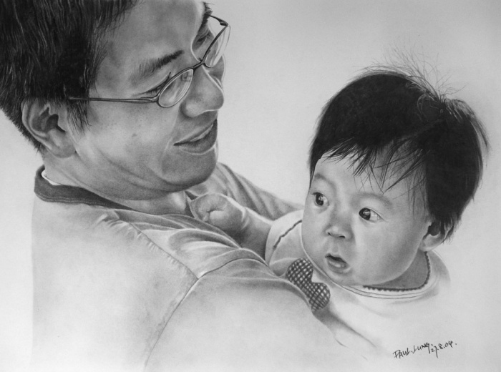](http://images.yandex.ru/yandsearch?text=%D1%80%D0%B8%D1%81%D0%BE%D0%B2%D0%B0%D0%BD%D0%BD%D1%8B%D0%B5%20%D0%BA%D0%B0%D1%80%D1%82%D0%B8%D0%BD%D0%BA%D0%B8%3A%20%D1%87%D0%B5%D0%BB%D0%BE%D0%B2%D0%B5%D0%BA&img_url=http%3A%2F%2Fpozitiv-news.ru%2Fwp-content%2Fuploads%2F2011%2F07%2F331.jpg&pos=10&rpt=simage&lr=47&noreask=1&source=wiz)[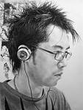](http://images.yandex.ru/yandsearch?source=wiz&fp=0&img_url=http%3A%2F%2Fpozitiv-news.ru%2Fwp-content%2Fuploads%2F2011%2F07%2F321.jpg&text=%D1%80%D0%B8%D1%81%D0%BE%D0%B2%D0%B0%D0%BD%D0%BD%D1%8B%D0%B5%20%D0%BA%D0%B0%D1%80%D1%82%D0%B8%D0%BD%D0%BA%D0%B8%3A%20%D1%87%D0%B5%D0%BB%D0%BE%D0%B2%D0%B5%D0%BA&noreask=1&pos=22&lr=47&rpt=simage)

**Күн – ахта,**

**[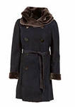](http://images.yandex.ru/yandsearch?p=6&text=%D1%80%D0%B8%D1%81%D0%BE%D0%B2%D0%B0%D0%BD%D0%BD%D1%8B%D0%B5%20%D0%BA%D0%B0%D1%80%D1%82%D0%B8%D0%BD%D0%BA%D0%B8%3A%20%D0%B2%D0%BE%D1%80%D0%BE%D1%82%D0%BD%D0%B8%D0%BA%20%D1%88%D1%83%D0%B1%D1%8B&fp=6&img_url=http%3A%2F%2Fimages.kakprosto.ru%2Ftumb%2Farticle-main%2Farticles%2F201103%2Farticle_453_0d283b4014ab42edadf923d35fc4ffef1300112698.jpg&pos=194&uinfo=ww-1349-wh-673-fw-1124-fh-467-pd-1&rpt=simage)**

**[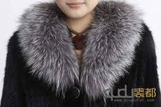](http://images.yandex.ru/yandsearch?p=1&text=%D1%80%D0%B8%D1%81%D0%BE%D0%B2%D0%B0%D0%BD%D0%BD%D1%8B%D0%B5%20%D0%BA%D0%B0%D1%80%D1%82%D0%B8%D0%BD%D0%BA%D0%B8%3A%20%D0%BE%D1%82%D0%B4%D0%B5%D0%BB%D1%8C%D0%BD%D1%8B%D0%B9%20%D0%BC%D0%B5%D1%85%D0%BE%D0%B2%D0%BE%D0%B9%20%D0%B2%D0%BE%D1%80%D0%BE%D1%82%D0%BD%D0%B8%D0%BA%20%D0%BF%D0%B0%D0%BB%D1%8C%D1%82%D0%BE%2C%20%D1%88%D1%83%D0%B1%D1%8B%2C%20%D1%82%D1%83%D0%BB%D1%83%D0%BF%D0%B0&fp=1&img_url=http%3A%2F%2Fmeha33.ru%2FuploadPics%2FFull%2F1060%2FQD2017_Genuine_Knitted_Mink_Fur_Coat_With_Fox_Collar_warm_classic_Drop_shipping_free_shipping_wholesale.jpg.jpeg&pos=48&uinfo=ww-1349-wh-673-fw-1124-fh-467-pd-1&rpt=simage) девл - захта**

**[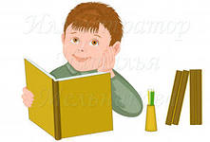](http://images.yandex.ru/yandsearch?p=7&text=%D1%80%D0%B8%D1%81%D0%BE%D0%B2%D0%B0%D0%BD%D0%BD%D1%8B%D0%B5%20%D0%BA%D0%B0%D1%80%D1%82%D0%B8%D0%BD%D0%BA%D0%B8%3A%20%D0%BC%D0%B0%D0%BB%D1%8C%D1%87%D0%B8%D0%BA%20%D0%B2%20%D0%BE%D1%87%D0%BA%D0%B0%D1%85%20%D0%B8%20%D1%81%20%D0%BA%D0%BD%D0%B8%D0%B3%D0%BE%D0%B9&fp=7&img_url=http%3A%2F%2Fillustrators.ru%2Fillustrations%2F504173_original.jpg&pos=235&uinfo=ww-1349-wh-673-fw-1124-fh-467-pd-1&rpt=simage)**

**болх баһасн,**

**[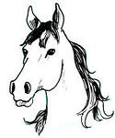](http://images.yandex.ru/yandsearch?p=1&text=%D1%80%D0%B8%D1%81%D0%BE%D0%B2%D0%B0%D0%BD%D0%BD%D1%8B%D0%B5%20%D0%BA%D0%B0%D1%80%D1%82%D0%B8%D0%BD%D0%BA%D0%B8%3A%20%D1%81%D0%BA%D0%B0%D0%BA%D1%83%D0%BD%2C%20%D0%B6%D0%B5%D1%80%D0%B5%D0%B1%D0%B5%D0%BD%D0%BE%D0%BA&fp=1&img_url=http%3A%2F%2Fs18.rimg.info%2Fcc744cc354b8bbd0cf1965f6dbbe7c2c.gif&pos=40&uinfo=ww-1349-wh-673-fw-1124-fh-467-pd-1&rpt=simage)**

**[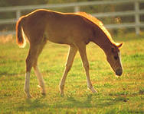](http://images.yandex.ru/yandsearch?text=%D1%80%D0%B8%D1%81%D0%BE%D0%B2%D0%B0%D0%BD%D0%BD%D1%8B%D0%B5%20%D0%BA%D0%B0%D1%80%D1%82%D0%B8%D0%BD%D0%BA%D0%B8%3A%20%D1%81%D0%BA%D0%B0%D0%BA%D1%83%D0%BD%2C%20%D0%B6%D0%B5%D1%80%D0%B5%D0%B1%D0%B5%D0%BD%D0%BE%D0%BA&fp=0&img_url=http%3A%2F%2Fimg-fotki.yandex.ru%2Fget%2F51%2F139660268.1%2F0_7342c_fae71952_XL&pos=3&uinfo=ww-1349-wh-673-fw-1124-fh-467-pd-1&rpt=simage)**

**күлг болх -асн**

[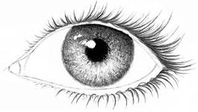](http://images.yandex.ru/yandsearch?text=%D1%80%D0%B8%D1%81%D0%BE%D0%B2%D0%B0%D0%BD%D0%BD%D1%8B%D0%B5%20%D0%BA%D0%B0%D1%80%D1%82%D0%B8%D0%BD%D0%BA%D0%B8%3A%20%D0%B3%D0%BB%D0%B0%D0%B7&fp=0&img_url=http%3A%2F%2Fwww.elpaste.ee%2Fnews%2Fuploads%2Fposts%2F2008-03%2Fthumbs%2F1205597906_post-34727-1195830088.jpg&pos=17&uinfo=ww-1349-wh-673-fw-1124-fh-467-pd-1&rpt=simage)

**ǝǝхǝс,**

**[](http://images.yandex.ru/yandsearch?p=3&text=%D1%80%D0%B8%D1%81%D0%BE%D0%B2%D0%B0%D0%BD%D0%BD%D1%8B%D0%B5%20%D0%BA%D0%B0%D1%80%D1%82%D0%B8%D0%BD%D0%BA%D0%B8%3A%20%D1%80%D1%83%D0%BA%D0%B8&fp=3&img_url=http%3A%2F%2Fmediasubs.ru%2Fgroup%2Fuploads%2Fho%2Fhochu-vsyo-znyitpoleznyie-sovetyi%2Fimage2%2FhLTgwYzAt.jpg&pos=111&uinfo=ww-1349-wh-673-fw-1124-fh-467-pd-1&rpt=simage) ǝǝдго**

[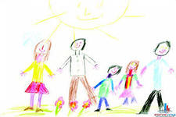](http://images.yandex.ru/yandsearch?p=3&text=%D1%80%D0%B8%D1%81%D0%BE%D0%B2%D0%B0%D0%BD%D0%BD%D1%8B%D0%B5%20%D0%BA%D0%B0%D1%80%D1%82%D0%B8%D0%BD%D0%BA%D0%B8%3A%D1%81%D0%B5%D0%BC%D1%8C%D1%8F&fp=3&img_url=http%3A%2F%2Fwww.2mm.ru%2Fimg%2Fdet_ris3.jpg&pos=90&uinfo=ww-1349-wh-673-fw-1124-fh-467-pd-1&rpt=simage)

**Садта күн –**

**[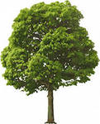](http://images.yandex.ru/yandsearch?text=%D1%80%D0%B8%D1%81%D0%BE%D0%B2%D0%B0%D0%BD%D0%BD%D1%8B%D0%B5%20%D0%BA%D0%B0%D1%80%D1%82%D0%B8%D0%BD%D0%BA%D0%B8%3A%D0%B2%D0%B5%D1%82%D0%B2%D0%B8%D1%81%D1%82%D0%BE%D0%B5%20%D0%B4%D0%B5%D1%80%D0%B5%D0%B2%D0%BE&fp=0&img_url=http%3A%2F%2Fwww.coollady.ru%2Fpuc%2F3%2Fderevo%2Fb%2F03.jpg&pos=25&uinfo=ww-1349-wh-673-fw-1124-fh-467-pd-1&rpt=simage)**

**салата**